 

**CLOUD BASED**

**STUDENT CAREER+ APP**

**A PROJECT REPORT**

***Submitted by***

|  |  |
| --- | --- |
| **T.SANTHOSH** | **(211417104243)** |
| **P.PRADEEP** | **(211417104190)** |
| **K.SURESH KANNAN** | **(211417104276)** |
|  |  |

***in partial fulfillment for the award of the degree***

***of***

**BACHELOR OF ENGINEERING**

***in***

**COMPUTER SCIENCE AND ENGINEERING**

**PANIMALAR ENGINEERING COLLEGE, POONAMALLEE**

**ANNA UNIVERSITY: CHENNAI 600 025**

**APRIL 2021**

**ANNA UNIVERSITY: CHENNAI 600 025**

## BONAFIDE CERTIFICATE

Certified that this project report **“CLOUD BASED STUDENT CAREER+ APP”** is the bonafide work of “**T.SANTHOSH (211417104243), K.SURESH KANNAN (211417104276), P.PRADEEP (211417104190),**” who carried out the project work under my supervision.

|  |  |
| --- | --- |
| **SIGNATURE** | **SIGNATURE** |
| **Dr. S. MURUGAVALLI, M.E., Ph.D.,**  **HEAD OF DEPARTMENT**      DEPARTMENT OF CSE,  PANIMALAR ENGINEERING COLLEGE, NAZARATHPETTAI,  POONAMALLEE,  CHENNAI-600 123. | **Mr. G. SENTHILKUMAR., M.C.A.,M.Phil.,M.B.A., M.E., (Ph.D),**  **SUPERVISOR**  ASSOCIATE PROFESSOR  DEPARTMENT OF CSE,  PANIMALAR ENGINEERING COLLEGE, NAZARATHPETTAI,  POONAMALLEE,  CHENNAI-600 123 |

Certified that the above candidate were examined in the university project viva-voice held on 26.03.2021

|  |  |
| --- | --- |
| **INTERNAL EXAMINER** | **EXTERNAL EXAMINER** |

**ACKNOWLEDGEMENT**

A project of this magnitude and nature requires kind co-operation and support from many for its successful completion. We wish to express our sincere thanks to all those who were involved in the completion of this project.

We would like to express our deep gratitude to our respected Secretary and Correspondent **Dr.P.CHINNADURAI, M.A., Ph.D.**, for his kind words and enthusiastic motivation, which inspired us a lot in completing this project.

We express our sincere thanks to our Directors **Tmt.C.VIJAYARAJESWARI**, **Thiru.C.SAKTHIKUMAR,M.E.,** and **Tmt. SARANYASREE SAKTHIKUMAR B.E.,** for providing us with the necessary facilities for completion of this project.

We also express our gratitude to our Principal **Dr.K.Mani, M.E., Ph.D.,**  who helped us in completing the project.

We thank the Head of the CSE Department, **Dr. S.MURUGAVALLI , M.E.,Ph.D.,** for the support extended throughout the project.

We would like to thank our internal guide **Mrs. ANURADHA, M.E.,**

**Associate Professor** and all the faculty members of the Department of CSE for their valuable guidance and continuous support for the development of our project.

### T.SANTHOSH (211417104243)

### K.SURESH KANNAN (211417104276)

### P.PRADEEP (211417104190)

### ABSTRACT

Due to the pandemic situation students were completely involved and depended on technology in order to communicate, learn and even take exams. Technologies will play a major role in every field in the mere future. But one thing that does not change is how we study even after the pandemic comes to an end. We will roll back to the traditional way of studying by attending classes physically. Nonetheless we also will be partially depending on technologies to study when we are at home.

To improve the experience of how a student can study, we develop a mobile application which acts as a median between the staff and the student. If a simple notification can remind us of several aspects, we can improvise our study experience by a simple notification that arrives directly from the staff to a student mobile mainly focussing on students with backlogs who can manage their study process in a much easier way.

**TABLE OF CONTENTS**

|  |  |  |
| --- | --- | --- |
| **CHAPTER NO** | **TITLE** | **PAGE NO** |
|  | **ABSTRACT** | iii |
|  | **LIST OF TABLES** | vi |
|  | **LIST OF FIGURES** | vii |
|  | **LIST OF SYMBOLS, ABBREVIATIONS** | ix |
| **1.** | **INTRODUCTION** | 01 |
|  | 1.1 OVERVIEW | 02 |
|  | 1.2 PROBLEM DEFINITION | 03 |
| **2.** | **LITERATURE SURVEY** | 04 |
| **3.** | **SYSTEM ANALYSIS** | 08 |
|  | 3.1 EXISTING SYSTEM | 09 |
|  | 3.2 PROPOSED SYSTEM | 10 |
|  | 3.3 REQUIREMENT ANALYSIS AND SPECIFICATION | 11 |
|  | 3.3.1 Hardware Requirements | 11 |
|  | 3.3.2 Software Requirements | 11 |
| **4.** | **SYSTEM DESIGN** | 12 |
|  | 4.1 UML DIAGRAMS | 13 |
|  | 4.1.1 Use Case Diagram | 13 |
|  | 4.1.2 Package Diagram | 14 |
|  | 4.1.3 Flow Diagram | 15 |
|  | 4.1.4 Sequence Diagram | 16 |
| **5.** | **SYSTEM ARCHITECTURE** | 17 |
|  | 5.1 ARCHITECTURE OVERVIEW  5.2 MODULE DESIGN SPECIFICATION  5.2.1 FRONT END  5.2.1 FLUTTER  5.2.1 DART  5.3 FIREBASE INTEGRATION  5.3.1 FIREBASE  5.3.2 FIREBASE AUTHENTICATION  5.3.3 FIREBASE FIRESTORE  5.3.4 DATABASE STRUCTURE  5.3.5 CLOUD STORAGE  5.3.6 CLOUD FUNCTION  5.3.7 FIREBASE CLOUD MESSAGING  5.3.8 GOOGLE CLOUD | 18  19  19  19  19  19  19  20  20  21  22  23  23  24 |
| **6.** | **SYSTEM IMPLEMENTATION** | 25 |
|  | 6.1 CODING | 26 |
| **7.** | **SYSTEM TESTING** | 68 |
|  | 7.1 UNIT TESTING | 69 |
|  | 7.2 INTEGRATION TESTING | 69 |
|  | 7.3 TEST CASES & REPORTS / PERFORMANCE ANALYSIS | 70 |
| **8.** | **CONCLUSION** | 86 |
|  | 8.1 CONCLUSION AND FUTURE ENHANCEMENTS | 87 |
|  | **APPENDICES** | 88 |
|  | A.1 SAMPLE SCREENS | 89 |
|  | **REFERENCES** | 99 |
|  |  |  |
|  |  |  |
|  |  |  |
|  |  |  |

**LIST OF TABLES**

|  |  |  |
| --- | --- | --- |
| **TABLE NO** | **TABLE** | **PAGE NO** |
| 5.2.1 | Database Structure | 21 |
|  |  |  |

**LIST OF FIGURES**

|  |  |  |
| --- | --- | --- |
| **FIGURE NO** | **NAME OF THE FIGURE** | **PAGE NO** |
| 4.1.1 | Use case Diagram | 13 |
| 4.1.2 | Package Diagram | 14 |
| 4.1.3 | Flow Diagram | 15 |
| 4.1.4 | Sequence Diagram | 16 |
| 5.1.1 | Architecture Diagram | 18 |
| 7.3.1.1 | Student Login Page Email id | 70 |
| 7.3.1.2 | Student Login Page Password | 71 |
| 7.3.2.1 | Staff Login Page Email id | 72 |
| 7.3.2.2  7.3.3.1  7.3.4.1  7.3.4.2  7.3.5.1  7.3.5.2  7.3.6.1  7.3.6.2  7.3.7.1  7.3.7.2  7.3.7.3  7.3.7.4  7.3.7.5  7.3.8.1  7.3.9.1  7.3.9.2  7.3.9.3 | Staff Login Page Password  Register Validation  General Notification Sent  Backlog Notification Sent  Notification Received Staff Login  Notification Received Student Login  No Image/Valid File Chosen  Upload Success  File Upload Error  Cancel OD Request  OD Request Success  Pending Request  Approved Request  Reset Linked Account  Login Error  Exit Confirmation  Logout Confirmation | 72  73  74  75  76  76  77  77  78  78  79  80  80  81  82  83  83 |
| A.1.1  A.1.2  A.1.3  A.1.4  A.1.5  A.1.6  A.1.7  A.1.8  A.1.9  A.1.10  A.2.1  A.2.2  A.2.3  A.2.4  A.2.5  A.2.6  A.2.7  A.2.8  A.2.9  A.2.10  A.2.11  A.2.12  A.2.13  A.2.14 | Staff Login Screen  Staff Profile Screen  General Notify Screen  Backlog Notify Screen  Student Search Modal Filter  View Student Screen  Modify Student Screen  Choose PDF Screen  View PDF Screen  Provide OD Screen  Student Login Screen  Student Register Screen  Password Reset Screen  Link Google Account Screen  Student Profile Screen  View General Notification Screen  Backlog Details Screen  View Backlog Notification Screen  View Notes Screen  Request OD Screen  View Requests Screen  Choose Image Screen  Upload PDF Preview  View Requests Not Approved | 87  87  88  88  89  89  90  90  91  91  92  92  93  93  94  94  95  95  96  96  97  97  98  98 |
|  |  |  |
|  |  |  |

**List Of Abbreviations**

|  |  |
| --- | --- |
| OD  FCM  OOP | On Duty  Firebase Cloud Messaging  Object Oriented Programming |
|  |  |
|  |  |
|  |  |
|  |  |
|  |  |
|  |  |
|  |  |
|  |  |
|  |  |
|  |  |
|  |  |
|  |  |
|  |  |
|  |  |
|  |  |
|  |  |
|  |  |
|  |  |

**CHAPTER 1**

**INTRODUCTION**

**CHAPTER 1**

**INTRODUCTION**

* 1. **OVERVIEW**

Technology has become a part of our lives as it plays a vital role in enhancing our workflow. From setting reminders to connecting with people from different places, technology could also be used for betterment of a student’s career. Every student today owns their personal smartphone. In order to improve the communication between students and staff, a mobile application could act as a median.

By implementing cloud functionalities over a mobile application, both students and staff could communicate professionally anywhere anytime. For students with backlogs, this application could help them manage their time by receiving messages everyday from the staff who taught him the subject. There are more functionalities added, that would benefit the overall career of a student.

* 1. **PROBLEM DEFINITION**

In our project, we have developed an application that would be handy, easy to use and stable in performing operations over cloud. By integrating Firebase services as backend, there is no need of managing backend for this app as it is taken care completely and analysed well by the firebase module. A student or staff can receive notifications anywhere and anytime as the cloud functions are deployed in Google cloud platform. As a single notification on any aspect is possibly able to manage our tasks, a notification from staff on managing the study progress of a student is what we are implementing by developing this mobile application.

This application has been developed with more features added such as notes management, progress tracking and managing OD approval for a student attending events. Since firebase storage is encapsulated with several security models, data piracy and other security attacks are taken care of by firebase itself.

**CHAPTER 2**

**LITERATURE SURVEY**

**CHAPTER 2**

**LITERATURE SURVEY**

**Paper 1 :“ A survey on android based instant notification system ”**

Enotice Application it is fluke for students and staff all are can access this application through via mobile phone ,there is no need to go and visit physically anywhere to visit the notice board with the help of this application students and staff will get all notifications regarding studies, institute and also they will get all updates about college department and Corporate.It is helpful for all updates and notification, it is simply way to convey message for students and staff. It is the best facility for everyone because at one click students and staff can get all notice, updates and Information. This system applied in educational institutes as an online path of notice board and sharing system that can access and use anytime anywhere that means all in your hand. It is about a virtual system where everyone can use this application anywhere, simply we can check mails and it is an easy way to access and fill any application form regarding college and studies.

**Paper 2 :“ Android based Student Reminder System ”**

This application is mainly useful for the students in managing some of their daily college activities. Library reminder system is one of the features of this application. In this application the student enters the book details such as name of the book and date of the book issued. This application calculates the speciﬁed renewal date and on that date it reminds the students to renew the book. The ﬂow of this feature is shown as in ﬁg. 1. The details get stored in the database so that the student can view the details of the book he has taken from the library. The details stored in the database are the name of the book, date of the book issued and the number of days after the book needs to be renewed etc.

**Paper 3 : “The use and effect of smartphones in students’ learning activities ”**

It is blatant that the proliferation of the Internet and Information Communication Technology has affected almost every facet of teaching and learning, especially in distance education where course 30 is being delivered either by blended mode of teaching or fully online. With reference to the findings of this study, it was revealed that the distance learning students of the University of Ghana find it easy to use a smartphone in their academic activities which enhance their perceived usefulness of using a smartphone for learning activities. The findings can be attributed to the fact that since part of their course is delivery via digital mode, there is the tendency that they were fueled to learn how to use a smartphone to access the Sakai which is a common platform for course delivery. Also, the study found a positive usefulness of the use of smartphone in the students' learning activities such as easy sharing and accessing of lecture materials online, easy communication with colleagues and course masters, being able to carry smartphone any anywhere and at any time because of its portability as compared to a laptop and many others.

**Article :“ Impact of Mobile Learning on Students’ Achievement Results ”**

The results of this article reveal that the final achievement tests (as described in the article) proved that most of the students who had not used the described app for practicing after regular classes had done badly although they had an opportunity to study these words and phrases discussed and written down in the face-to-face classes on their own after the classes. However, they were not sent the notifications to remind them to study them, and thus they had fewer opportunities of exposure to the target language. The learning materials and tools, such as the described mobile app, designed based on students’ needs and continuously facilitated by a teacher, are effective in the enhancement of students’ performance and contribute to positive learning outcomes. In addition, the results also confirm that mobile learning can serve as an appropriate complementary method to other forms of course delivery thanks to its opportunities of frequent exposure to the target language. However, students were also encouraged to use the mobile app for the meaningful content and immediate feedback they received.

**CHAPTER 3**

**SYSTEM ANALYSIS**

**CHAPTER 3**

**SYSTEM ANALYSIS**

**3.1 EXISTING SYSTEM**

Each college could have their own database of managing student details. Each student can login with their credentials and see their career progress over there. But when a student moves to next semester with a backlog, he or she will not be getting any advice from the staff for the respective backlog subject on how to manage time and study for clearing the backlog. Time management is what matters for a student where they must have to focus on both their current progress as well as their backlogs. With the help of staff, they can achieve their needs by getting advice on planning their study periods. But, there occurs a situation where one staff cannot handle a large set of students. A staff might teach the same subject for different semesters of different years. One student from a particular semester might have to approach the staff even after a year or two. In such cases the time management for staff becomes hard and they might end up spending extra time after their work hours.

**EXISTING SYSTEM DISADVANTAGES**

* Students are not notified instantly on any general circular.
* Staff will not be able to communicate with each student who has a backlog in each subject.
* Security of files transferred through web portal.

**3.2 PROPOSED SYSTEM**

Developing a mobile application which would enhance the study experience of a student, especially a student with backlogs would find it very easy to study and organize his or her time. Students will gain confidence once the right advice on organizing their study process becomes handy. As like students, teachers will also be able to provide tasks to backlog students with ease. This application has several features such as notify students with backlogs for a particular department or for a set of classes. Students will get notified instantly as the backend functionality is implemented in the cloud. There is separate login for students and staff. Students could view their backlogs, view notes provided by respective staff, request for an OD on a particular date and view messages sent by staff in general or as backlog notification. Similarly, a staff can login with his own credentials. A staff would be able to manage notes, send notifications either generally or specifically to backlog students of certain classes, manage OD requests, modify student backlogs and search for student details to view his progress.

**Advantage:**

* Time management
* Instant cloud messaging
* Secured file management
* Quick approval of OD requests

**3.3 REQUIREMENT ANALYSIS AND SPECIFICATION**

**3.3.1 HARDWARE REQUIREMENTS**

* Laptop or Personal Computer with 64bit architecture
* Processor intel core i3 or above with 4GB RAM
* Graphics memory of 2GB or above
* Smartphone running Android 4.0 or above.

**3.3.2 SOFTWARE REQUIREMENTS**

* Android Studio
* Visual Studio Code
* Flutter SDK
* Dart SDK
* Android SDK
* Firebase Integration Toolkit

**CHAPTER 4**

**SYSTEM DESIGN**

**CHAPTER 4**

**SYSTEM DESIGN**

**4.1 UML DIAGRAMS**

**4.1.1 USE CASE DIAGRAM**

A **use case diagram** at its simplest is a representation of a user's interaction with the system that shows the relationship between the user and the different use cases in which the user is involved. A use case diagram can identify the different types of users of a system and the different use cases and will often be accompanied by other types of diagrams as well.

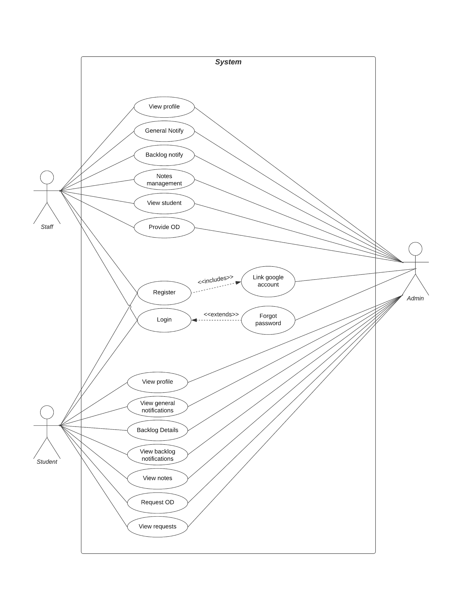

**Fig 4.1.1. Use case diagram**

**4.1.2 PACKAGE DIAGRAM**

A package diagram, a kind of structural diagram, shows the arrangement and organization of model elements in middle to large scale projects. The package diagram can show both structure and dependencies between subsystems or modules, showing different views of a system.

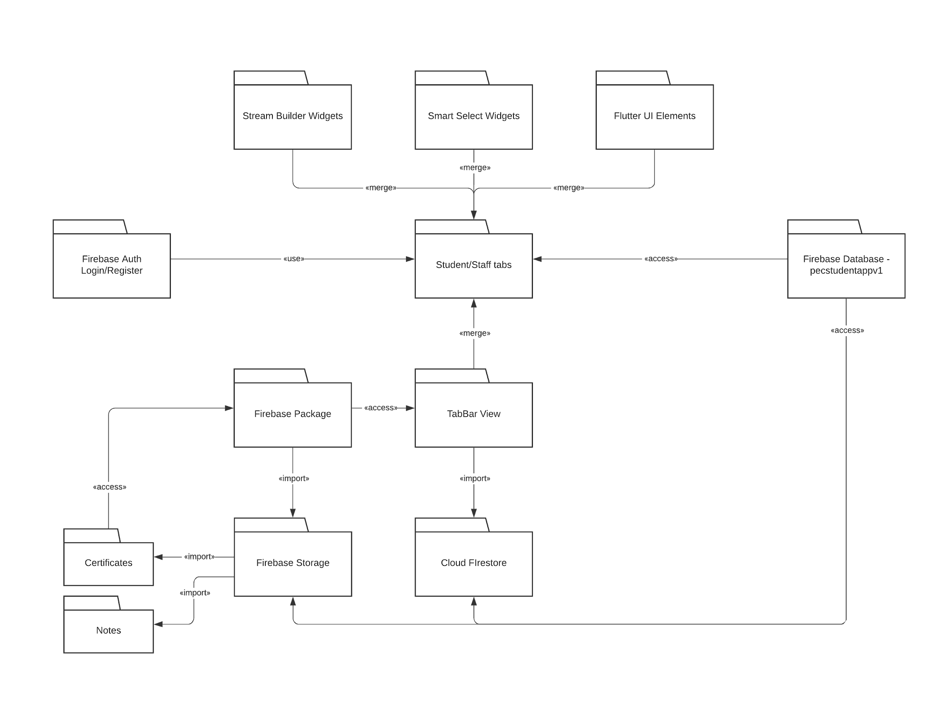

**Fig 4.1.2. Package diagram**

**4.1.3 FLOW DIAGRAM**

A diagram of the sequence of movements or actions of people or things involved in a complex system or activity.

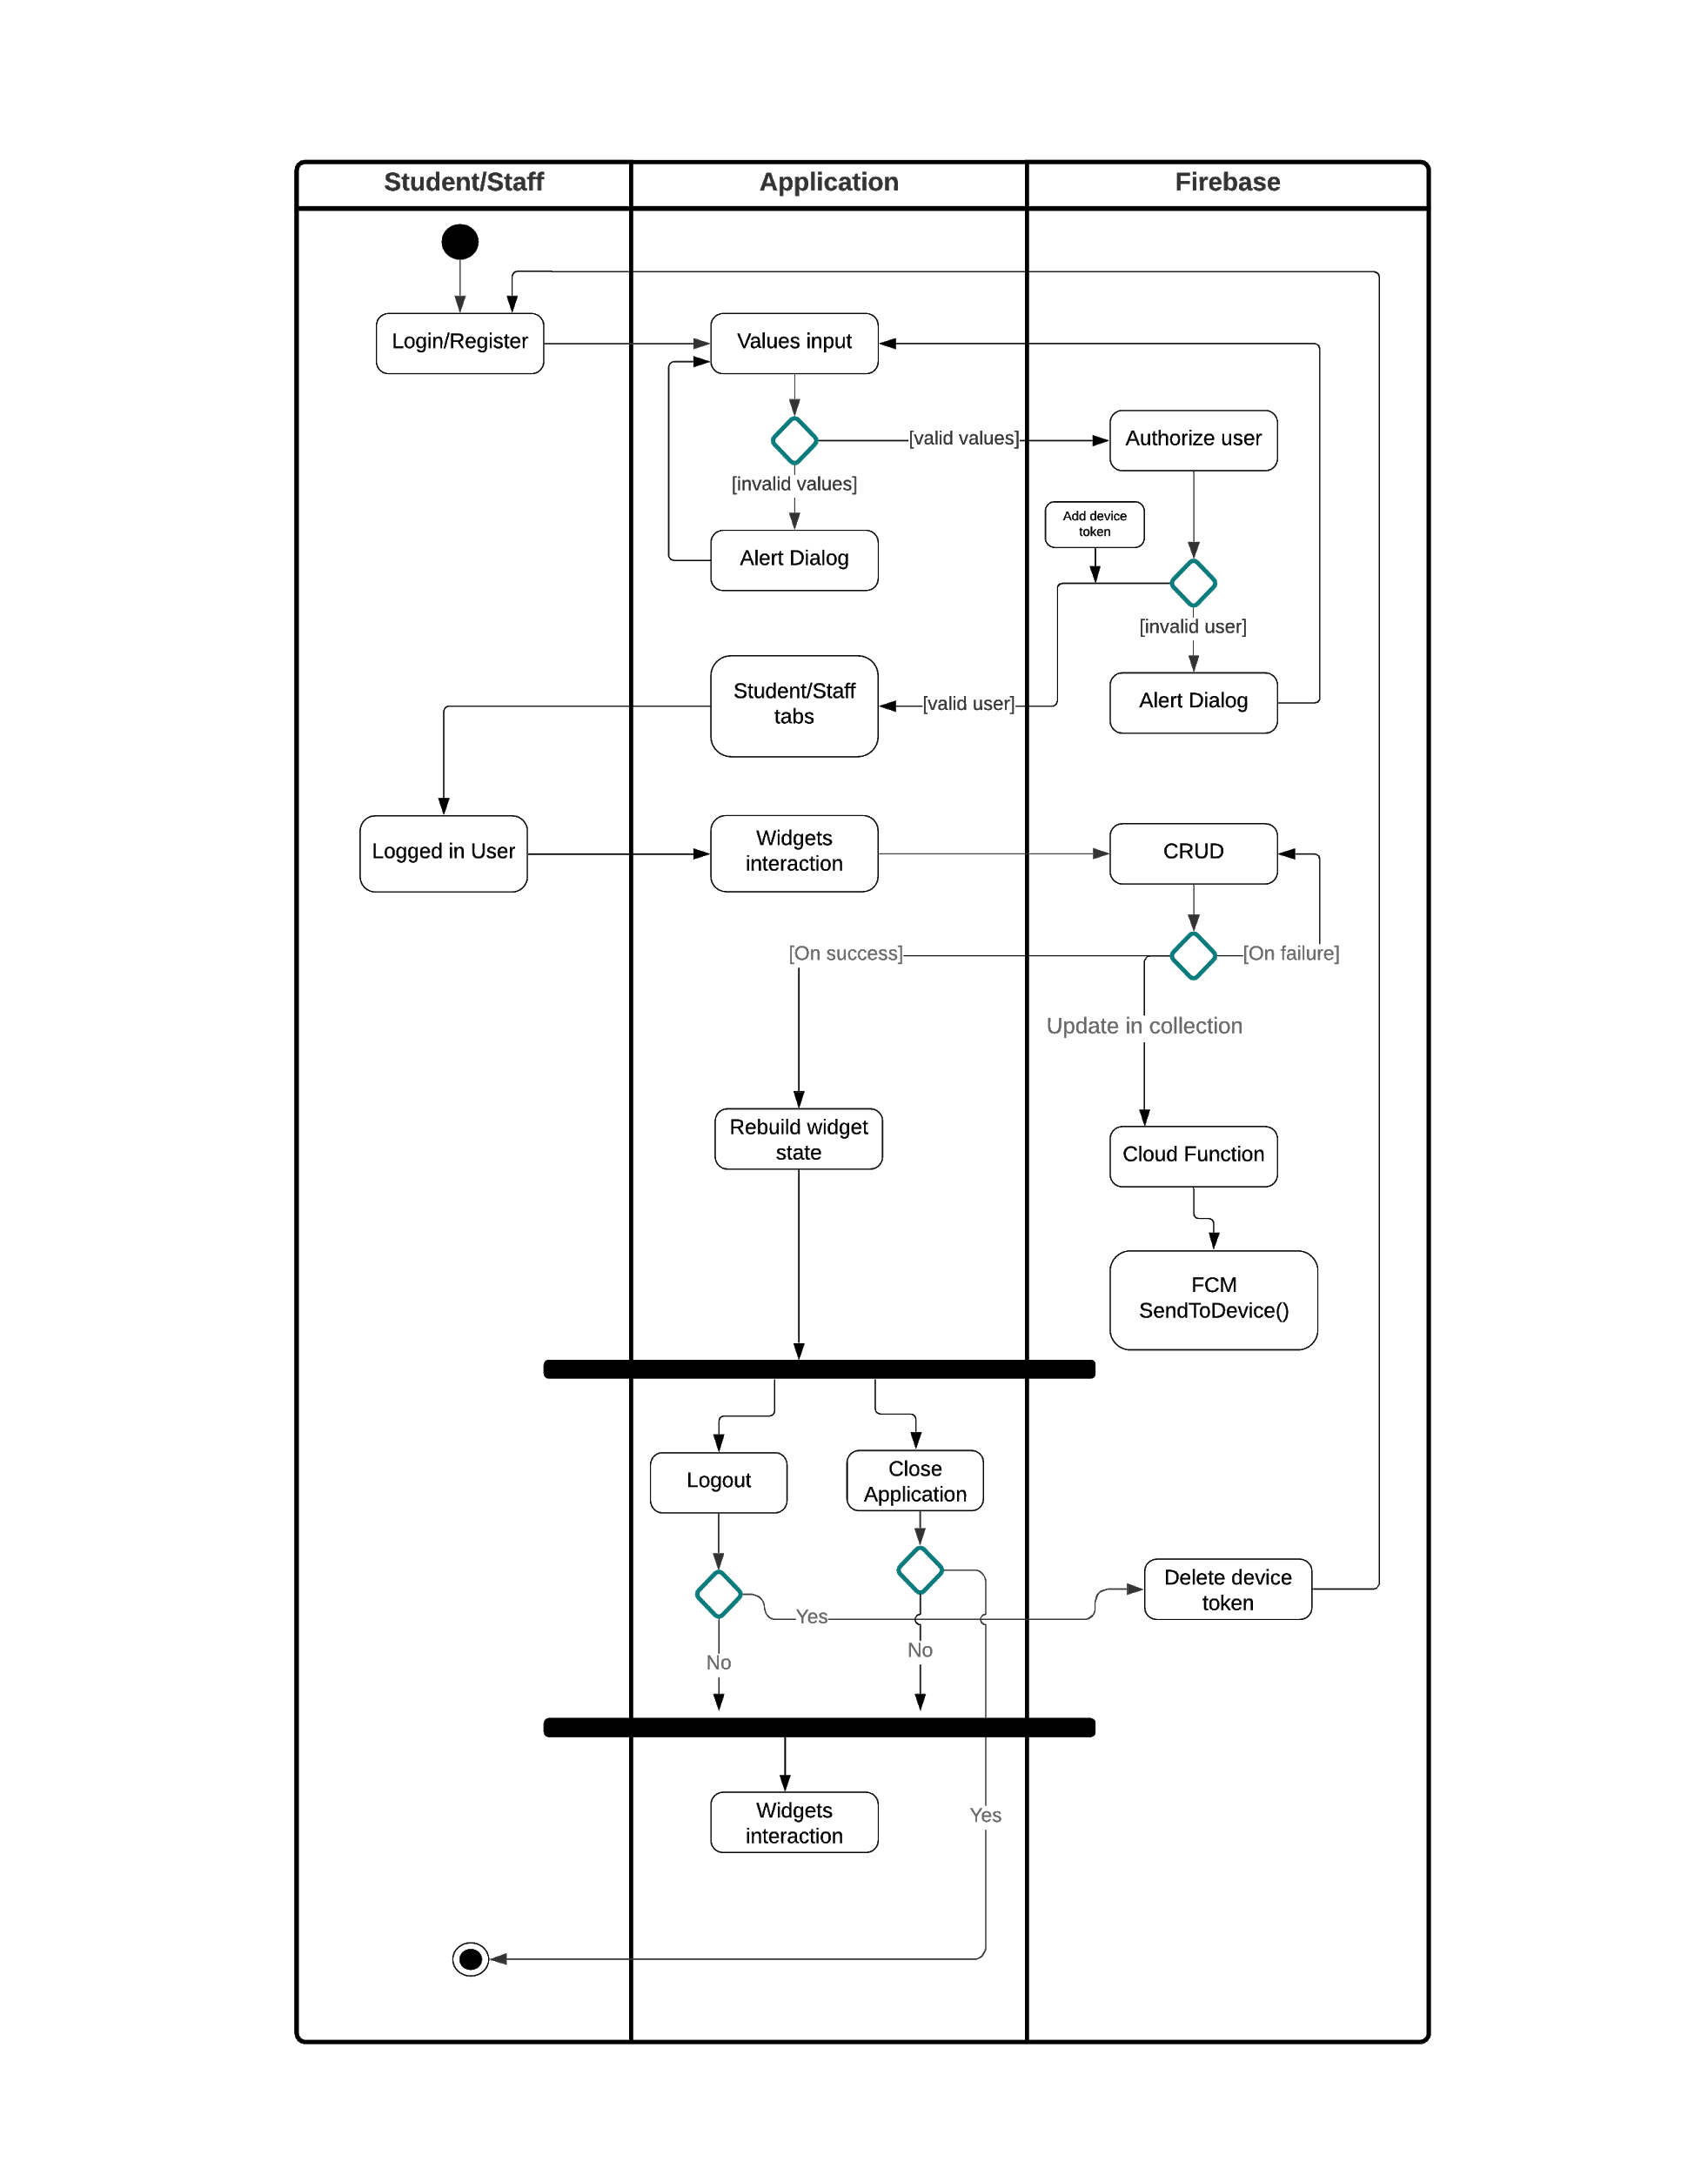

**Fig 4.1.3. Flow diagram**

**4.1.4 SEQUENCE DIAGRAM**

A sequence diagram shows object interactions arranged in time sequence. It depicts the objects and classes involved in the scenario and the sequence of messages exchanged between the objects needed to carry out the functionality of the scenario. Sequence diagrams are typically associated with use case realizations in the sequence diagram of the system under development.

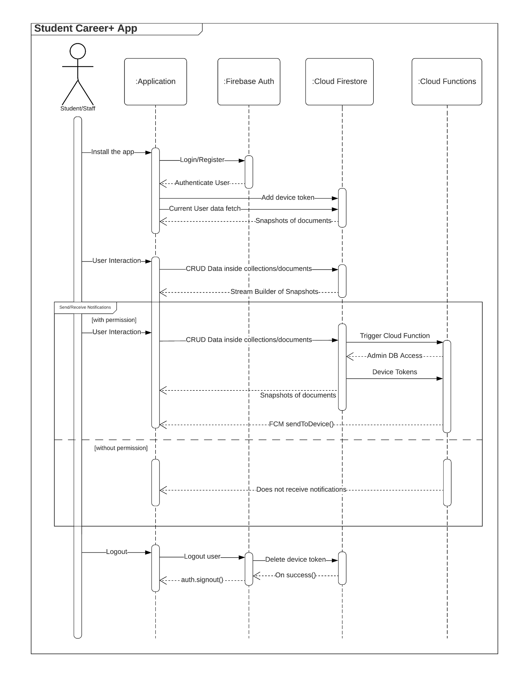

**Fig 4.1.4. Sequence Diagram**

**CHAPTER 5**

**SYSTEM ARCHITECTURE**

**CHAPTER 5**

**SYSTEM ARCHITECTURE**

**5.1 ARCHITECTURE OVERVIEW**

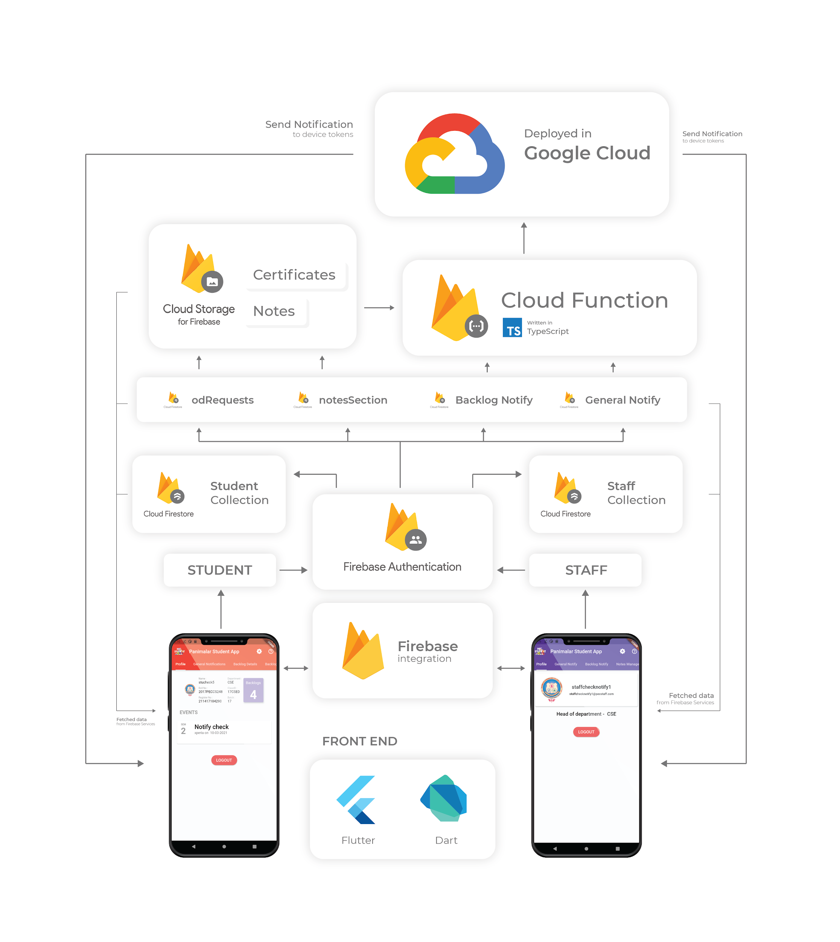

**Fig 5.1.1 Architecture Diagram**

**5.2 MODULE DESIGN SPECIFICATION**

**5.2.1 FRONT END**

The front end for this application is developed using Flutter and Dart. By using flutter, the UI widgets are very much capable of rebuilding themselves on any changes that occur inside the firebase module integrated with the application. Flutter’s stateful and stateless widgets are the key to building interactive user interfaces. Dart language makes it possible to implement OOP concepts in the app development process.

**5.2.2 FLUTTER**

Flutter is Google’s UI toolkit for building beautiful, natively compiled applications for [mobile](https://flutter.dev/docs), [web](https://flutter.dev/web), and [desktop](https://flutter.dev/desktop) from a single codebase.

**5.2.3 DART**

Dart is a client-optimized language for fast apps on any platform

Features of Dart Language:

* Mature and complete [async-await](https://dart.dev/codelabs/async-await) for user interfaces containing event-driven code.
* Make changes to your source code iteratively, using [hot reload](https://flutter.dev/docs/development/tools/hot-reload) to instantly see the effect in the running app

**5.3 FIREBASE INTEGRATION**

**5.3.1 FIREBASE**

Firebase is Google’s mobile application development platform that helps us build, improve, and grow our app.

**5.3.2 FIREBASE AUTHENTICATION**

Firebase Authentication provides backend services, easy-to-use SDKs, and ready-made UI libraries to authenticate users to our app. It supports authentication using passwords, phone numbers, popular federated identity providers like Google, Facebook and Twitter, and more.

Firebase Authentication integrates tightly with other Firebase services, and it leverages industry standards like OAuth 2.0 and OpenID Connect, so it can be easily integrated with our custom backend.

In this app, we have included the basic email and password login auth for both staff and students. After successful registration the user might have to link the account with his/her google account for future recovery purposes.

**5.3.3 FIREBASE FIRESTORE**

Cloud Firestore is a flexible, scalable database for mobile, web, and server development from Firebase and Google Cloud. Like Firebase Realtime Database, it keeps your data in sync across client apps through real time listeners and offers offline support for mobile and web so we can build responsive apps that work regardless of network latency or Internet connectivity. Cloud Firestore also offers seamless integration with other Firebase and Google Cloud products, including Cloud Functions.

The data is stored as collections and documents in the database. A document consists of a set of fields and values. A document can also contain collections and it expands horizontally.

**5.3.4 FIRESTORE DATABASE STRUCTURE**

|  |  |  |
| --- | --- | --- |
| **collection** | **document** | **fields** |
| generalNotifyStudents | docID | classID: Array  dateAndTime: String  department: String  email: String  message: String  messageTitle: String  semester: String |
| notesSection | subject code - (c) staff mail - docID | classID: Array  department: String  filename: String  notesPath: String  notesURL: String  subject: String  uploadedBy: String |
| notifyStudents | docID | backlogsubs: Array  classID: Array  dateAndTIme: String  department: String  email: String  message: String  semester: String |
| odRequests | docID | ODApproval: boolean  certificatePath: String  certificateURL: String  classID: String  date: String  department: String  email: String  eventLocation: String  eventTitle: String  semester: String |
| staffs | docID | (c) - tokens  Name: String  department: String  designation: String  email: String  recoveryMail: String |
| students | docID | (c) - tokens  backlogNumber: int  backlogs: boolean  backlogsubs: Array  classID: String  department: String  email: String  name: String  recoveryMail: String  regno: String  rollno: String |

***Table 5.3.1 Database Structure***

**5.3.5 CLOUD STORAGE**

Cloud Storage for Firebase is a powerful, simple, and cost-effective object storage service built for Google scale. The Firebase SDKs for Cloud Storage add Google security to file uploads and downloads for our Firebase app, regardless of network quality.

We can use firebase SDKs to store images, audio, video, or other user-generated content. On the server, we can use [Google Cloud Storage APIs](https://cloud.google.com/storage/docs/reference/libraries) to access the same files.

The project consists of two folders inside Cloud Storage:

* certificates
* notes

The path and url of the uploaded files are stored in firestore for further read, write or delete operations.

**5.3.6 CLOUD FUNCTIONS**

Cloud Functions for Firebase is a serverless framework that lets us automatically run backend code in response to events triggered by Firebase features and HTTPS requests. Our TypeScript code is stored in Google's cloud and runs in a managed environment. There's no need to manage and scale our own servers.

The functions we write can respond to events generated by various Firebase and Google Cloud features, from [Firebase Authentication triggers](https://firebase.google.com/docs/functions/auth-events) to [Cloud Storage Triggers](https://firebase.google.com/docs/functions/gcp-storage-events).

Integrating across Firebase features using the [Admin SDK](https://firebase.google.com/docs/admin/setup) together with Cloud Functions, and integrating with third-party services by writing our own webhooks. Cloud Functions minimizes boilerplate code, making it easier to use Firebase and Google Cloud inside our function.

**5.3.7 FIREBASE CLOUD MESSAGING**

Firebase Cloud Messaging (FCM) is a cross-platform messaging solution that lets us reliably send messages at no cost. Using FCM, we can notify a client app that new email or other data is available to sync. We can send notification messages to drive user re-engagement and retention. For use cases such as instant messaging, a message can transfer a payload of up to 4KB to a client app. [Firebase Cloud Messaging](https://firebase.google.com/docs/cloud-messaging) (FCM) provides a sophisticated set of tools to send notifications only to users who actually want them. Device notifications may also be tied to a database event, but are more likely to be related to a specific user.

For example, let’s imagine we have an ***orders*** collection and want to notify a seller when a new order has been finalized. In this case, we will query the tokens subcollection under the user, then send a notification to all of their device tokens.

**5.3.8 GOOGLE CLOUD**

Google Cloud Platform (GCP), offered by google, is a suite of cloud computing services that runs on the same infrastructure that Google uses internally for its end-user products, like google-search and youtube. Alongside a set of management tools, it also provides a series of modular cloud services including computing, data storage, data analytics and machine learning registrations.

Google Cloud Platform provides a systematic infrastructure and various other important platform as a service that features a serverless computing environment.

**CHAPTER 6**

**SYSTEM IMPLEMENTATION**

**CHAPTER 6**

**SYSTEM IMPLEMENTATION**

**6.1 CODING**

**main.dart**

import 'package:flutter/material.dart';

import 'package:theme_patrol/theme_patrol.dart';

import 'welcome_screen.dart';

import 'package:firebase_core/firebase_core.dart';

void main() async {

WidgetsFlutterBinding.ensureInitialized();

await Firebase.initializeApp();

runApp(MyApp());

}

class MyApp extends StatelessWidget {

@override

Widget build(BuildContext context) {

return ThemePatrol(

light: ThemeData(

brightness: Brightness.light,

primarySwatch: Colors.red,

primaryColor: Colors.red,

accentColor: Colors.red,

visualDensity: VisualDensity.adaptivePlatformDensity,

useTextSelectionTheme: true),

dark: ThemeData(

brightness: Brightness.dark,

primarySwatch: Colors.red,

primaryColor: Colors.red,

accentColor: Colors.red,

toggleableActiveColor: Colors.red,

visualDensity: VisualDensity.adaptivePlatformDensity,

useTextSelectionTheme: true),

mode: ThemeMode.system,

builder: (context, theme) {

return MaterialApp(

debugShowCheckedModeBanner: false,

title: 'Panimalar Student App',

theme: theme.light,

darkTheme: theme.dark,

themeMode: theme.mode,

home: WelcomeScreen(),

);

},

);

}

}

**LOGIN FUNCTIONALITY**

**Student Login**

final newStudent = await _auth

.signInWithEmailAndPassword(

email: email,

password: password);

if (newStudent != null) {

studentID = _auth.currentUser.uid;

Navigator.push(

context,

MaterialPageRoute(

builder: (context) {

return StudentMainScreen(); //StaffChoose();

},

),

);

}

**Student Register**

final newStudent = await _auth

.createUserWithEmailAndPassword(

email: email,

password: password);

User student = newStudent.user;

String stuid = student.uid;

_store

.collection('students')

.doc(stuid)

.set({

'name': name,

'department': department,

'email': email,

'classID': classID,

'regno': regno,

'rollno': rollno,

'backlogs': backlog,

'backlognumber': backlognumber,

"backlogsubs": _subjectcode,

"recoveryMail": recoveryMail,

});

//addBacklogDetails(stuid);

//addData();

if (newStudent != null) {

studentID = _auth.currentUser.uid;

Navigator.push(

context,

MaterialPageRoute(

builder: (context) {

return GoogleAccountLink(

studentOrStaff: 'student',

);

},

),

);

}

**Staff Login**

final newStaff = await _auth

.signInWithEmailAndPassword(

email: email,

password: password);

if (newStaff != null) {

staffID = _auth.currentUser.uid;

Navigator.push(

context,

MaterialPageRoute(

builder: (context) {

return StaffMainScreen(); //StaffChoose();

},

),

);

}

**Staff Register**

final newStaff = await _auth

.createUserWithEmailAndPassword(

email: email,

password: password);

User staff = newStaff.user;

String staffid = staff.uid;

_store.collection('staffs')

..doc(staffid).set({

'Name': name,

'department': department,

'email': email,

'designation': designation,

"recoveryMail": recoveryMail,

});

if (newStaff != null) {

staffID = _auth.currentUser.uid;

Navigator.push(

context,

MaterialPageRoute(

builder: (context) {

return GoogleAccountLink(

studentOrStaff: 'staff',

);

},

),

);

}

**Reset Password**

Future sendResetMail(String recoverymail) async {

print('send reset called');

try {

await _auth.sendPasswordResetEmail(email: recoverymail);

return showDialog();

} catch (e) {

return showDialog();

}

**Google account link**

Future linkEmailGoogle() async {

//get currently logged in user

existingUser = _auth.currentUser;

//get the credentials of the new linking account

final GoogleSignIn _googleSignIn = GoogleSignIn();

final GoogleSignInAccount googleUser = await _googleSignIn.signIn();

final GoogleSignInAuthentication googleAuth =

await googleUser.authentication;

final AuthCredential gcredential = GoogleAuthProvider.credential(

accessToken: googleAuth.accessToken,

idToken: googleAuth.idToken,

);

//now link these credentials with the existing user

try {

linkauthresult = await existingUser.linkWithCredential(gcredential);

linkedSuccess = true;

} catch (e) {

linkedSuccess = false;

return showDialog(

context: context,

builder: (BuildContext context) {

return AlertDialog();

}

// existingUser.updateEmail(googleUser.email);

}

**CLOUD FUNCTION**

**FUNCTIONS DIRECTORY**

**index.ts**

import * as functions from 'firebase-functions';

import * as admin from 'firebase-admin';

admin.initializeApp();

const db = admin.firestore();

const fcm = admin.messaging();

export const sendToDevice = functions.firestore

.document('generalNotifyStudents/{generalNotifyId}')

.onCreate(async snapshot => {

if(!snapshot.exists){

console.log('No devices');

return ;

}

const tokens = [] as any;

var classForGen = [];

const newGenNotify = snapshot.data();

console.log('newGenNotify ',newGenNotify);

for(var i=0;i<newGenNotify.classID.length;i++){

classForGen.push(newGenNotify.classID[i]);

}

console.log('classForGen ',classForGen);

const studentDetails = await admin.firestore().collection('students').get();

for(var j=0;j<classForGen.length;j++){

for( var stuClass of studentDetails.docs){

const classID = stuClass.get('classID');

console.log('classID ',classID);

console.log('classForGen[j] ',classForGen[j]);

if(classID == classForGen[j]){

var stuDocID = stuClass.id;

console.log(stuDocID);

const querySnapshot = await db

.collection('students')

.doc(stuDocID)

.collection('tokens')

.get();

console.log(querySnapshot);

const deviceToken = querySnapshot.docs.map(snap => snap.id);

console.log('deviceToken ',deviceToken);

for(var k=0;k<deviceToken.length;k++){

tokens.push(deviceToken[k]);

}

}

}

}

const payload: admin.messaging.MessagingPayload = {

notification: {

title: `${newGenNotify.department} - ${newGenNotify.messageTitle}`,

body: `${newGenNotify.message}`,

// icon: 'your-icon-url',

click_action: 'FLUTTER_NOTIFICATION_CLICK'

}

};

console.log('Final tokens', tokens);

return fcm.sendToDevice(tokens, payload);

});

export const backlogNotify = functions.firestore

.document('notifyStudents/{notifyStudentsId}')

.onCreate(async snapshot => {

if(!snapshot.exists){

console.log('No devices');

return ;

}

const backlogtokens = [] as any;

var classForBacklog = [];

var subjectBacklog = [];

const newBacklogNotify = snapshot.data();

console.log('newBacklogNotify ',newBacklogNotify);

for(var l=0;l<newBacklogNotify.classID.length;l++){

classForBacklog.push(newBacklogNotify.classID[l]);

}

for(var m=0;m<newBacklogNotify.backlogsubs.length;m++){

subjectBacklog.push(newBacklogNotify.backlogsubs[m]);

}

console.log('classForBacklog ',classForBacklog);

console.log('subjectForBacklog ',subjectBacklog);

const studentDetails = await admin.firestore().collection('students').get();

for(var n=0;n<classForBacklog.length;n++){

for( var stuClass of studentDetails.docs){

const classID = stuClass.get('classID');

console.log('classID ',classID);

console.log('classForBacklog[n] ',classForBacklog[n]);

if(classID == classForBacklog[n]){

// for(var stuBacklog of studentDetails.docs){}

const stuBackLogSubs = stuClass.get('backlogsubs');

for(var p=0;p<subjectBacklog.length;p++){

for(var q=0;q<stuBackLogSubs.length;q++){

if(stuBackLogSubs[q]==subjectBacklog[p]){

var stuDocID = stuClass.id;

console.log(stuDocID);

const querySnapshot = await db

.collection('students')

.doc(stuDocID)

.collection('tokens')

.get();

console.log(querySnapshot);

const deviceToken = querySnapshot.docs.map(snap => snap.id);

console.log('deviceToken ',deviceToken);

for(var r=0;r<deviceToken.length;r++){

backlogtokens.push(deviceToken[r]);

}

}

}

}

}

}

}

const payload: admin.messaging.MessagingPayload = {

notification: {

title: `${newBacklogNotify.email} `,

body: `${newBacklogNotify.message}`,

// icon: 'your-icon-url',

click_action: 'FLUTTER_NOTIFICATION_CLICK'

}

};

console.log('Final Backlog tokens', backlogtokens);

return fcm.sendToDevice(backlogtokens, payload);

});

export const ODProvideNotify = functions.firestore

.document('odRequests/{odRequestsId}')

.onCreate(async snapshot => {

if(!snapshot.exists){

console.log('No devices');

return ;

}

const Stafftokens = [] as any;

const OdRequests = snapshot.data();

console.log('OdRequests ',OdRequests);

const staffDetails = await admin.firestore().collection('staffs').get();

for( var staffDep of staffDetails.docs){

const staffDepartment = staffDep.get('department');

console.log('staffDepartment ',staffDepartment);

if(staffDepartment == OdRequests.department){

var staffDocID = staffDep.id;

console.log(staffDocID);

const querySnapshot = await db

.collection('staffs')

.doc(staffDocID)

.collection('tokens')

.get();

console.log(querySnapshot);

const deviceToken = querySnapshot.docs.map(snap => snap.id);

console.log('deviceToken ',deviceToken);

for(var k=0;k<deviceToken.length;k++){

Stafftokens.push(deviceToken[k]);

}

}

}

const payload: admin.messaging.MessagingPayload = {

notification: {

title: `${OdRequests.classID} - ${OdRequests.email}`,

body: `${OdRequests.date} for event ${OdRequests.eventTitle}`,

// icon: 'your-icon-url',

click_action: 'FLUTTER_NOTIFICATION_CLICK'

}

};

console.log('Final tokens', Stafftokens);

return fcm.sendToDevice(Stafftokens, payload);

});

**StreamBuilder and Building cards using Stateful widgets**

**student_search.dart**

import 'package:carousel_slider/carousel_slider.dart';

import 'package:flutter/material.dart';

import 'package:smart_select/smart_select.dart';

import 'package:student_app/student_details_modify.dart';

import '../choices.dart' as choices;

import 'package:cloud_firestore/cloud_firestore.dart';

final _store = FirebaseFirestore.instance;

List<String> _classid = [];

String Department;

String stuDocumentID;

String stuMail;

String stuName;

String stuRoll;

String stuReg;

String stuClassID;

String stuBatch;

String stuBacklogNum;

class FeaturesTileStudent extends StatefulWidget {

@override

_FeaturesTileStudentState createState() => _FeaturesTileStudentState();

}

class _FeaturesTileStudentState extends State<FeaturesTileStudent> {

final dataKey = new GlobalKey();

@override

void initState() {

super.initState();

setState(() {

StudentStream();

ChosenStudentStream();

StudentSearchCard();

});

}

Color get primaryColor => Theme.of(context).primaryColor;

@override

Widget build(BuildContext context) {

return Padding(

padding: const EdgeInsets.all(8.0),

child: Column(

mainAxisSize: MainAxisSize.min,

children: <Widget>[

const SizedBox(height: 7),

Card(

key: dataKey,

elevation: 3,

margin: const EdgeInsets.all(5),

shape: const RoundedRectangleBorder(

borderRadius: BorderRadius.all(Radius.circular(5.0)),

),

),

SmartSelect<String>.multiple(

title: 'Choose classes',

value: _classid,

choiceItems: S2Choice.listFrom<String, Map>(

source: choices.classid,

value: (index, item) => item['value'],

title: (index, item) => item['title'],

group: (index, item) => item['department'],

),

onChange: (state) => setState(() {

_classid = state.value;

_classid.sort();

print(_classid);

}),

modalType: S2ModalType.bottomSheet,

modalConfirm: true,

modalFilter: true,

choiceGrouped: true,

tileBuilder: (context, state) {

return Card(

elevation: 3,

margin: const EdgeInsets.all(5),

shape: const RoundedRectangleBorder(

borderRadius: BorderRadius.all(Radius.circular(5.0)),

),

child: S2Tile.fromState(

state,

hideValue: true,

title: const Text('Search Department/Class'),

trailing: const Icon(Icons.add_circle_outline),

body: S2TileChips(

chipLength: state.valueObject.length,

chipLabelBuilder: (context, i) {

return Text(state.valueObject[i].title);

},

chipOnDelete: (i) {

setState(() {

_classid.remove(state.valueObject[i].value);

_classid.sort();

print(_classid);

});

},

chipColor: Colors.deepPurple[200],

chipRaised: true,

),

),

);

},

),

const SizedBox(height: 7),

Flexible(

child: _classid.isNotEmpty

? StudentStream(

classID: _classid,

)

: Padding(

padding: const EdgeInsets.all(12.0),

child: Text('Please choose a class to view students'),

),

),

],

),

);

}

}

class StudentStream extends StatefulWidget {

StudentStream({

this.classID,

});

List<String> classID = [];

@override

_StudentStreamState createState() => _StudentStreamState();

}

class _StudentStreamState extends State<StudentStream> {

List<String> chosenStuRoll = [];

final ScrollController _scrollController = ScrollController();

@override

Widget build(BuildContext context) {

return StreamBuilder<QuerySnapshot>(

stream: _store.collection('students').snapshots(),

builder: (context, snapshot) {

if (!snapshot?.hasData ?? true) {

return Center(

child: CircularProgressIndicator(

backgroundColor: Colors.lightBlueAccent,

// ignore: missing_return

),

);

}

final studentDetails = snapshot.data.docs;

List<Map<String, dynamic>> stuChoiceDetails = [];

for (var students in studentDetails) {

final studName = students.data()['name'];

final rollNum = students.data()['rollno'];

final department = students.data()['department'];

final ClassID = students.data()['classID'];

for (var classes in widget.classID) {

if (classes == ClassID) {

Department = department;

print(Department);

stuName = studName;

stuRoll = rollNum;

Map<String, dynamic> studentChoiceString = ({

'value': stuRoll,

'title': stuName,

'department': Department

});

stuChoiceDetails.add(studentChoiceString);

}

final ids =

stuChoiceDetails.map((e) => e.values.toString()).toSet();

stuChoiceDetails

.retainWhere((x) => ids.remove(x.values.toString()));

}

}

return ListView(

physics: NeverScrollableScrollPhysics(),

shrinkWrap: true,

reverse: false,

children: [

SmartSelect<String>.multiple(

title: 'Choose student',

value: chosenStuRoll,

choiceItems: S2Choice.listFrom<String, Map>(

source: stuChoiceDetails,

value: (index, item) => item['value'],

title: (index, item) => item['value'],

group: (index, item) => item['department'],

),

onChange: (state) {

setState(() {

chosenStuRoll = state.value;

StudentStream();

// SubjectNumber = _subjectcode.length;

// print(SubjectNumber);

});

},

modalType: S2ModalType.bottomSheet,

modalConfirm: true,

modalFilter: true,

choiceGrouped: true,

tileBuilder: (context, state) {

return Card(

elevation: 3,

margin: const EdgeInsets.all(5),

shape: const RoundedRectangleBorder(

borderRadius: BorderRadius.all(Radius.circular(5.0)),

),

child: S2Tile.fromState(

state,

hideValue: true,

title: const Text('Choose Student'),

trailing: const Icon(Icons.add_circle_outline),

body: Column(

children: [

S2TileChips(

chipLength: state.valueObject.length,

chipLabelBuilder: (context, i) {

return Text(state.valueObject[i].title);

},

chipOnDelete: (i) {

setState(() {

chosenStuRoll.remove(state.valueObject[i].value);

});

},

chipColor: Colors.deepPurple[200],

chipRaised: true,

),

],

),

),

);

},

),

chosenStuRoll != null

? ChosenStudentStream(

chosenStuRollList: chosenStuRoll,

)

: Padding(

padding: const EdgeInsets.all(12.0),

child: Text('Please select atleast one student'),

),

],

);

},

);

}

}

class ChosenStudentStream extends StatefulWidget {

ChosenStudentStream({

this.chosenStuRollList,

});

List<String> chosenStuRollList = [];

@override

_ChosenStudentStreamState createState() => _ChosenStudentStreamState();

}

class _ChosenStudentStreamState extends State<ChosenStudentStream> {

final ScrollController _scrollController = ScrollController();

@override

void initState() {

print(widget.chosenStuRollList);

// TODO: implement initState

super.initState();

}

@override

Widget build(BuildContext context) {

return StreamBuilder<QuerySnapshot>(

stream: _store.collection('students').snapshots(),

builder: (context, snapshot) {

if (!snapshot?.hasData ?? true) {

return Center(

child: CircularProgressIndicator(

backgroundColor: Colors.lightBlueAccent,

// ignore: missing_return

),

);

}

final ChosenStudentDetails = snapshot.data.docs;

List<StudentSearchCard> displayCards = [];

for (var chosenStudent in ChosenStudentDetails) {

final chosenStudName = chosenStudent.data()['name'];

final chosenStudentEmail = chosenStudent.data()['email'];

final chosenRollNum = chosenStudent.data()['rollno'];

final chosenDepartment = chosenStudent.data()['department'];

final chosenRegNum = chosenStudent.data()['regno'];

final chosenClassID = chosenStudent.data()['classID'];

List<String> chosenBacklogsubjects =

List.castFrom(chosenStudent.data()['backlogsubs'] as List ?? []);

for (var stuRollNum in widget.chosenStuRollList) {

if (stuRollNum == chosenRollNum) {

final stuDocID = chosenStudent.id;

stuDocumentID = stuDocID;

Department = chosenDepartment;

print(Department);

stuName = chosenStudName;

stuMail = chosenStudentEmail;

stuRoll = chosenRollNum;

print(chosenRollNum);

stuReg = chosenRegNum;

stuBacklogNum = chosenBacklogsubjects.length.toString();

stuClassID = chosenClassID;

stuBatch = stuClassID.substring(0, 2);

final studentBubble = StudentSearchCard(

studentName: stuName,

studentMail: stuMail,

studentBatch: stuBatch,

//studentEvents: ,

studentReg: stuReg,

studentRoll: stuRoll,

classID: stuClassID,

backlogNum: stuBacklogNum,

department: Department,

stuDoc: stuDocumentID,

);

displayCards.add(studentBubble);

}

}

}

return Scrollbar(

// isAlwaysShown: true,

controller: _scrollController,

child: ListView(

controller: _scrollController,

shrinkWrap: true,

reverse: false,

padding: EdgeInsets.symmetric(horizontal: 10, vertical: 20),

children: displayCards != null

? displayCards

: Padding(

padding: const EdgeInsets.all(8.0),

child: Center(

child: CircularProgressIndicator(

strokeWidth: 1,

backgroundColor: Colors.lightBlueAccent,

// ignore: missing_return

),

),

),

),

);

},

);

}

}

class StudentSearchCard extends StatefulWidget {

StudentSearchCard({

this.studentName,

this.studentMail,

this.studentReg,

this.studentRoll,

this.studentBatch,

this.department,

this.classID,

//this.studentEvents,

this.backlogNum,

this.stuDoc,

//this.rollNumber,

});

final String studentMail;

final String studentName;

final String studentRoll;

final String studentReg;

final String department;

final String studentBatch;

final String classID;

final String backlogNum;

final String stuDoc;

//final String studentEvents;

@override

_StudentSearchCardState createState() =>

_StudentSearchCardState(mailCheck: studentMail);

}

class _StudentSearchCardState extends State<StudentSearchCard>

with SingleTickerProviderStateMixin {

bool isActive = false;

AnimationController _animationController;

_StudentSearchCardState({

this.mailCheck,

});

final String mailCheck;

@override

void initState() {

_animationController = AnimationController(

vsync: this,

duration: Duration(milliseconds: 200),

);

// TODO: implement initState

super.initState();

// setState(() {

// EventStream();

// });

}

@override

Widget build(BuildContext context) {

return Container(

child: Card(

Flexible(

child: Container(

height: 120,

child: mailCheck.isNotEmpty

? Padding(

padding: const EdgeInsets.all(10.0),

child: EventStream(

MailCheck: mailCheck,

),

)

: Padding(

padding: const EdgeInsets.all(12.0),

child: Text(

'Please wait until all events get loaded'),

)),

),

Row(

mainAxisAlignment: MainAxisAlignment.end,

children: [

TextButton(

child: Text("Modify backlog"),

onPressed: () {

Navigator.push(

context,

MaterialPageRoute(

builder: (context) {

return StudentDetailsModify(

stuDocReceived: widget.stuDoc,

);

},

),

);

},

),

],

),

),

);

}

}

class EventStream extends StatefulWidget {

EventStream({this.MailCheck});

final String MailCheck;

@override

_EventStreamState createState() => _EventStreamState();

}

class _EventStreamState extends State<EventStream> {

String semNumber;

String Title;

String Location;

String Date;

List<Widget> nilEvents = [

ListView(

children: [

Center(

child: Text(

'Student has not attended/requested for OD on any events yet')),

],

),

];

@override

Widget build(BuildContext context) {

return StreamBuilder<QuerySnapshot>(

stream: _store.collection('odRequests').snapshots(),

builder: (context, snapshot) {

if (!snapshot?.hasData ?? true) {

return Center(

child: CircularProgressIndicator(

backgroundColor: Colors.lightBlueAccent,

// ignore: missing_return

),

);

}

final eventDetails = snapshot.data.docs;

List<EventCards> eventDetailsList = [];

print(widget.MailCheck);

for (var details in eventDetails) {

final studentEmail = details.data()['email'];

final semesterNumber = details.data()['semester'];

final titleEvent = details.data()['eventTitle'];

final locationEvent = details.data()['eventLocation'];

final dateEvent = details.data()['date'];

final ODApproval = details.data()['ODApproval'];

if (widget.MailCheck == studentEmail) {

if (ODApproval == true) {

semNumber = semesterNumber;

print(semNumber);

Title = titleEvent;

print(Title);

Location = locationEvent;

print(Location);

Date = dateEvent;

print(Date);

final eventBubble = EventCards(

semNum: semNumber,

title: Title,

location: Location,

date: Date,

);

eventBubble != Null

? eventDetailsList.add(eventBubble)

: print('NULL');

}

}

}

return Container(

height: 120,

child: eventDetailsList.length > 1

? CarouselSlider(

options: CarouselOptions(

height: 400,

aspectRatio: 16 / 9,

viewportFraction: 0.8,

initialPage: 0,

// enableInfiniteScroll: true,

reverse: false,

autoPlay: eventDetailsList.length > 1 ? true : false,

autoPlayInterval: Duration(seconds: 3),

autoPlayAnimationDuration: Duration(milliseconds: 800),

autoPlayCurve: Curves.fastOutSlowIn,

enlargeCenterPage: true,

// onPageChanged: callbackFunction,

scrollDirection: Axis.horizontal,

),

items: eventDetailsList != null

? eventDetailsList

: Padding(

padding: const EdgeInsets.all(8.0),

child: Center(

child: CircularProgressIndicator(

strokeWidth: 1,

backgroundColor: Colors.lightBlueAccent,

// ignore: missing_return

),

),

),

)

: Container(

height: 100,

child: ListWheelScrollView(

physics: BouncingScrollPhysics(),

itemExtent: 100,

diameterRatio: 2,

children: eventDetailsList.length == 1

? eventDetailsList

: nilEvents),

),

);

},

);

}

}

class EventCards extends StatefulWidget {

EventCards({

this.semNum,

this.title,

this.location,

this.date,

});

final String semNum;

final String title;

final String location;

final String date;

@override

_EventCardsState createState() => _EventCardsState();

}

class _EventCardsState extends State<EventCards> {

@override

Widget build(BuildContext context) {

return Container(

child: Card(

//Build card widgets

),

);

}

}

**View PDF Files**

import 'package:flutter/material.dart';

import 'package:flutter_plugin_pdf_viewer/flutter_plugin_pdf_viewer.dart';

import 'package:fluttertoast/fluttertoast.dart';

class ViewPdf extends StatefulWidget {

ViewPdf({this.pdfURL, this.pdfName});

final String pdfURL;

final String pdfName;

@override

_ViewPdfState createState() => _ViewPdfState();

}

class _ViewPdfState extends State<ViewPdf> {

Color get primaryColor => Theme.of(context).primaryColor;

PDFDocument doc;

@override

Widget build(BuildContext context) {

ViewNow() async {

Fluttertoast.showToast(

toastLength: Toast.LENGTH_SHORT,

gravity: ToastGravity.CENTER,

msg: "To go back use the top left navigation icon",

backgroundColor: Colors.black,

textColor: Colors.white);

print(widget.pdfURL);

doc = await PDFDocument.fromURL(widget.pdfURL);

setState(() {});

}

Widget Loading() {

try {

ViewNow().whenComplete(() {

if (doc == null) {

return showDialog(

context: context,

builder: (BuildContext context) {

return AlertDialog(

shape: RoundedRectangleBorder(

borderRadius: BorderRadius.circular(10),

),

contentPadding: EdgeInsets.all(20),

title: Text('Oops! your file cannot be loaded'),

content: Text(

'Please check your internet connectivity and try again'),

actions: [

Padding(

padding: const EdgeInsets.all(8.0),

child: Row(

children: [

RaisedButton(

padding: EdgeInsets.symmetric(

vertical: 10.0, horizontal: 20.0),

color: Color(0xFFFFFFFF),

shape: RoundedRectangleBorder(

borderRadius: BorderRadius.circular(10),

),

onPressed: () {

Navigator.of(context).pop(false);

// setState(() {

// showSpinner = false;

// });

},

child: Text(

"OK",

style: TextStyle(

fontFamily: 'Roboto',

fontSize: 17.0,

color: Color(0xFFEE6666),

),

),

),

],

),

)

],

);

});

}

});

} catch (e) {

showDialog(

context: context,

builder: (BuildContext context) {

return AlertDialog(

shape: RoundedRectangleBorder(

borderRadius: BorderRadius.circular(10),

),

contentPadding: EdgeInsets.all(20),

title: Text('Unable to fetch data !'),

content: Text(e),

actions: [

Padding(

padding: const EdgeInsets.all(8.0),

child: Row(

children: [

RaisedButton(

padding: EdgeInsets.symmetric(

vertical: 10.0, horizontal: 20.0),

color: Color(0xFFFFFFFF),

shape: RoundedRectangleBorder(

borderRadius: BorderRadius.circular(10),

),

onPressed: () {

Navigator.of(context).pop(false);

// setState(() {

// showSpinner = false;

// });

},

child: Text(

"OK",

style: TextStyle(

fontFamily: 'Roboto',

fontSize: 17.0,

color: Color(0xFFEE6666),

),

),

),

],

),

)

],

);

});

}

}

Future<bool> _onBackPressed() {

Navigator.of(context).pop(false);

}

return WillPopScope(

onWillPop: _onBackPressed,

child: Scaffold(

appBar: AppBar(

backgroundColor: primaryColor,

title: Text(widget.pdfName != null ? widget.pdfName : 'View file'),

),

body: doc == null ? Loading() : PDFViewer(document: doc),

),

);

}

}

**Local Database for using in Smart Select Package widgets**

**Choices.dart**

import 'package:smart_select/smart_select.dart' show S2Choice;

List<S2Choice<String>> semester = [

S2Choice<String>(value: '1', title: 'One'),

S2Choice<String>(value: '2', title: 'Two'),

S2Choice<String>(value: '3', title: 'Three'),

S2Choice<String>(value: '4', title: 'Four'),

S2Choice<String>(value: '5', title: 'Five'),

S2Choice<String>(value: '6', title: 'Six'),

S2Choice<String>(value: '7', title: 'Seven'),

S2Choice<String>(value: '8', title: 'Eight'),

];

List<S2Choice<String>> year = [

S2Choice<String>(value: '1', title: 'One'),

S2Choice<String>(value: '2', title: 'Two'),

S2Choice<String>(value: '3', title: 'Three'),

S2Choice<String>(value: '4', title: 'Four'),

];

List<S2Choice<String>> department = [

S2Choice<String>(value: 'CSE', title: 'CSE'),

S2Choice<String>(value: 'ECE', title: 'ECE'),

S2Choice<String>(value: 'EEE', title: 'EEE'),

S2Choice<String>(value: 'MECH', title: 'MECH'),

S2Choice<String>(value: 'EIE', title: 'EIE'),

];

List<Map<String, dynamic>> classid = [

{'value': '17CSEA', 'title': '17CSEA', 'department': 'CSE'},

{'value': '17CSEB', 'title': '17CSEB', 'department': 'CSE'},

{'value': '17CSEC', 'title': '17CSEC', 'department': 'CSE'},

{'value': '17CSED', 'title': '17CSED', 'department': 'CSE'},

{'value': '17CSEE', 'title': '17CSEE', 'department': 'CSE'},

{'value': '17CSEF', 'title': '17CSEF', 'department': 'CSE'},

{'value': '18CSEA', 'title': '18CSEA', 'department': 'CSE'},

{'value': '18CSEB', 'title': '18CSEB', 'department': 'CSE'},

{'value': '18CSEC', 'title': '18CSEC', 'department': 'CSE'},

{'value': '18CSED', 'title': '18CSED', 'department': 'CSE'},

{'value': '18CSEE', 'title': '18CSEE', 'department': 'CSE'},

{'value': '18CSEF', 'title': '18CSEF', 'department': 'CSE'},

];

List<Map<String, dynamic>> subjectcode = [

{'value': 'CS0000', 'title': 'Programming in C', 'department': 'CSE'},

{'value': 'CS0001', 'title': 'Programming in Python', 'department': 'CSE'},

{'value': 'CS0002', 'title': 'Programming in Java', 'department': 'CSE'},

{'value': 'CS0003', 'title': 'Flutter programming', 'department': 'CSE'},

];

**Logout**

RaisedButton(

padding: EdgeInsets.symmetric(

vertical: 10.0, horizontal: 20.0),

color: Color(0xFFEE6666),

shape: RoundedRectangleBorder(

borderRadius:

BorderRadius.circular(10),

),

onPressed: () {

getValidationData(false, fcmToken)

.whenComplete(() {

_auth.signOut();

Navigator.of(context)

.pushAndRemoveUntil(

MaterialPageRoute(

builder: (context) =>

Screen2()),

(Route<dynamic> route) =>

false);

});

},

child: Text(

"YES",

style: TextStyle(

fontFamily: 'Roboto',

fontSize: 17.0,

color: Color(0xFFFFFFFF),

),

),

),

**Cloud Firestore Rules**

rules_version = '2';

service cloud.firestore {

match /databases/{database}/documents {

match /{document=**} {

allow read, write: if true;

}

}

}

**CHAPTER 7**

**SYSTEM TESTING**

**CHAPTER 7**

**SYSTEM TESTING**

**7.1 UNIT TESTING**

Unit testingis a type of software testing where individual units or components of a software are tested. The purpose is to validate that each unit of the software code performs as expected. Unit Testing is done during the development (coding phase) of an application by the developers. Unit Tests isolate a section of code and verify its correctness. A unit may be an individual function, method, procedure, module, or object. In SDLC, STLC, V Model, Unit testing is the first level of testing done before integration testing. Unit testing is a White Box testing technique that is usually performed by the developer. Though, in a practical world due to time crunch or reluctance of developers to tests, QA engineers also do unit testing.

**7.2 INTEGRATION TESTING**

Integration testing is a systematic technique for constructing the program structure while at the same time conducting tests to uncover errors associated with interfacing. i.e., integration testing is the complete testing of the set of modules which makes up the product. The objective is to take untested modules and build a program structure tester should identify critical modules. Critical modules should be tested as early as possible. One approach is to wait until all the units have passed testing, and then combine them and then tested. This approach is evolved from unstructured testing of small programs. Another strategy is to construct the product in increments of tested units. The major error that was faced during the project is linking error. When all the modules are combined the link is not set properly with all support files. Then we checked out for interconnection and the links. Errors are localized to the new module and its intercommunications. Testing is completed when the last module is integrated and tested.

**7.3 TEST CASES & REPORTS / PERFORMANCE ANALYSIS**

**7.3.1 Test Case 1: Student Login Page**

In the application if wrong Student Email id or password is given instead of the correct Email id or password , Error alert notification will be displayed as illustrated in the figure 7.3.1.1 and figure 7.3.1.2

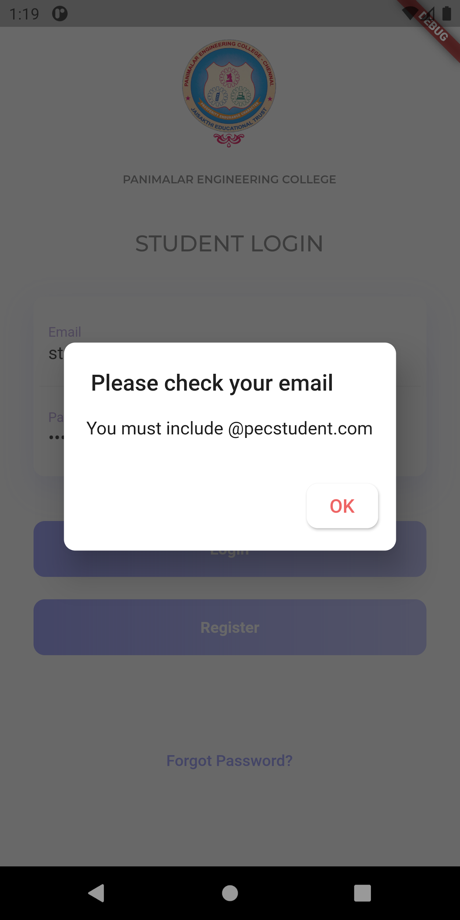

**Figure 7.3.1.1**

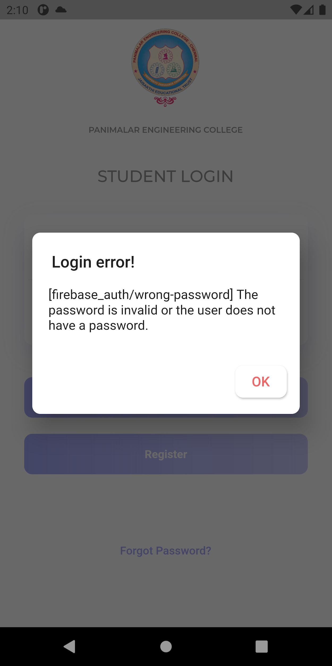

**Figure 7.3.1.2**

**7.3.2 Test Case 2: Staff Login Page**

In the application if wrong Staff Email id or password is given instead of the correct Email id or password , Error alert notification will be displayed as illustrated in the figure 7.3.2.1 and figure 7.3.2.2

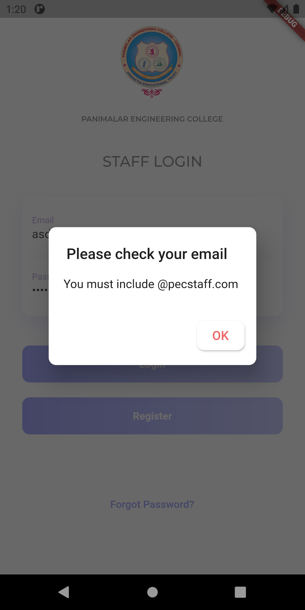

**Figure 7.3.2.1**

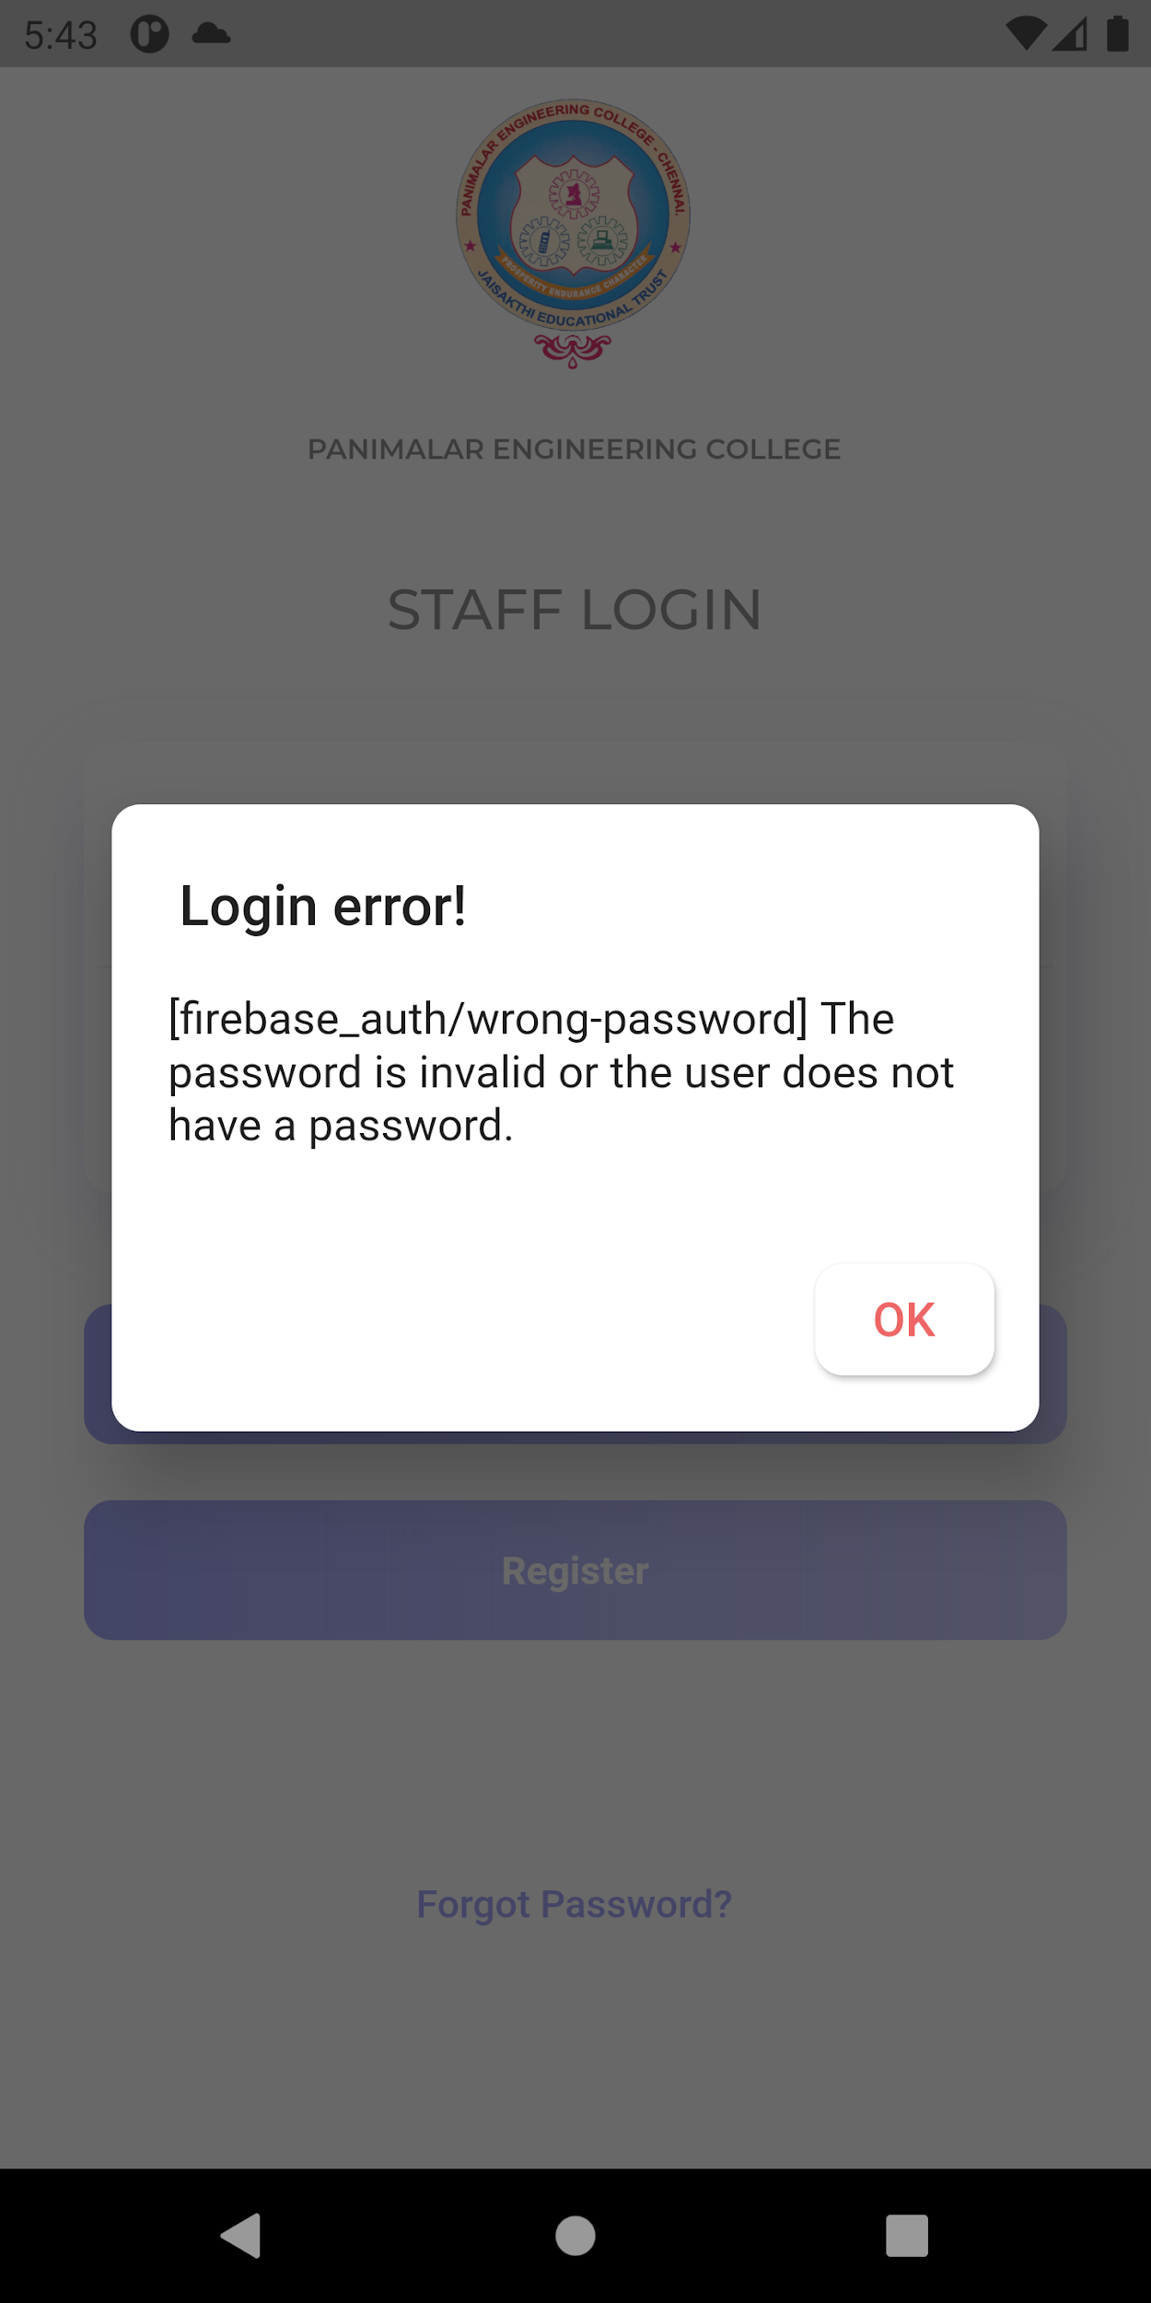

**Figure 7.3.2.2**

**7.3.3 Test Case 3: Register Page**

In the application if invalid details is given instead of valid details , Error alert notification will be displayed as illustrated in the figure 7.3.3.1

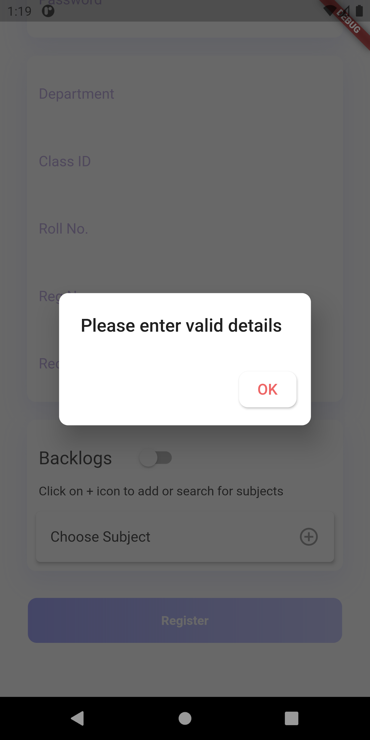

**Figure 7.3.3.1**

**7.3.4.1 Test Case 4: General Notification Sent Module**

In this module we tested whether the general notifications are sent properly to the students form the staffs as illustrated in the figure 7.3.4.1

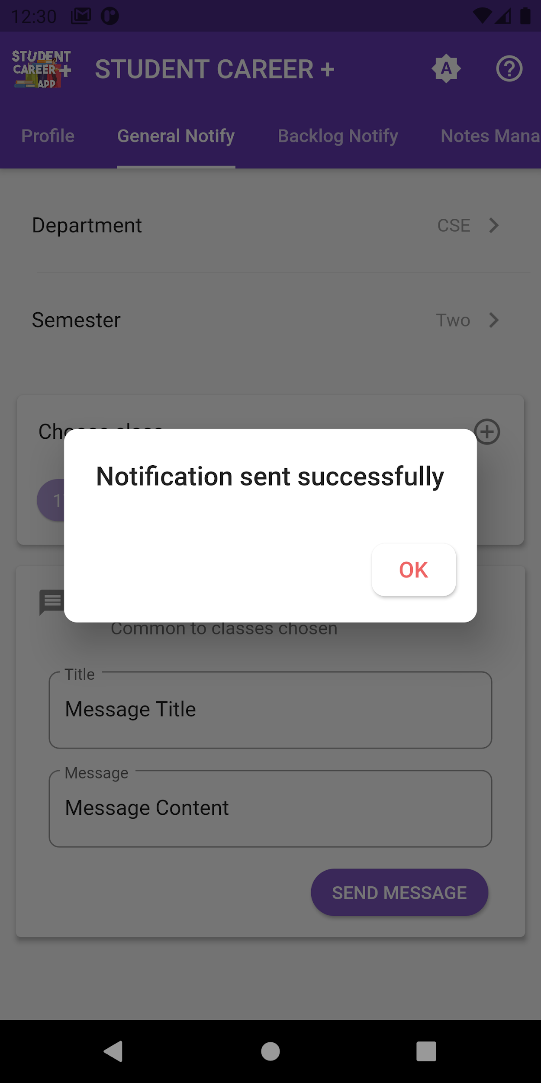

**figure 7.3.4.1**

**7.3.4.2 Test Case 5: Backlog Notification Sent Module**

In this module we tested whether the Backlog notifications are sent properly to the students who have backlog on the particular subject form the staffs as illustrated in the figure 7.3.4.2

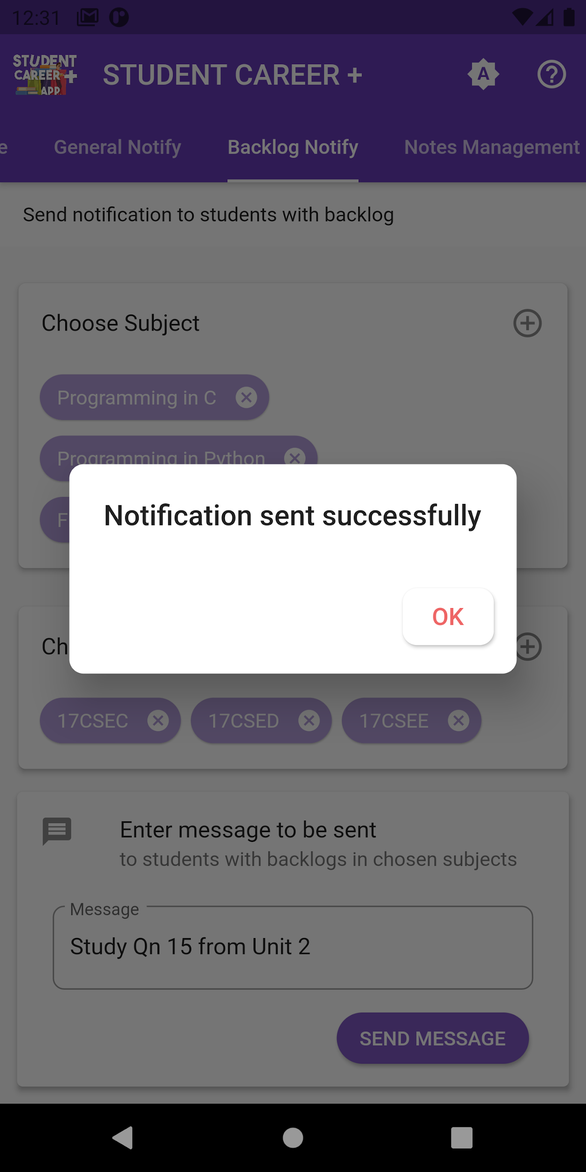

**figure 7.3.4.2**

**7.3.5 Test Case 6 : Notification received module**

In this Module we tested whether all the notifications sent by the staffs are received properly to the students and vice versa as shown in the figure 7.3.5.1 and 7.3.5.2

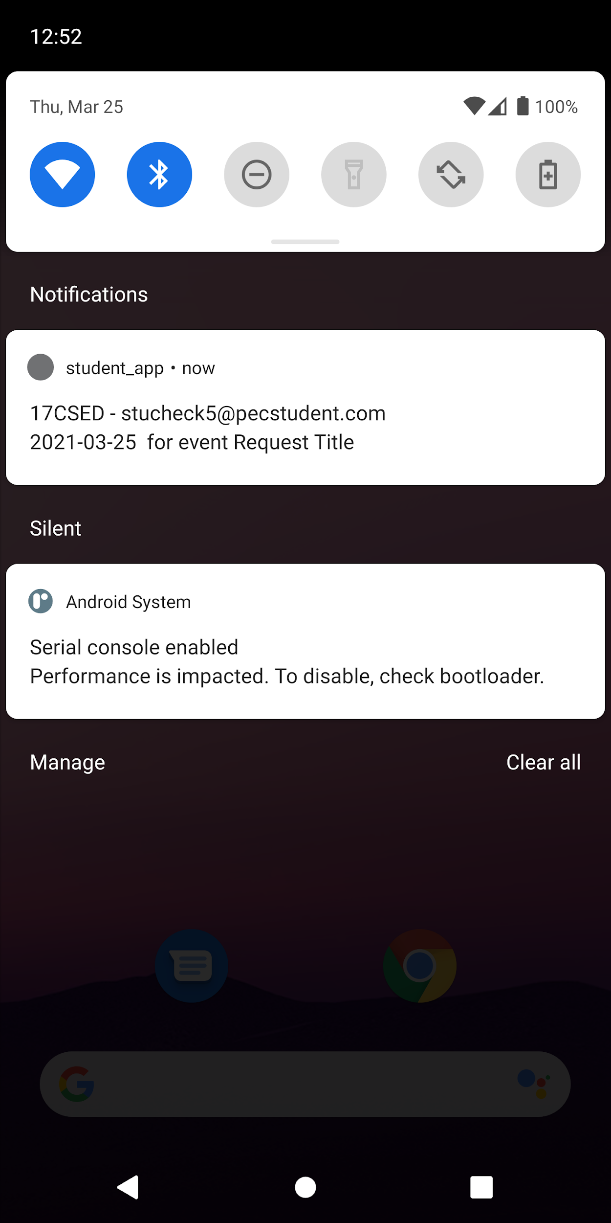 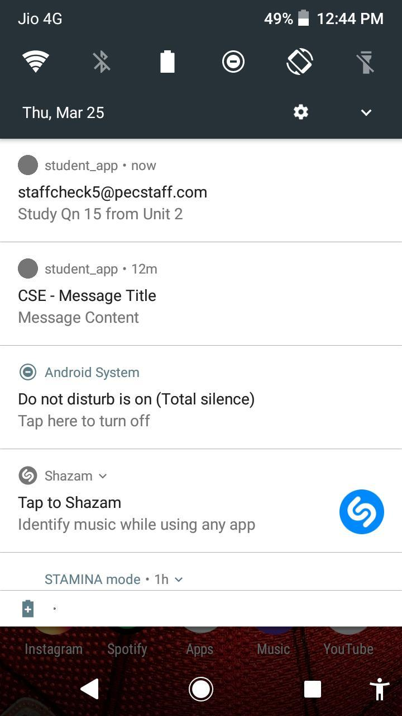

**figure 7.3.5.1 figure 7.3.5.2**

**7.3.6 Test Case 7 : Upload module**

In this module we tested by not selecting the image to be uploaded by the student under request OD and an error alert message was shown as no file is chosen as illustrated in the figure 7.3.6.1 and then we tested in staff login Notes management module by uploading notes as shown in the figure 7.3.6.2. The alert dialog of the will be shown if there was no file selected for upload in notes management module.

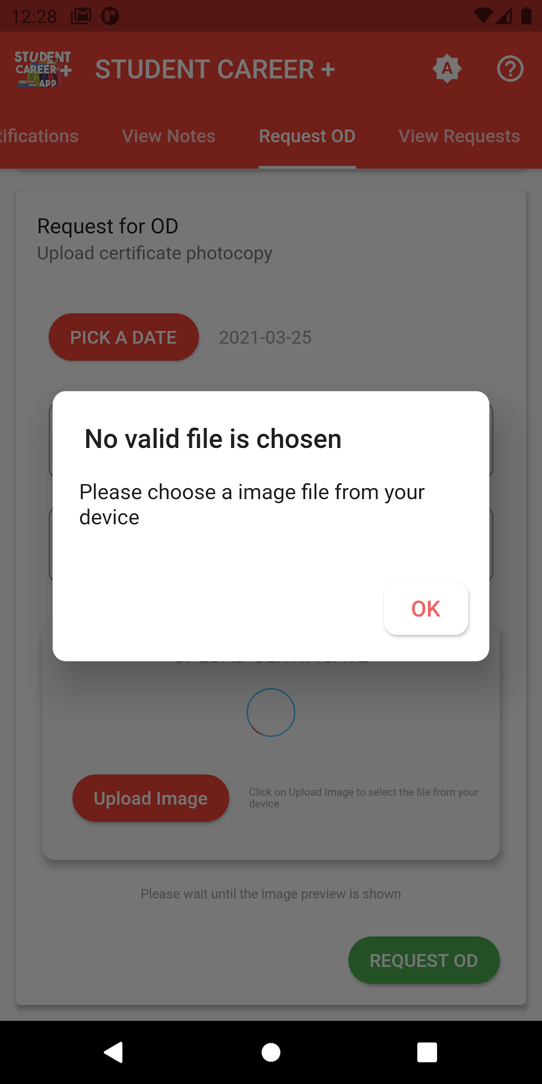 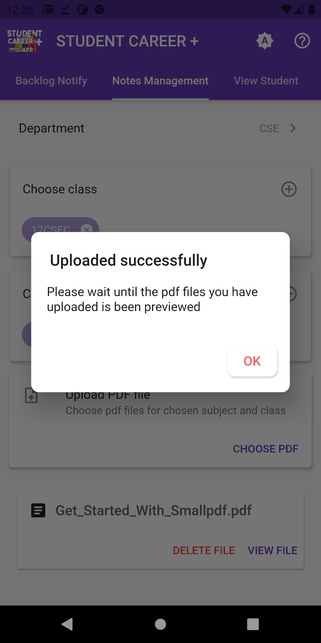

**Figure 7.3.6.1 Figure 7.3.6.2**

**7.3.7 Test case 8 : OD Module**

In this module we tested by trying to upload invalid image type a file upload error was displayed as shown in the figure 7.3.7.1 , Then we uploaded with valid image and details and the request was uploaded successfully as illustrated in the figure 7.3.7.3 , And further we tried to cancel the OD request which can be done successfully as displayed in the figure 7.3.7.2 .

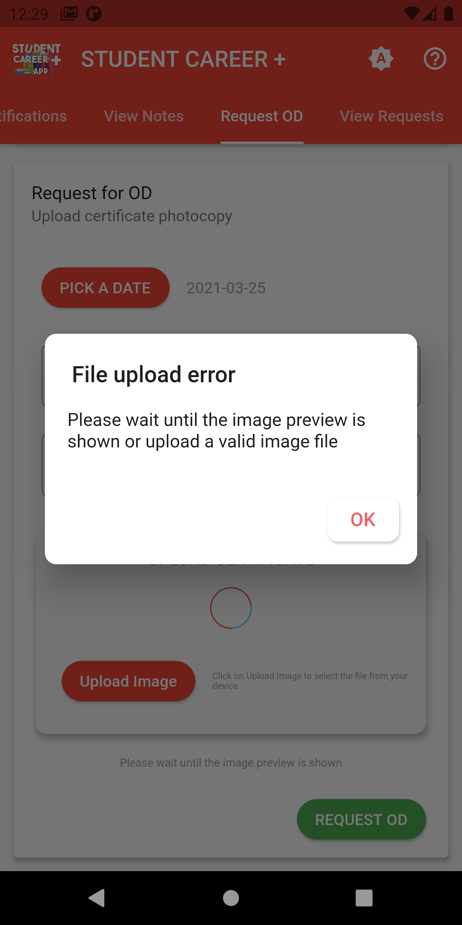

**Figure 7.3.7.1**

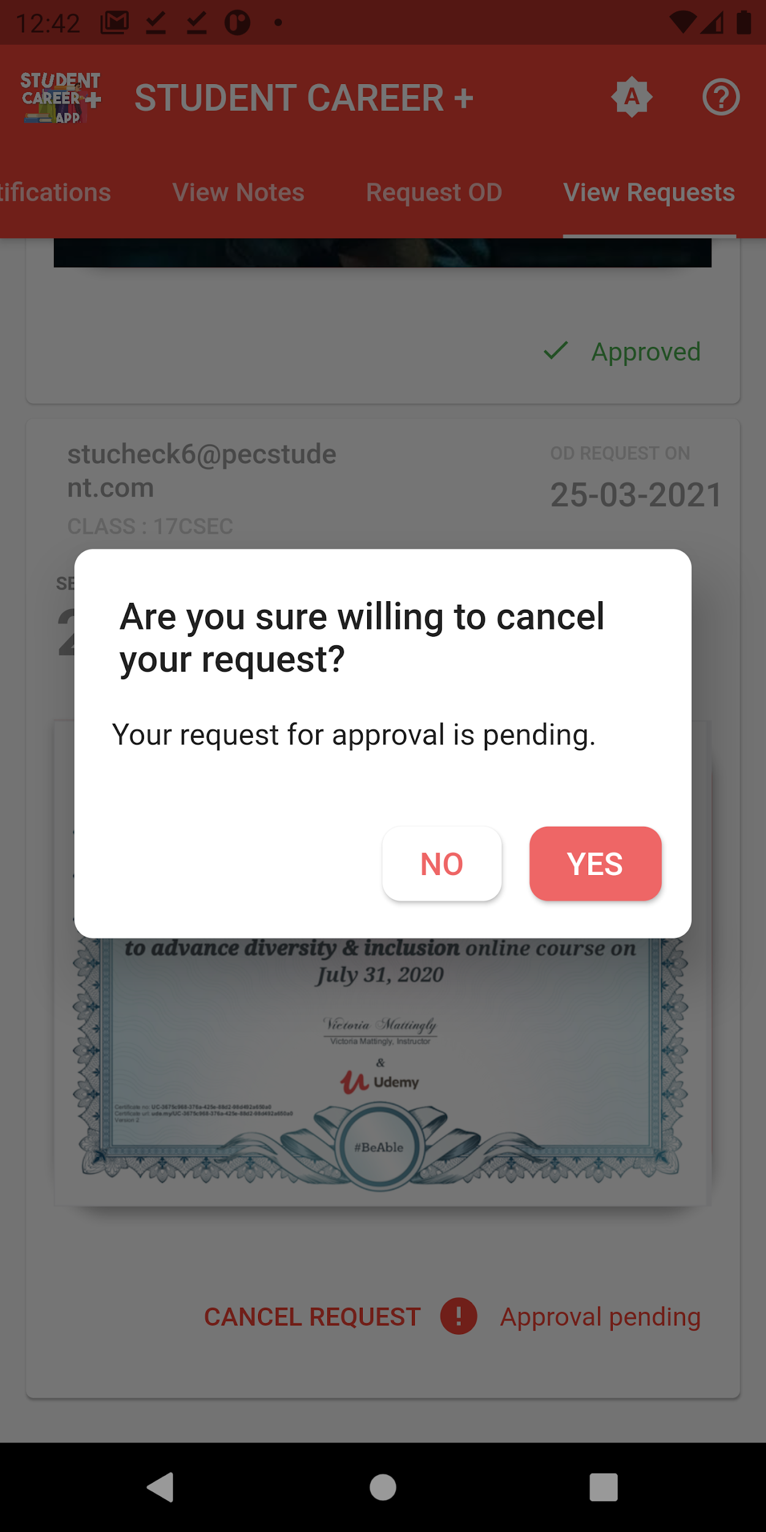

**Figure 7.3.7.2**

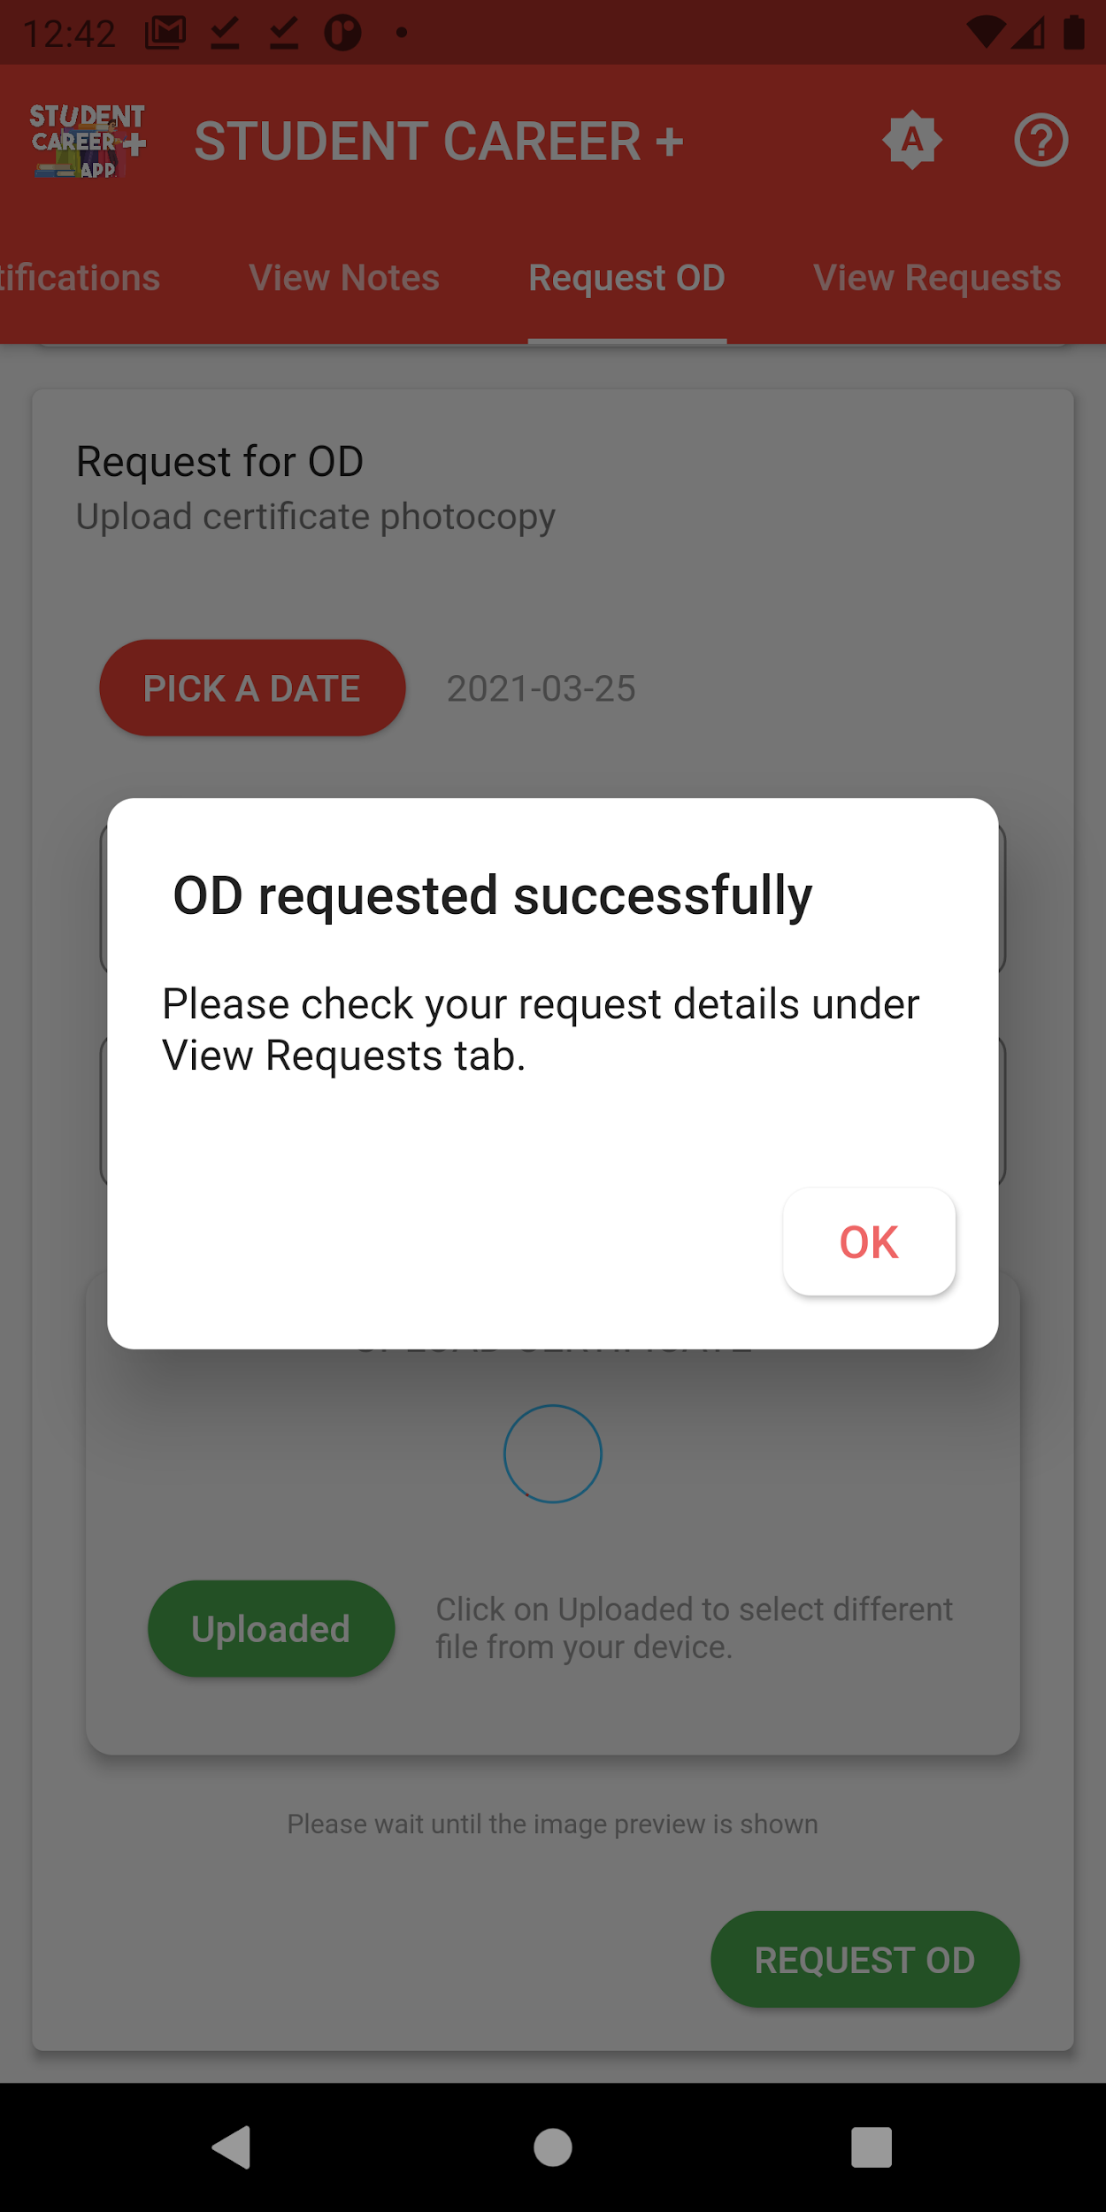

**Figure 7.3.7.3**

From the staff login we tried to give permission to the OD requested by the student , and it was possible to grant permission successfully to the OD request as shown in the figure 7.3.7.4 and 7.3.7.5

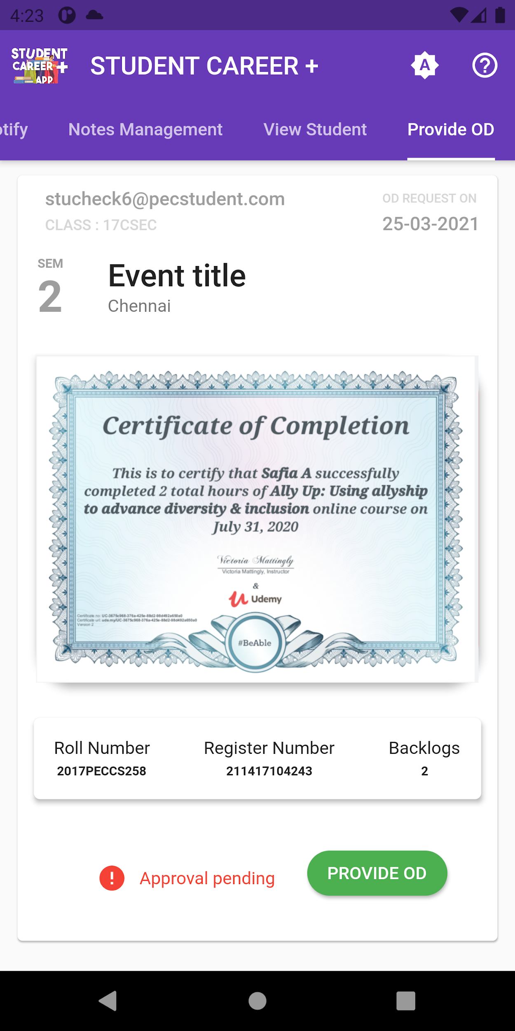

**Figure 7.3.7.4**

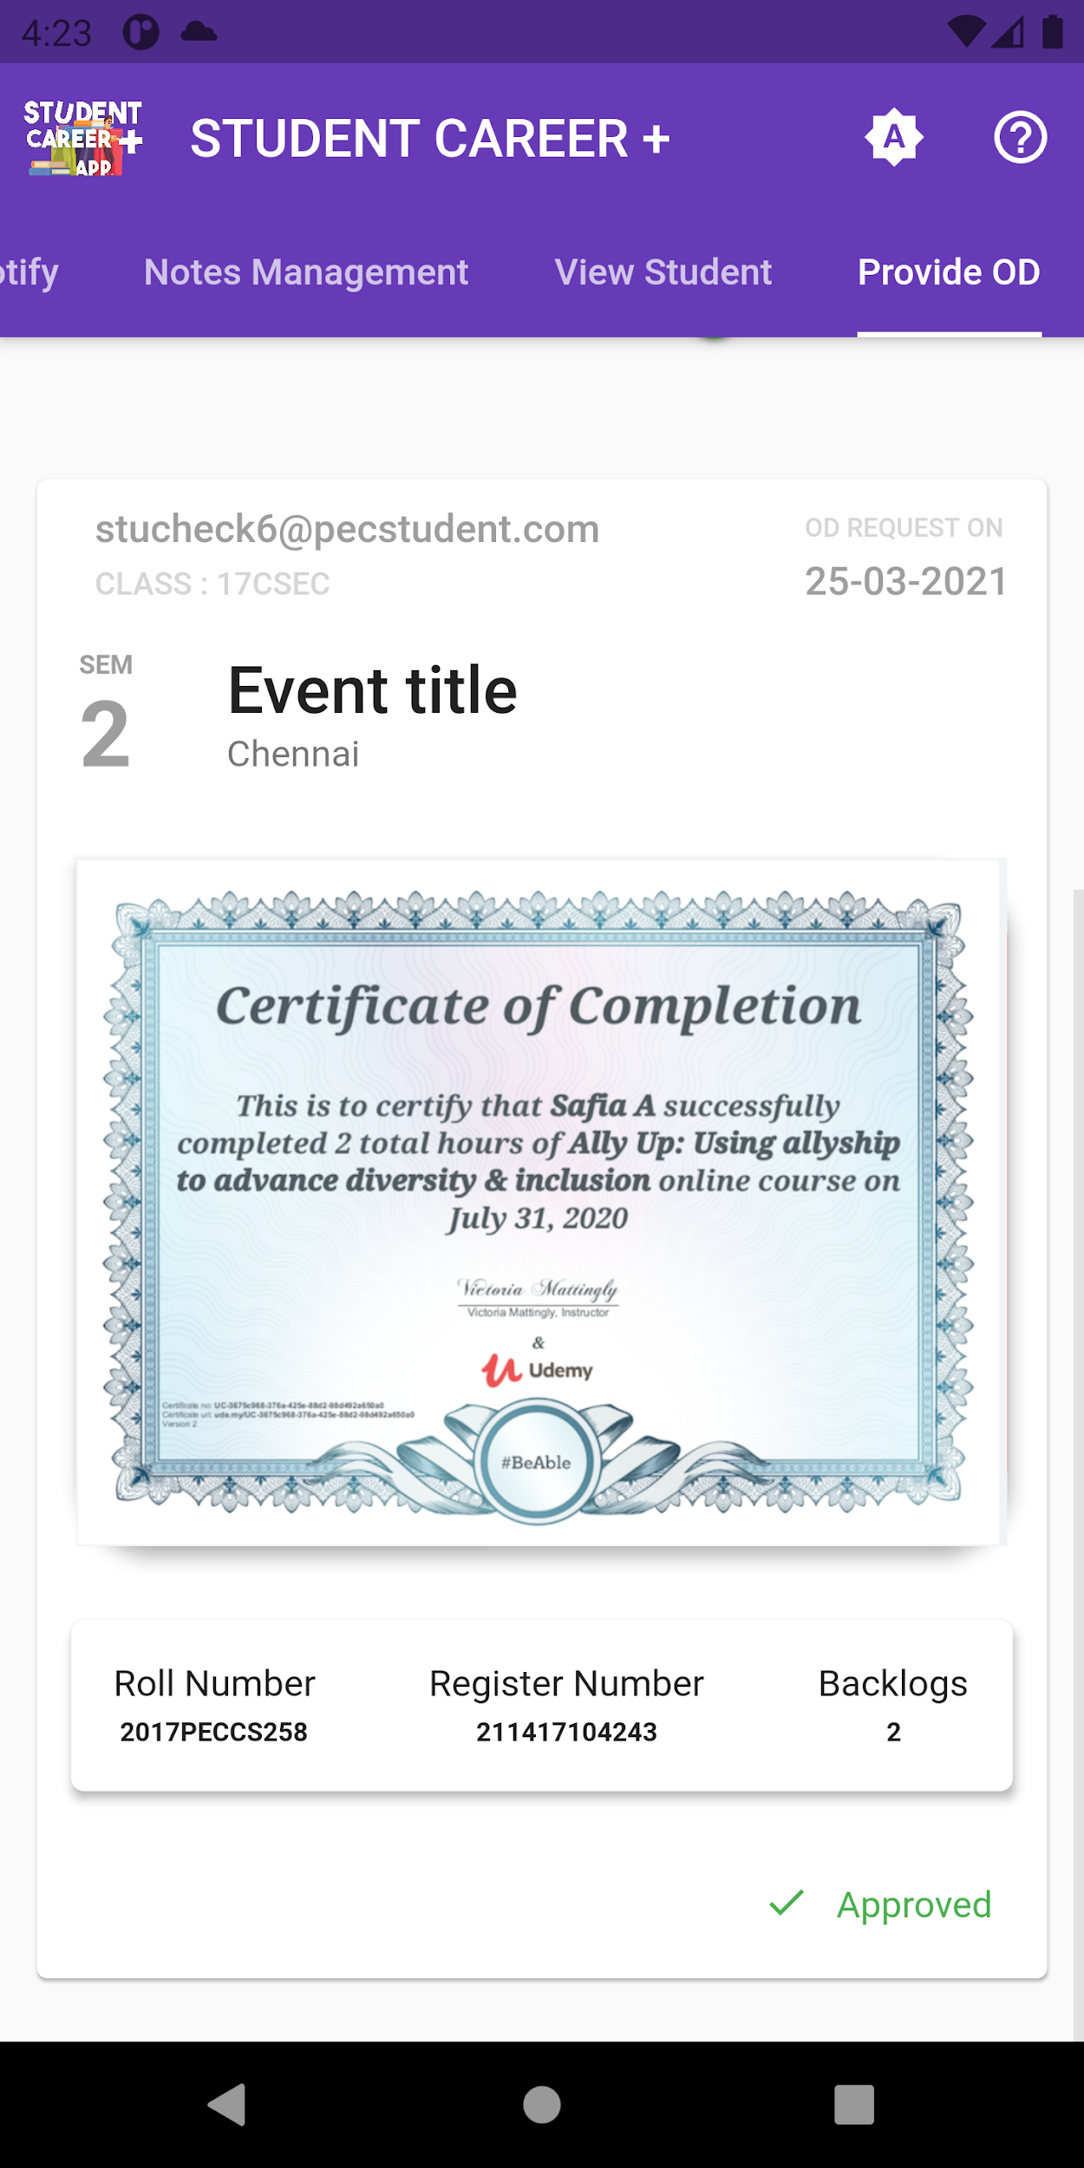

**Figure 7.3.7.5**

**7.3.8 Test case 9 : Reset google linked account**

In this module we tested to reset the google id linked to our account and it was possible to change the linked account as illustrated in the figure 7.3.8.1

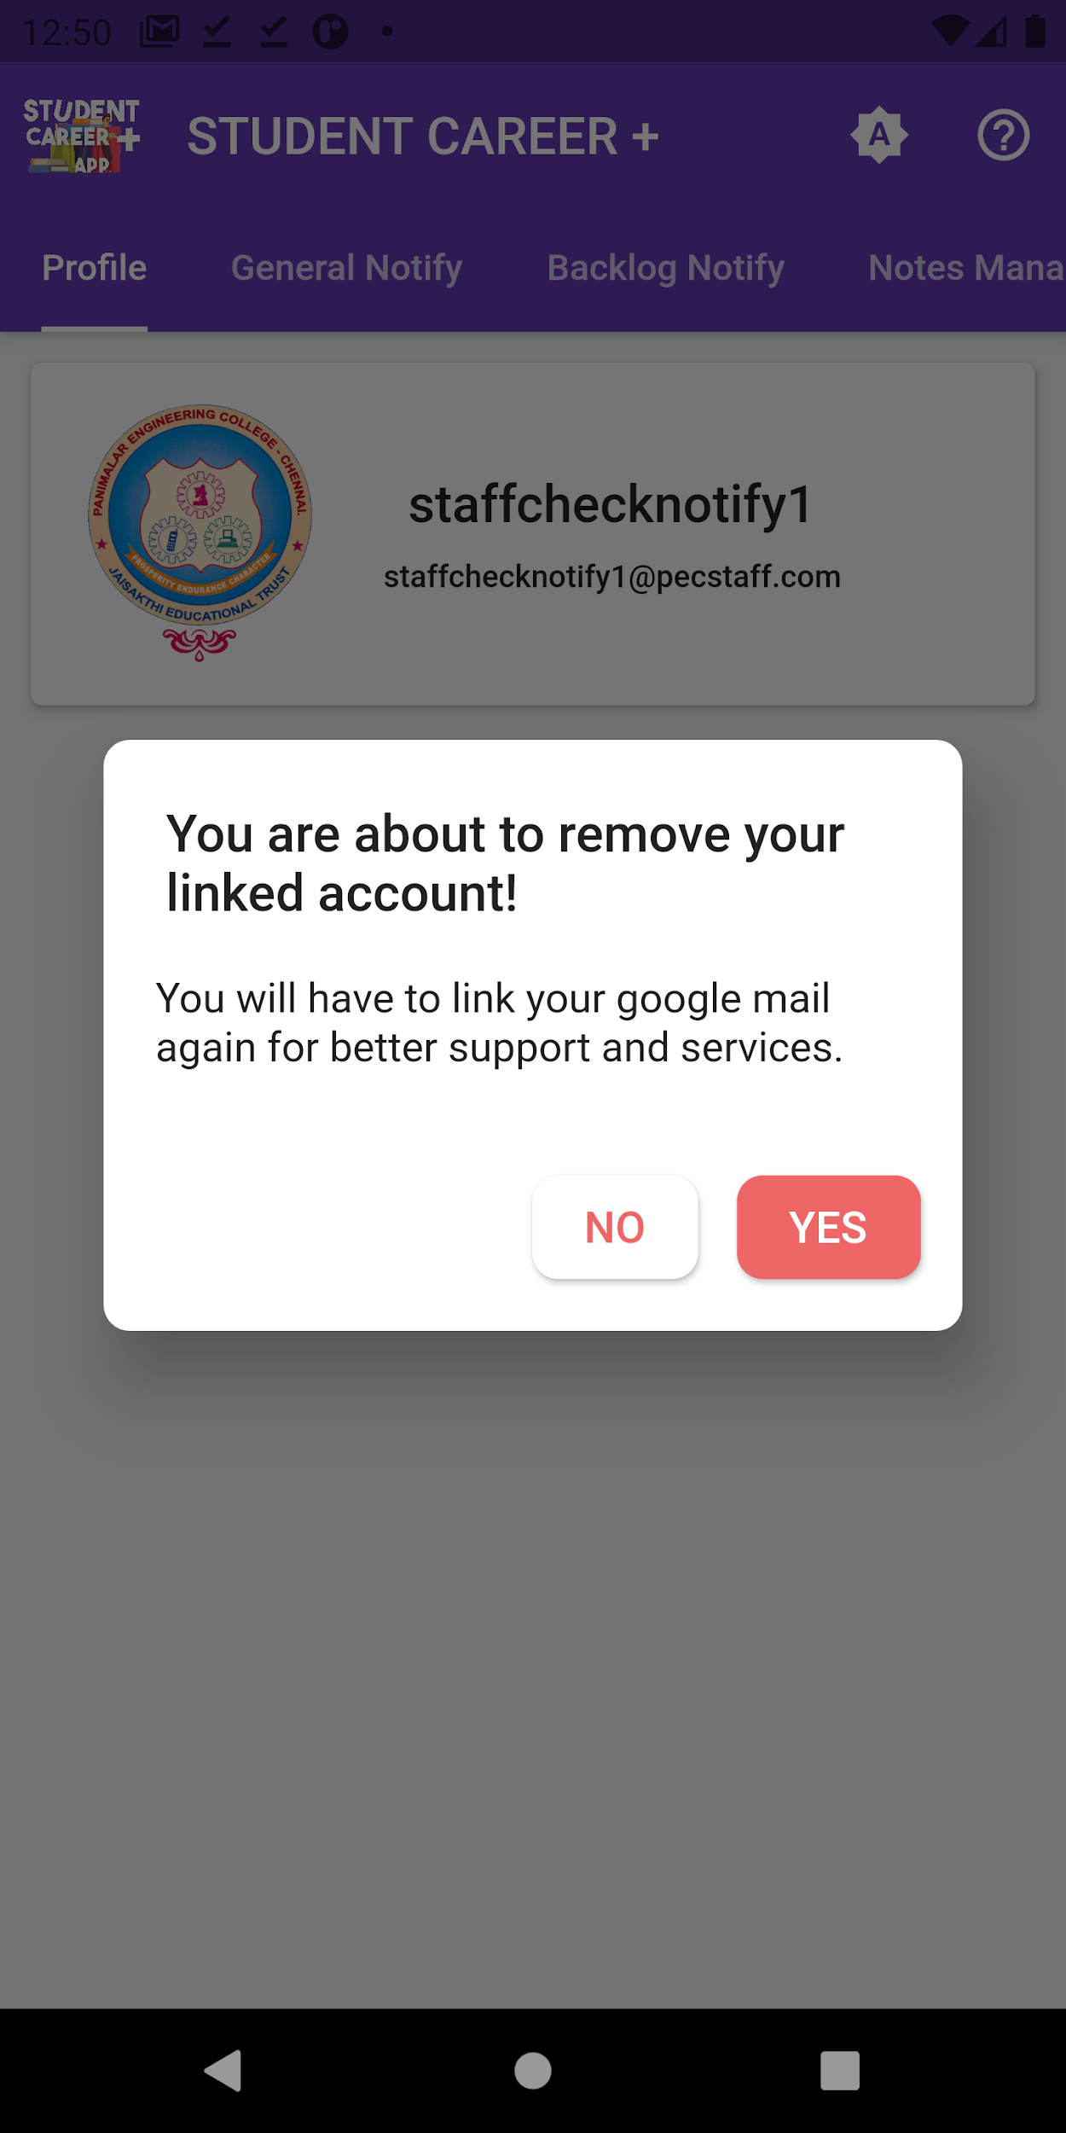

**Figure 7.3.8.1**

**7.3.9 Test case 10: Login and Logout Module**

In this module we tried the different types to login and logout from the application . we tried to login to the application without the access of internet and Error occurred as shown in the figure 7.3.9.1

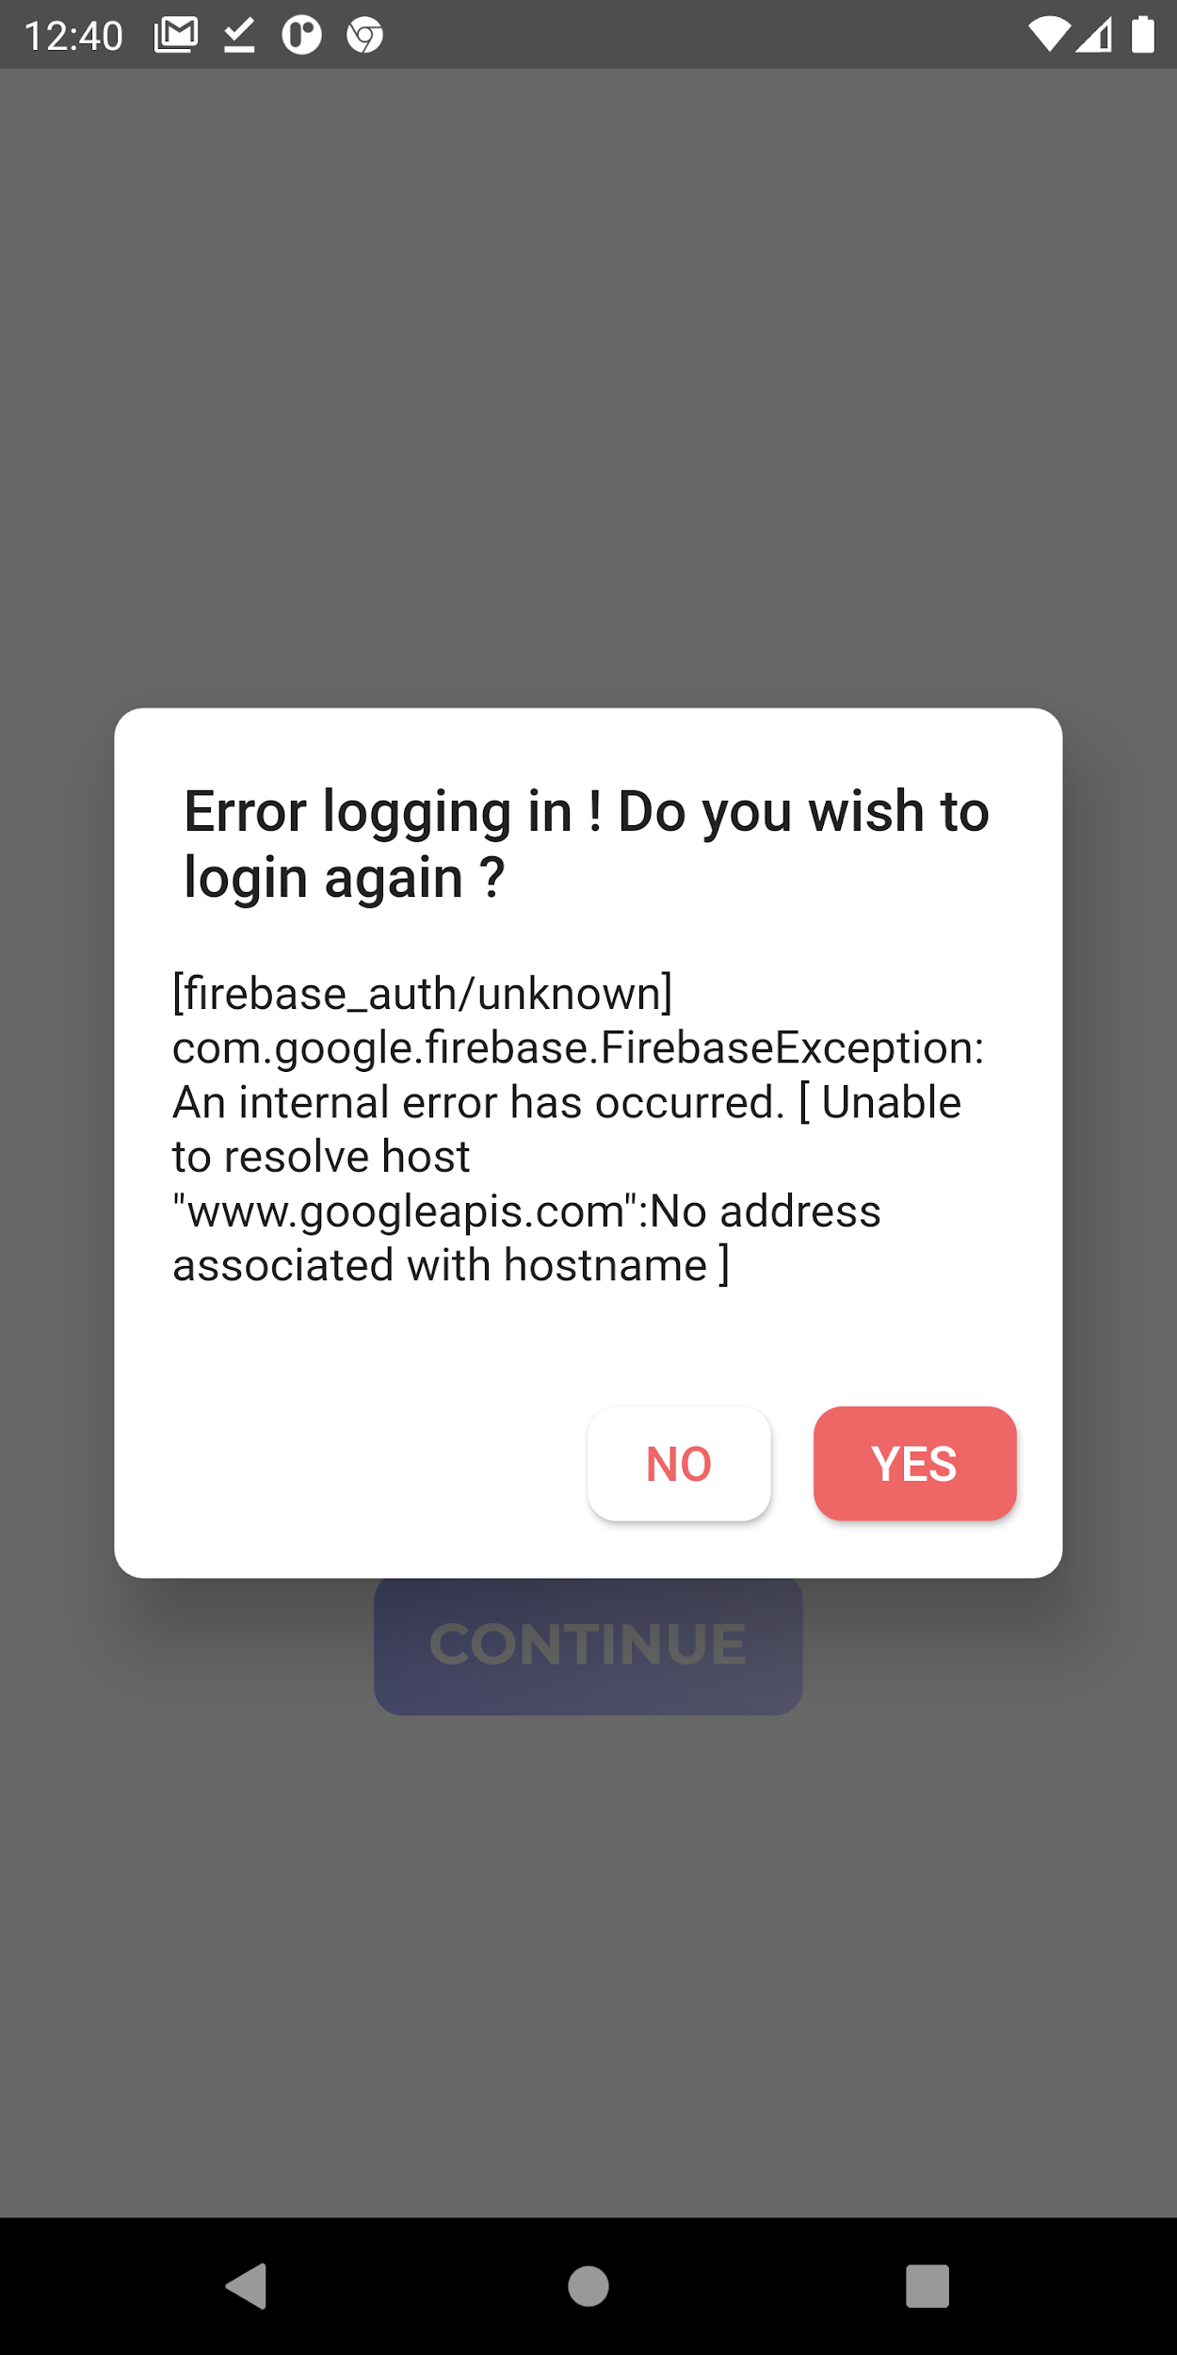

**Figure 7.3.9.1**

We tried to exit the application, a alert message was displayed as illustrated in the figure 7.3.9.2 and then we tried to logout our application and another alert message popped out as shown in the figure 7.3.9.3

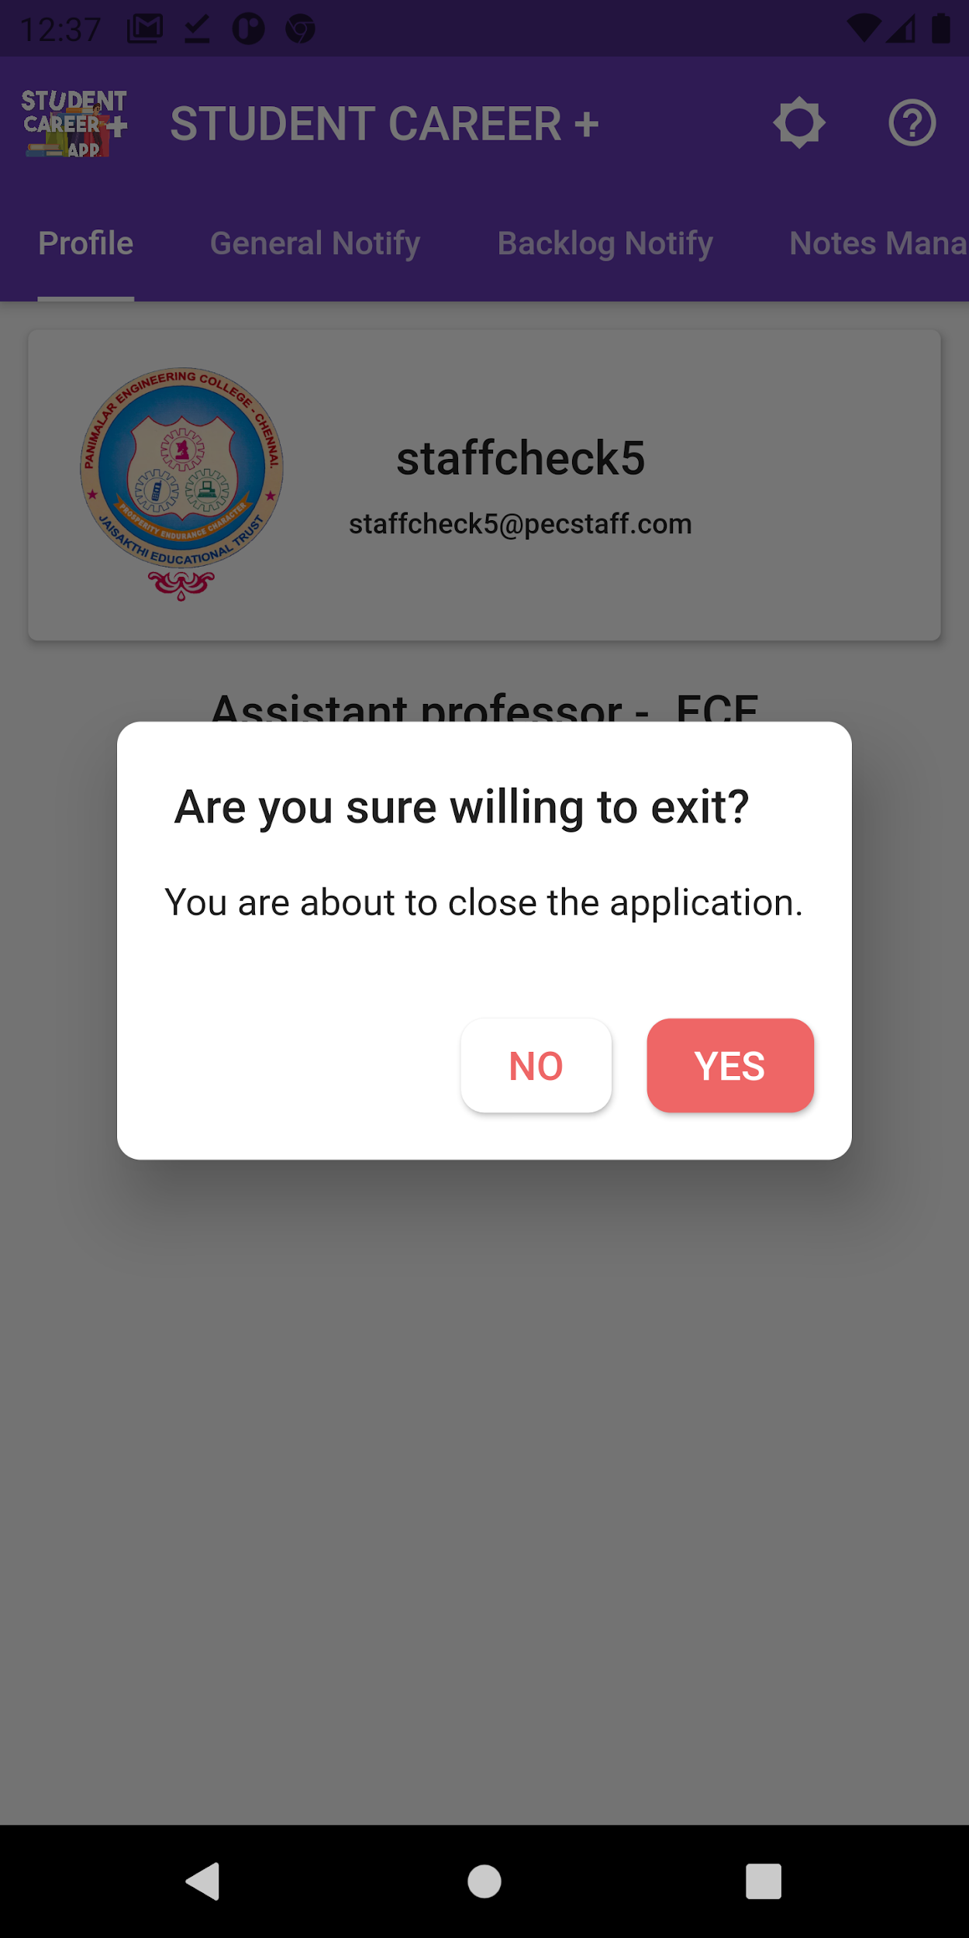 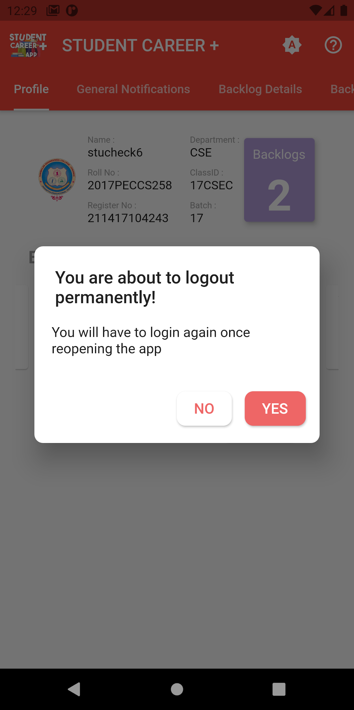

**Figure 7.3.9.2 Figure 7.3.9.3**

**CHAPTER 8**

**CONCLUSION**

**CHAPTER 8**

**CONCLUSION**

**8.1 CONCLUSION AND FUTURE ENHANCEMENTS**

**8.1.1 CONCLUSION**

This project focuses mainly on enhancing communication between the staff and students with the use of trending technologies. A simple notification that can be received anywhere anytime could possibly make an impact over a student’s career.

* + 1. **FUTURE ENHANCEMENTS**
* Tracking student progress including his attendance, academic performance and extra activities.
* Personal chat box for student staff interaction.
* Firebase password recovery using a linked secondary account.
* Reminder on timetable and events.
* Offline Notes view.

**APPENDICES**

**APPENDICES**

**A.1 SAMPLE SCREENS - STAFF MODULE**

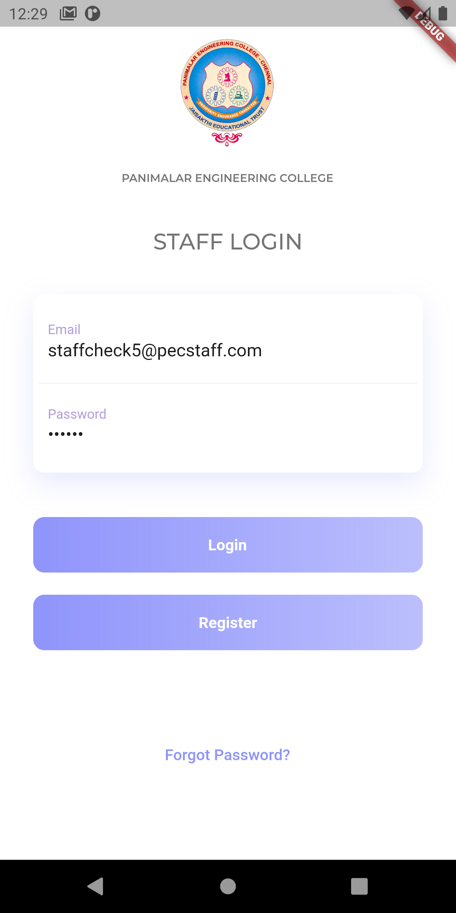 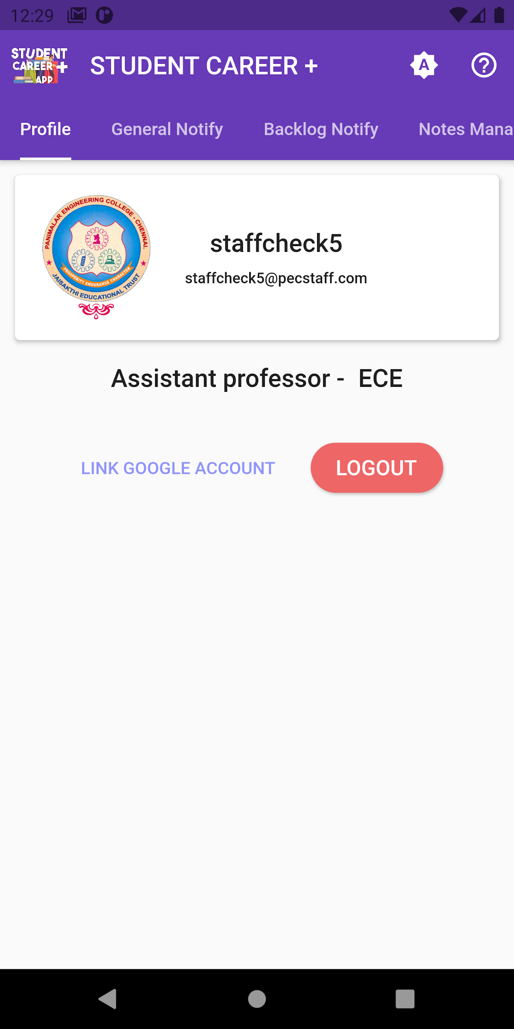

**Figure A.1.1 Figure A.1.2**

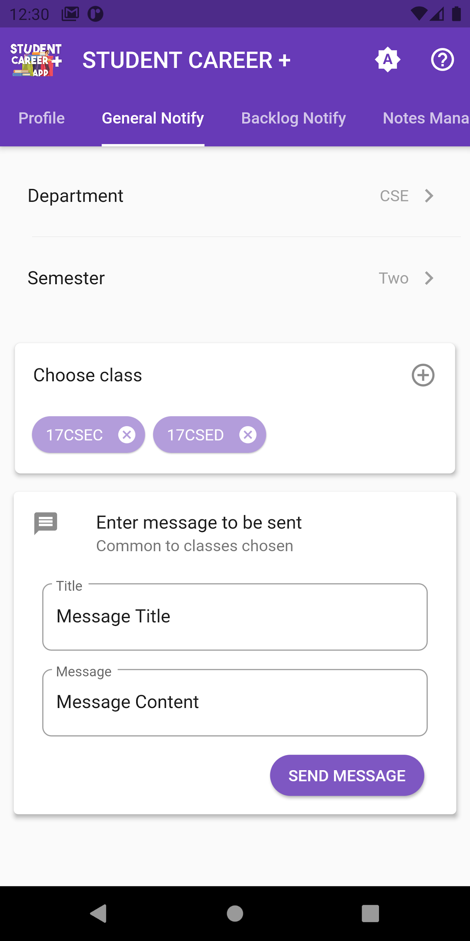 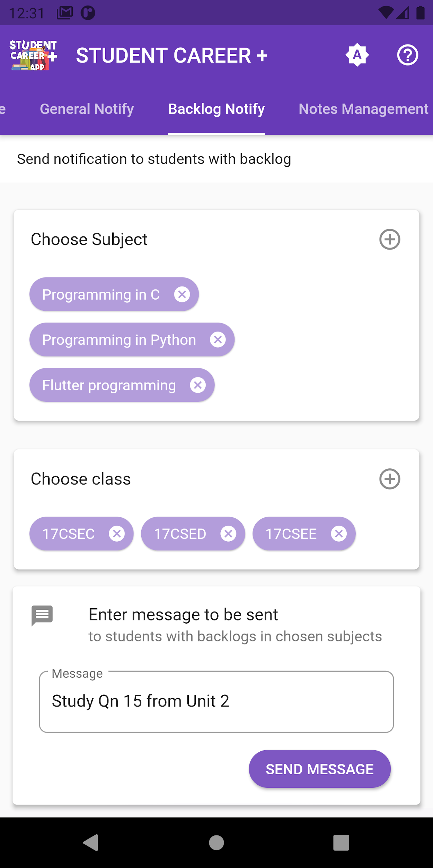

**Figure A.1.3 Figure A.1.4**

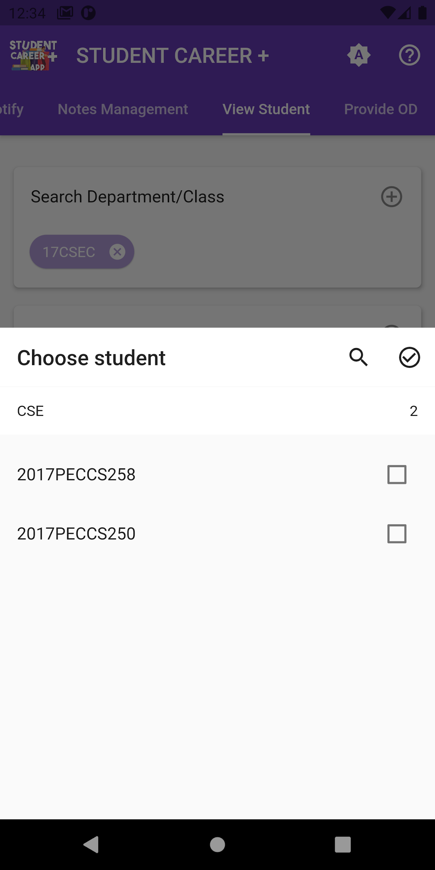 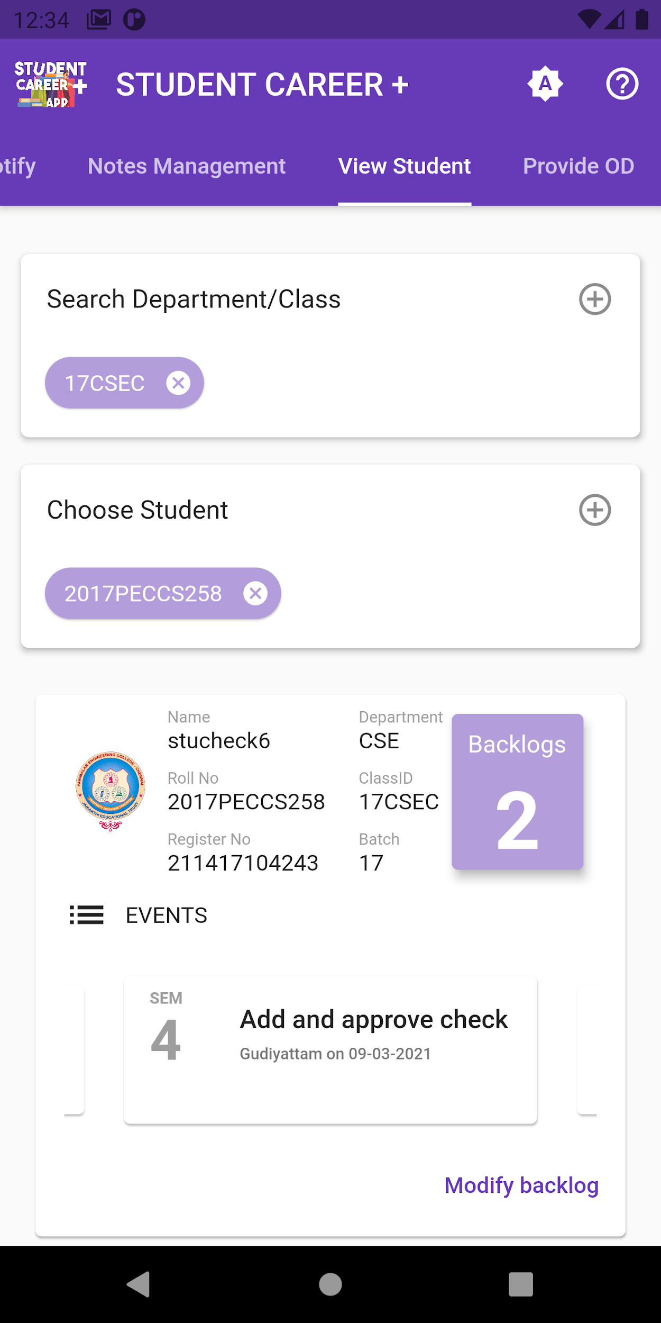

**Figure A.1.5 Figure A.1.6**

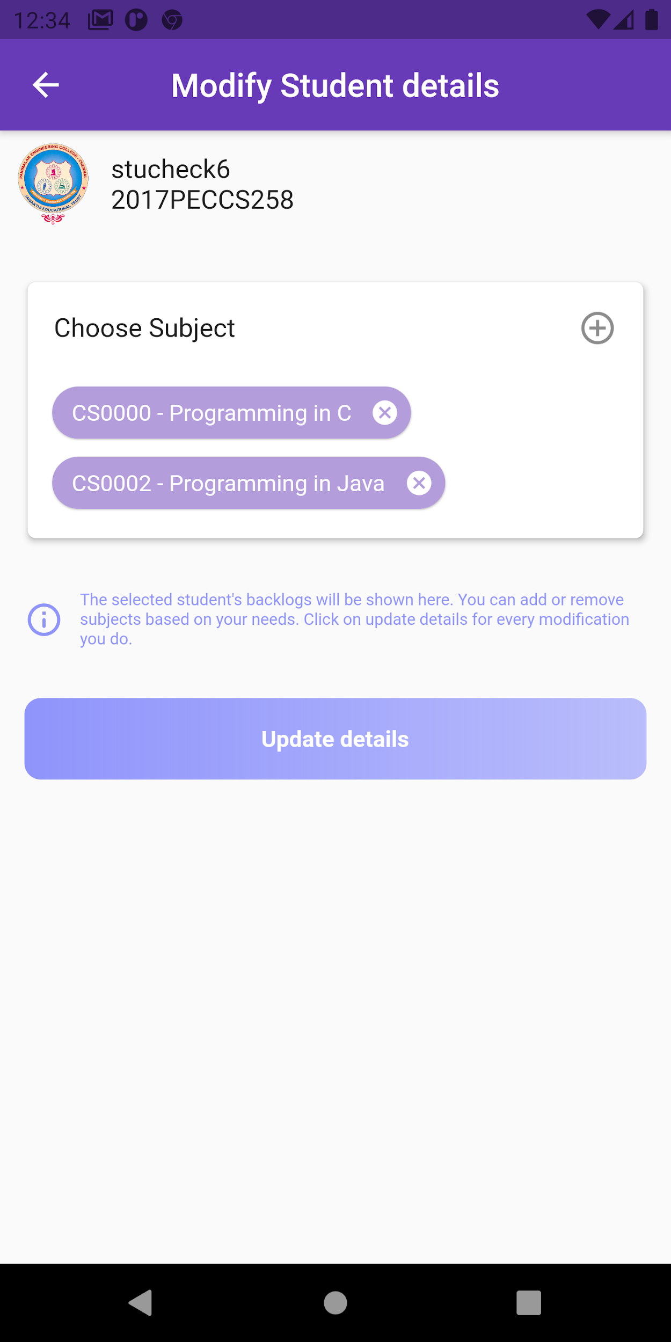 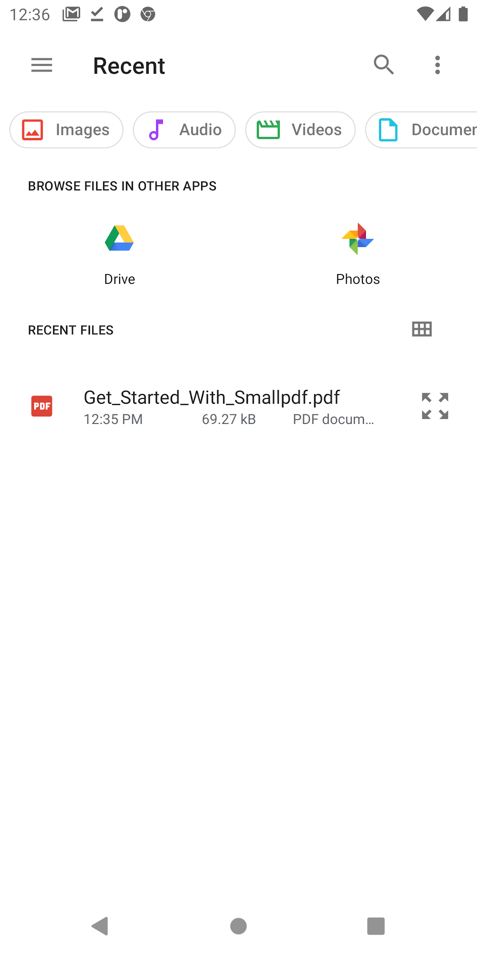

**Figure A.1.7 Figure A.1.8**

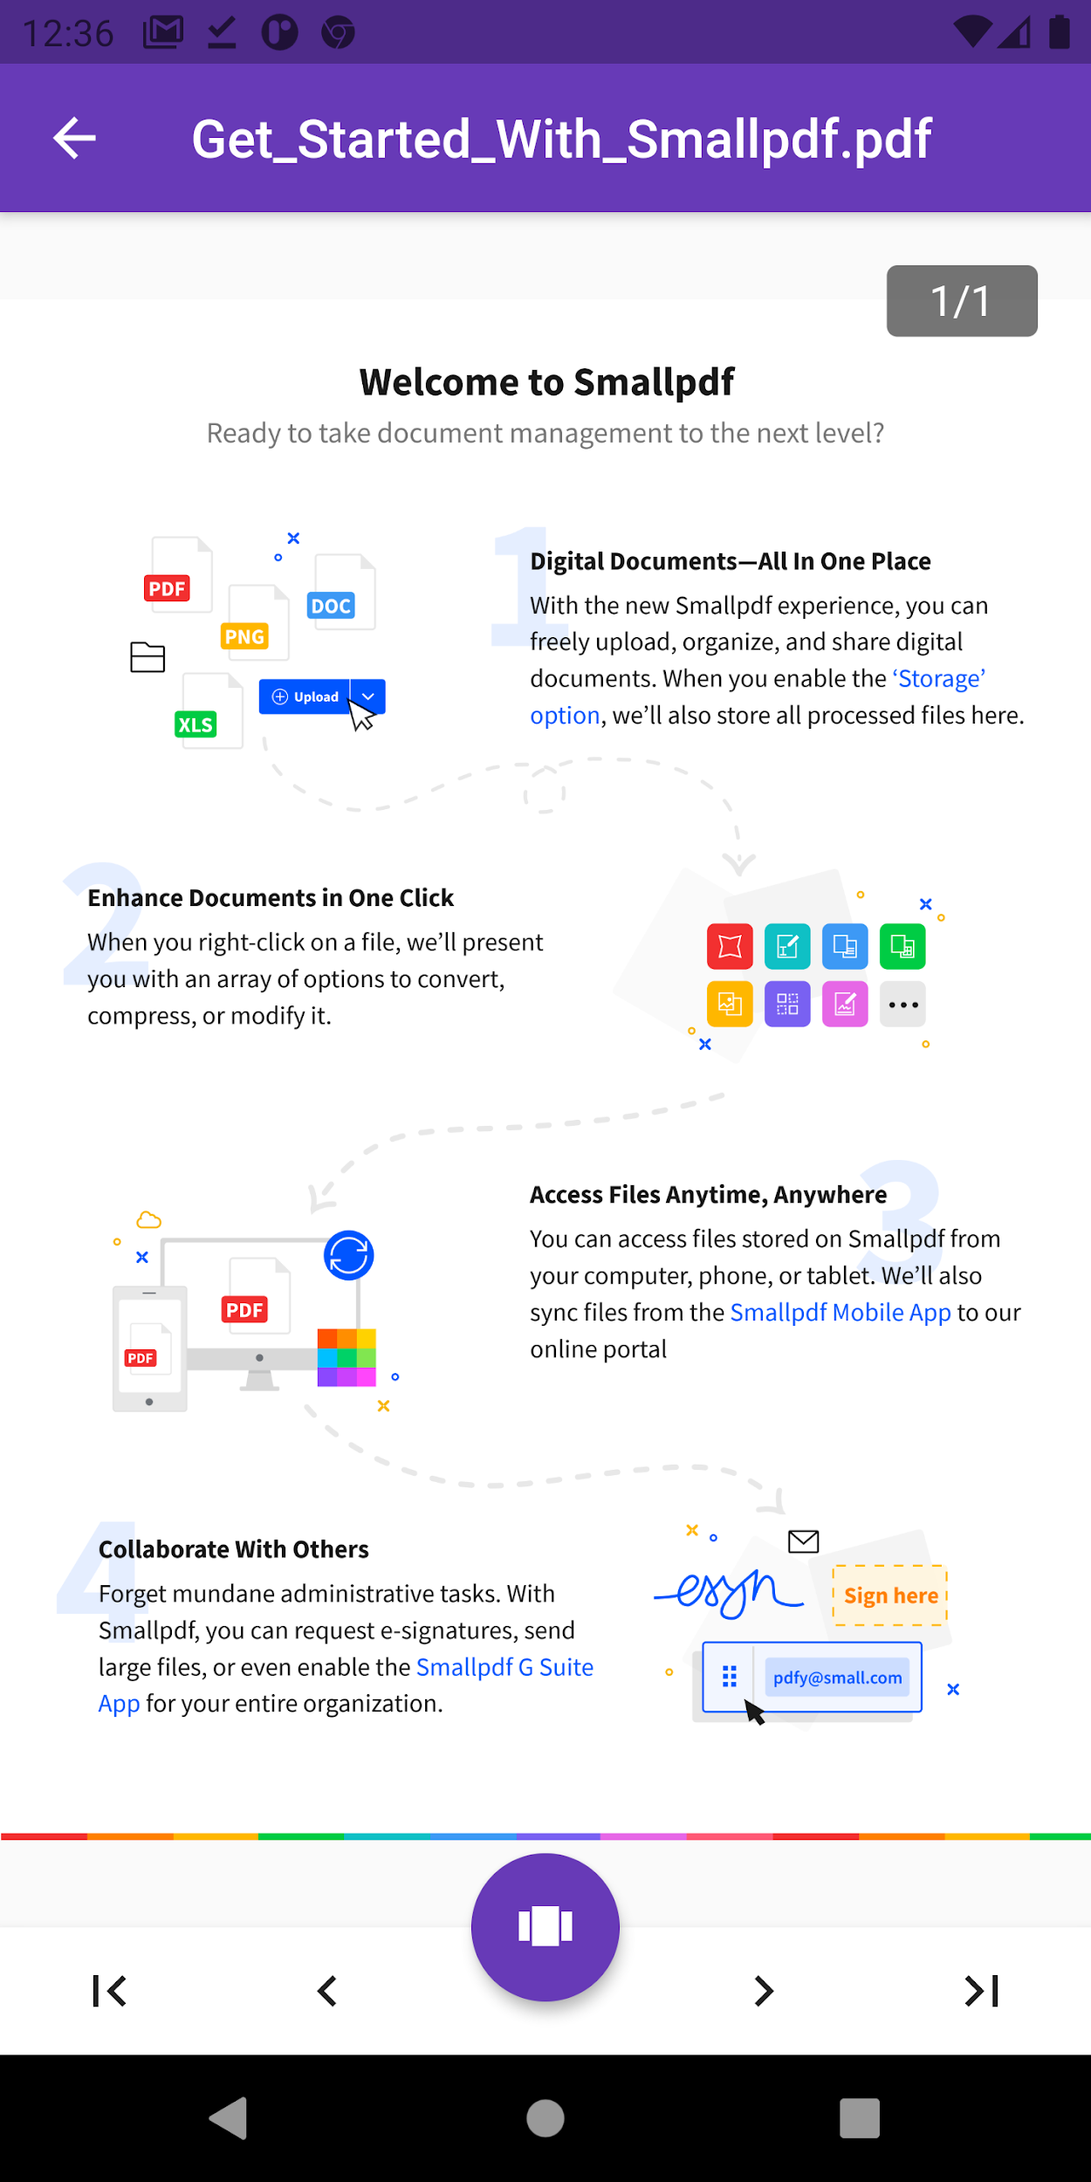 

**Figure A.1.9 Figure A.1.10**

**A.2 SAMPLE SCREENS - STUDENT MODULE**

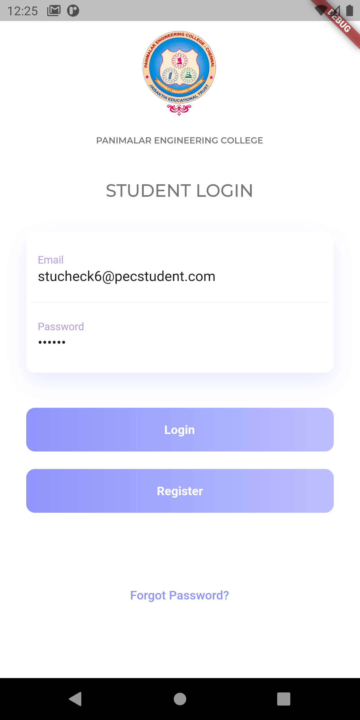 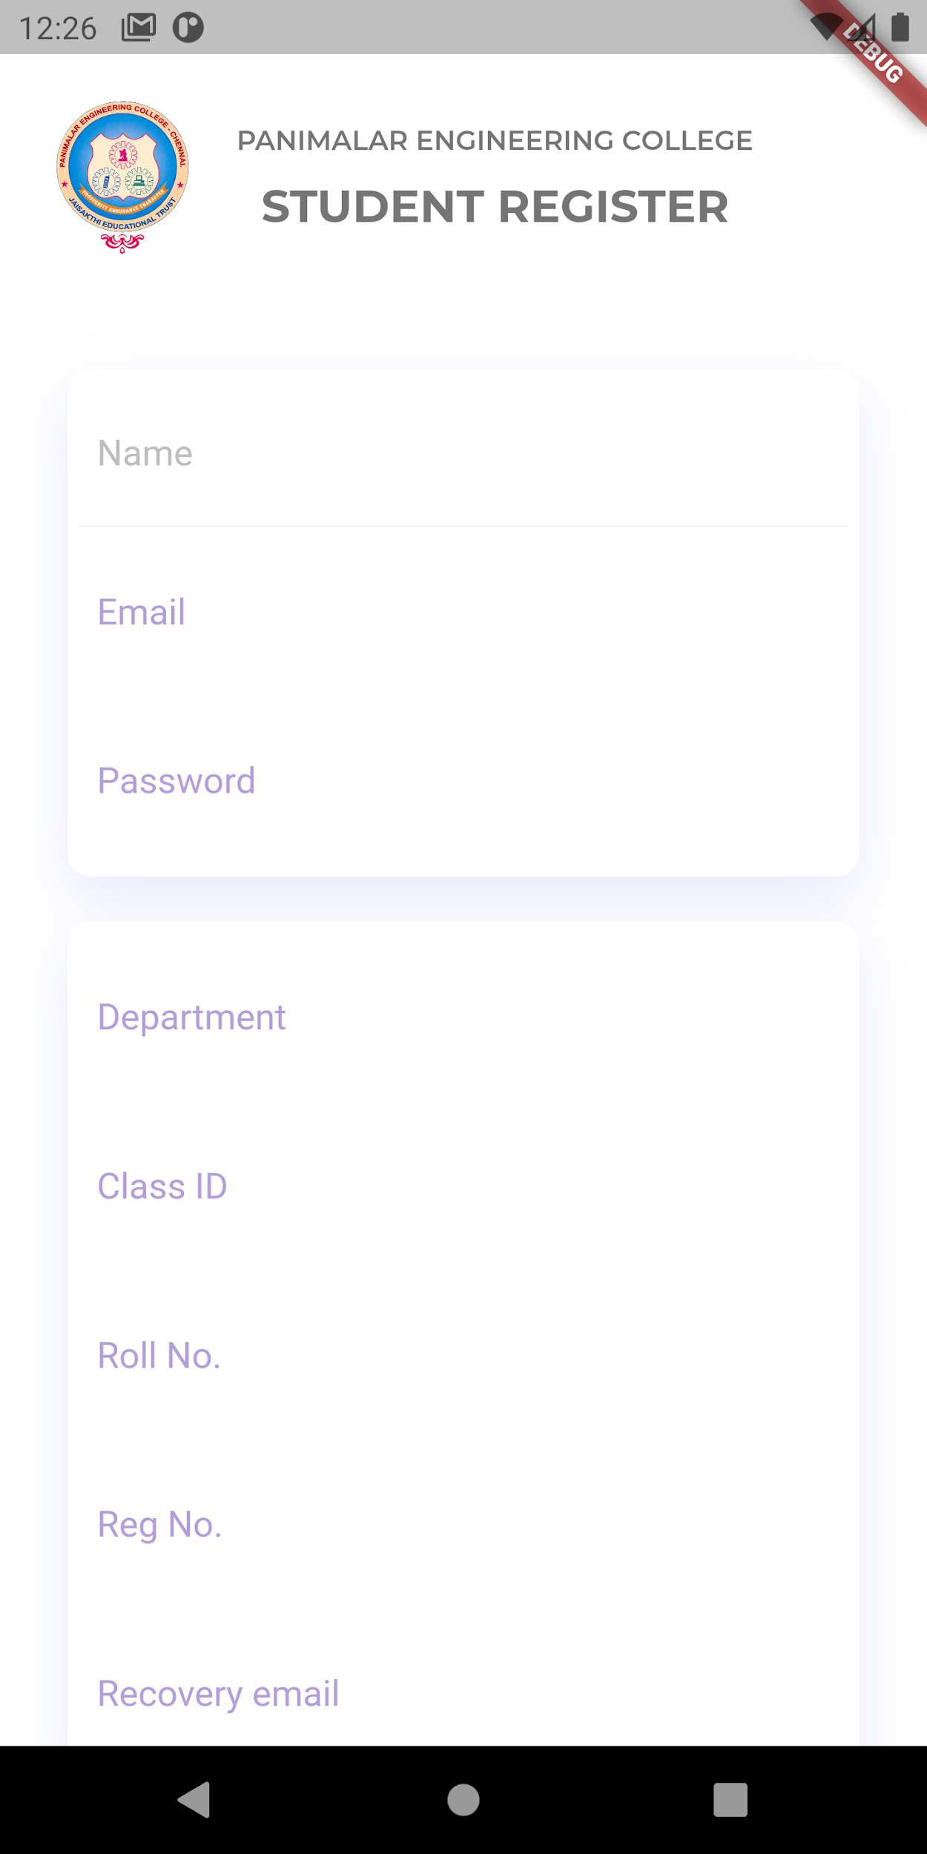

**Figure A.2.1 Figure A.2.2**

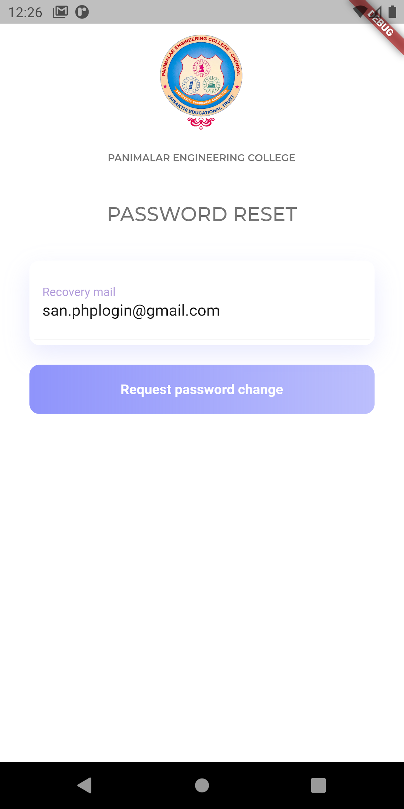 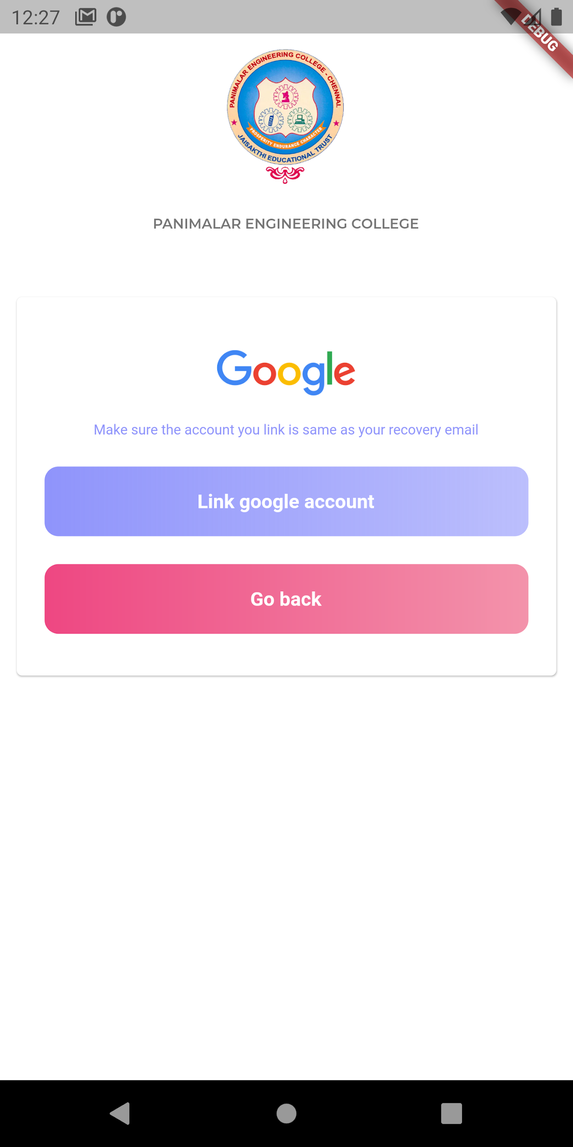

**Figure A.2.3 Figure A.2.4**

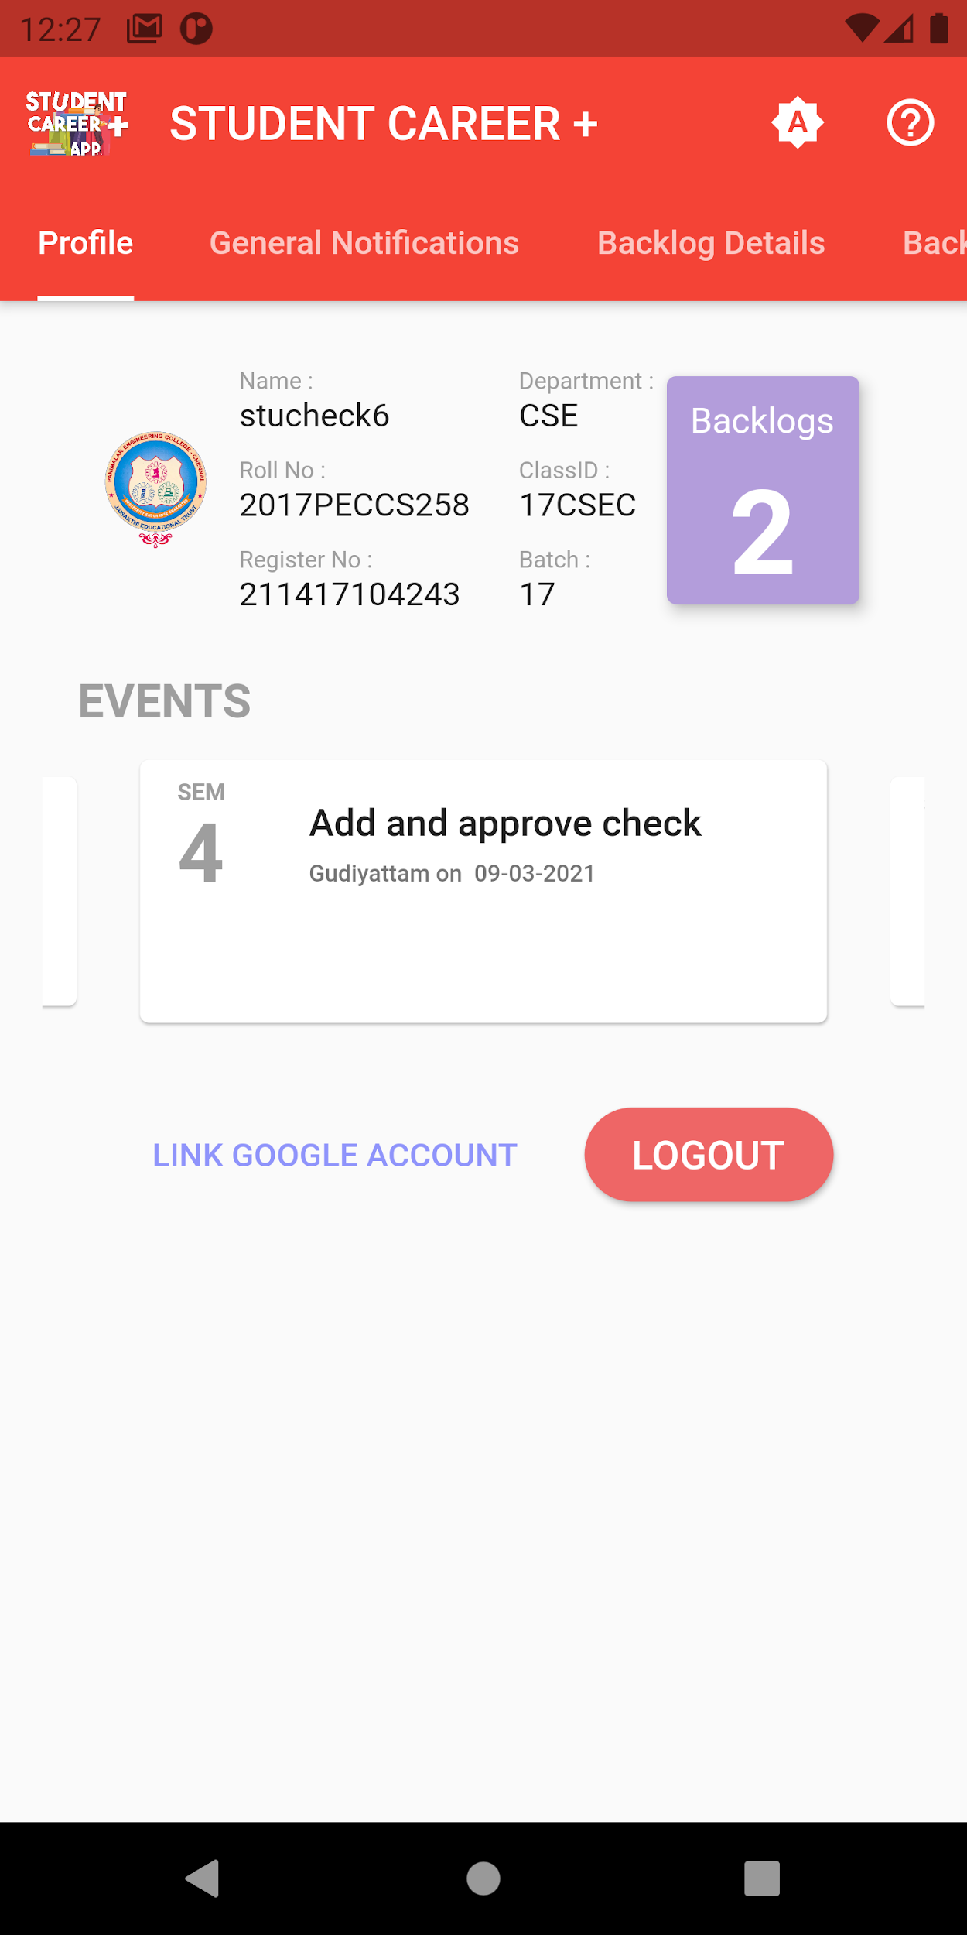 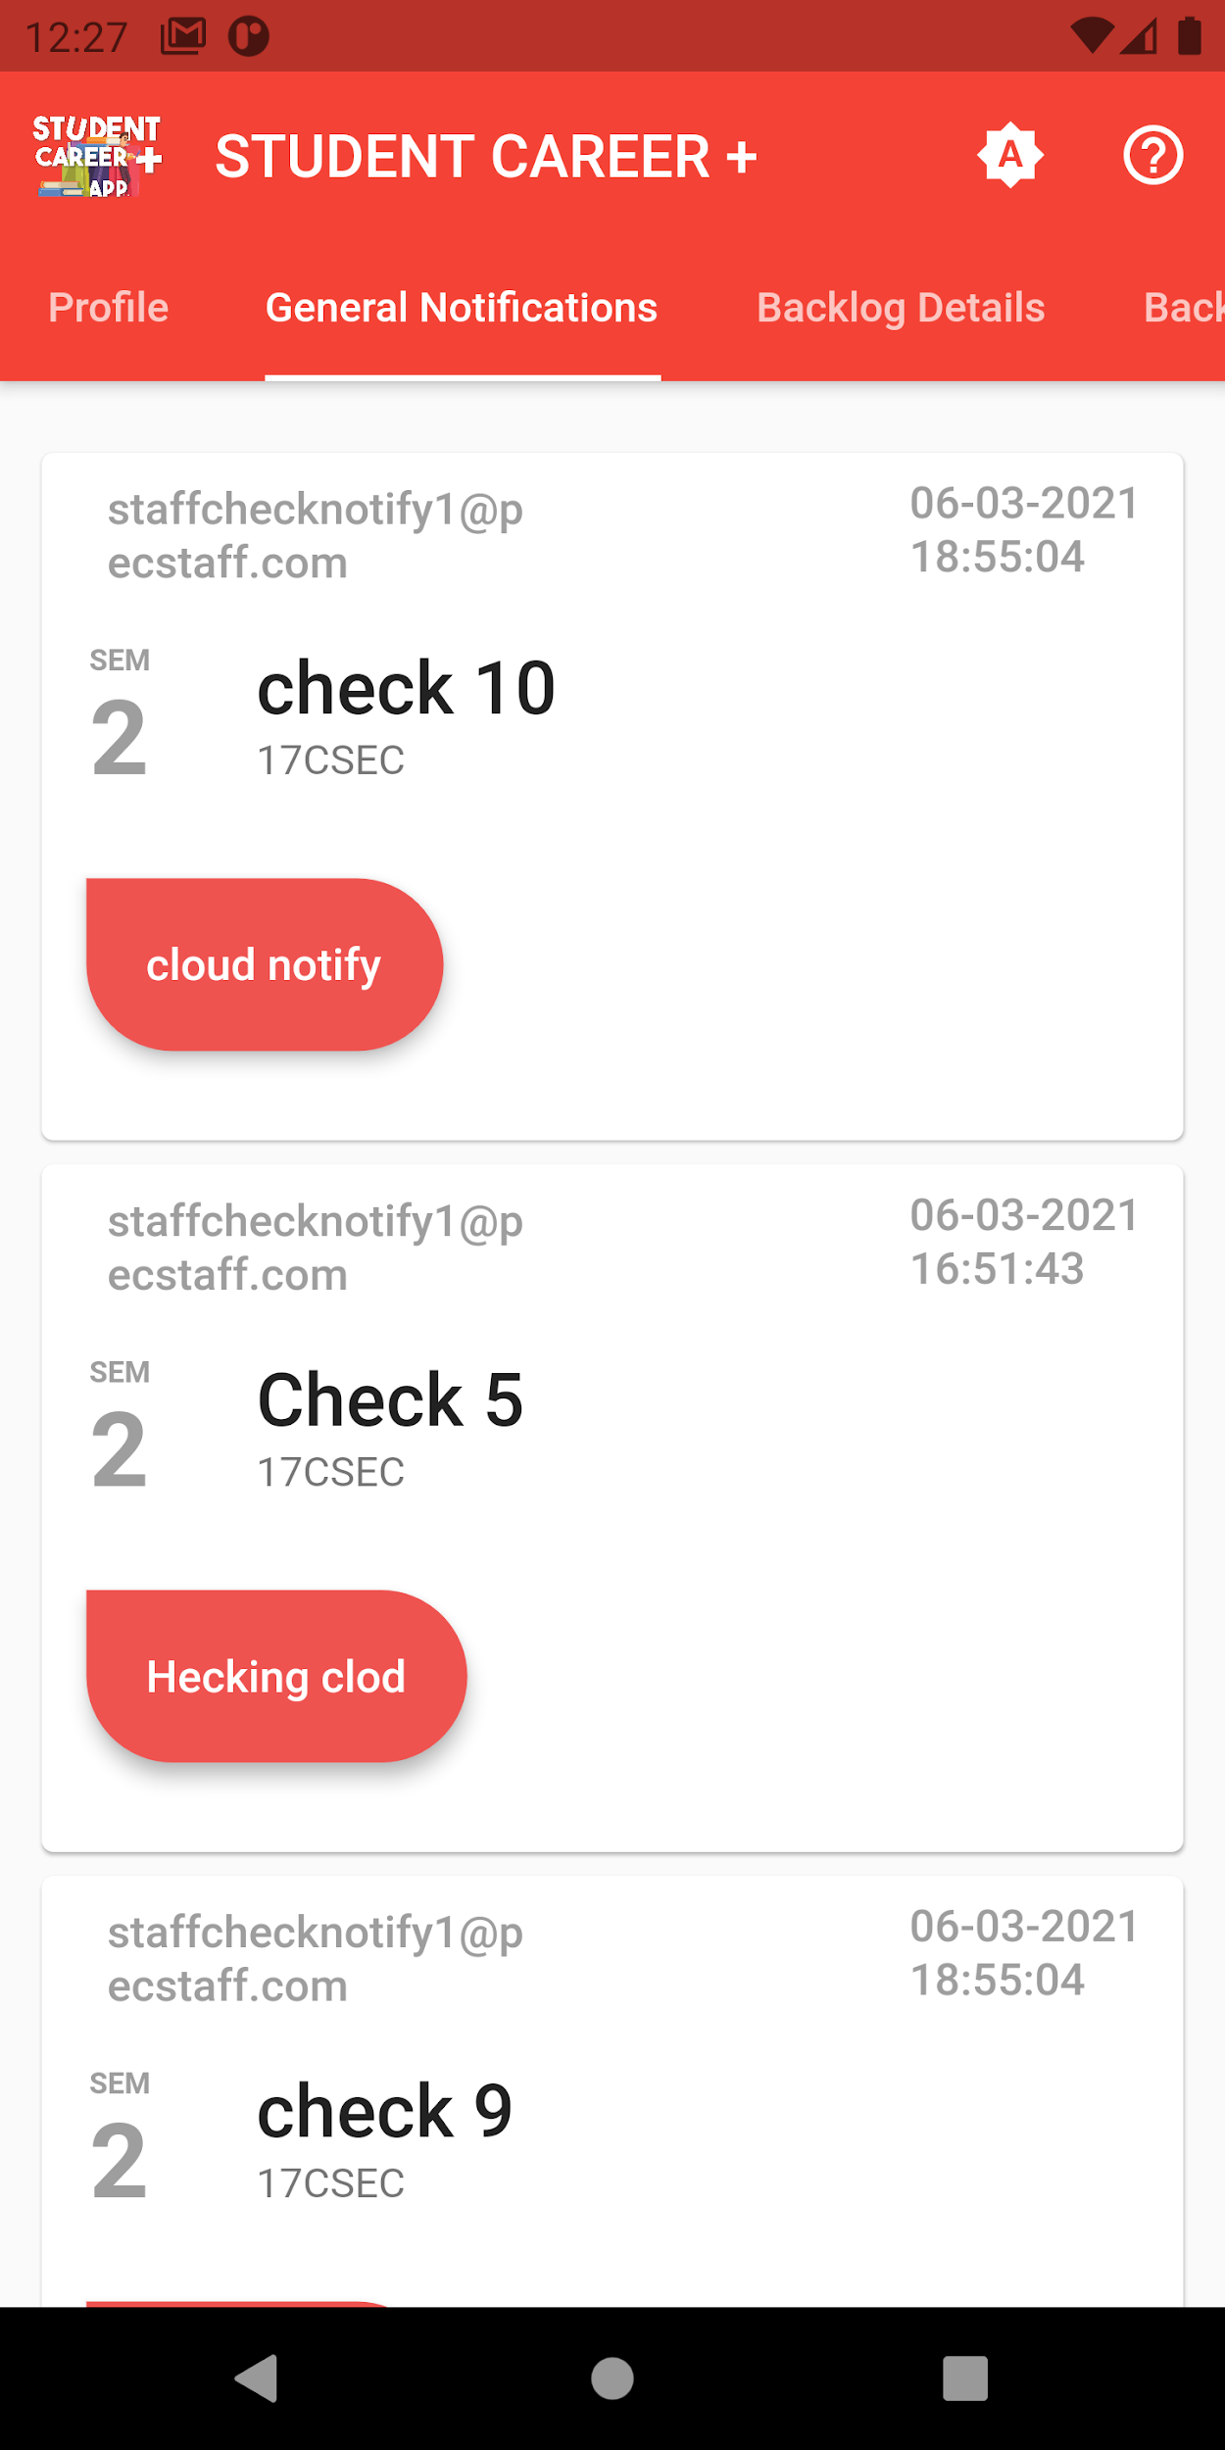

**Figure A.2.5 Figure A.2.6**

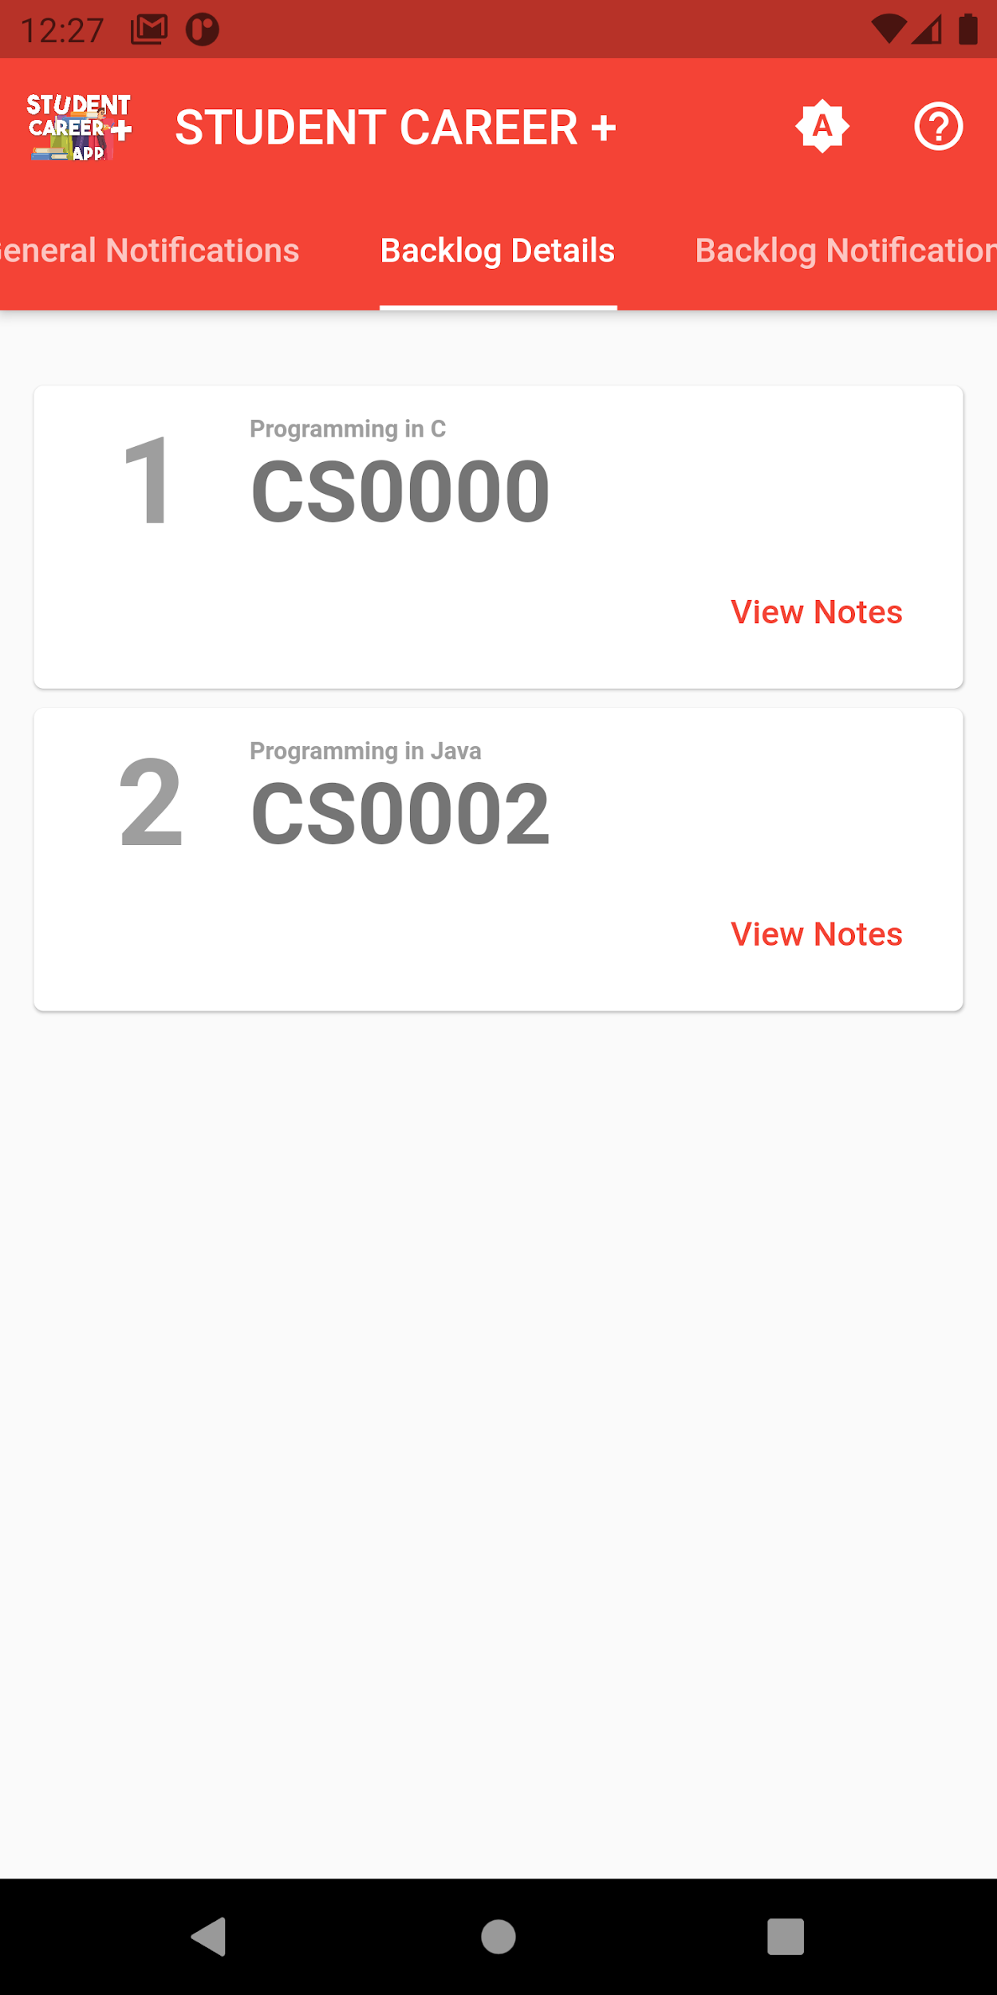 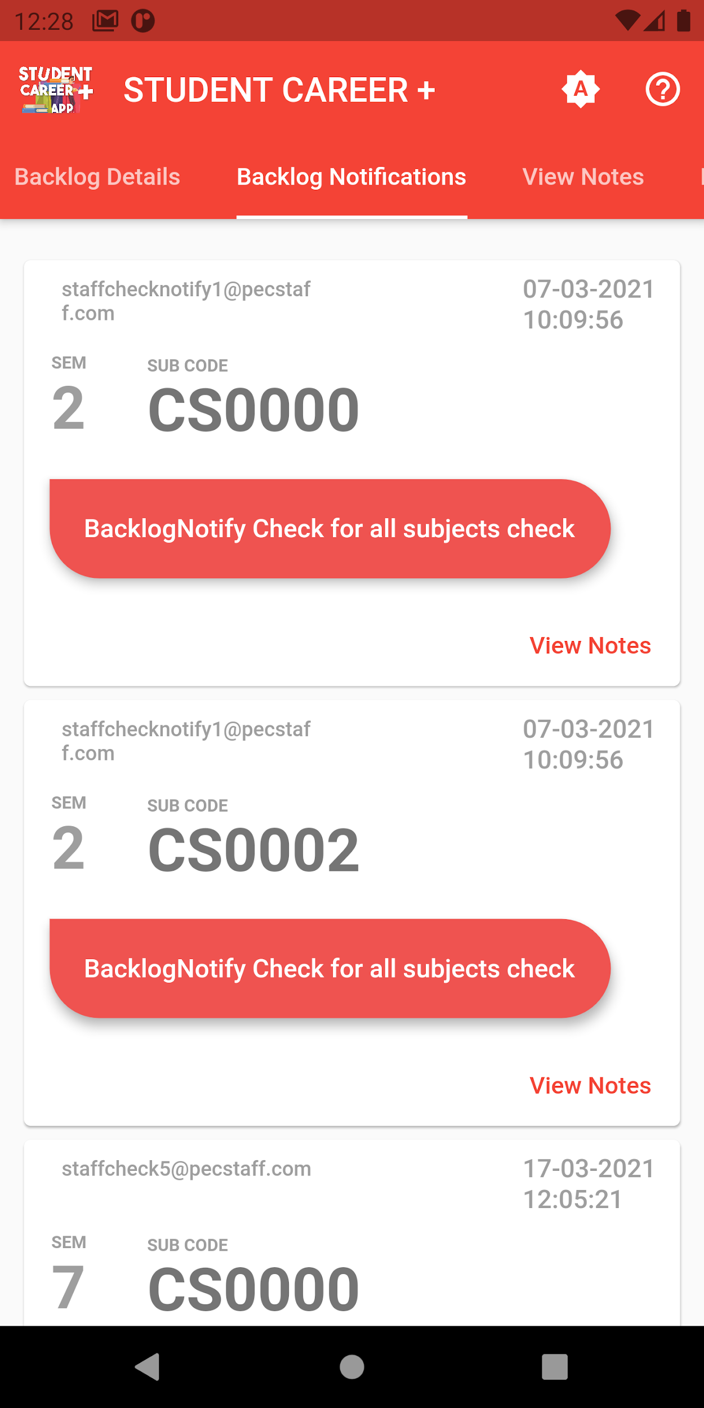

**Figure A.2.7 Figure A.2.8**

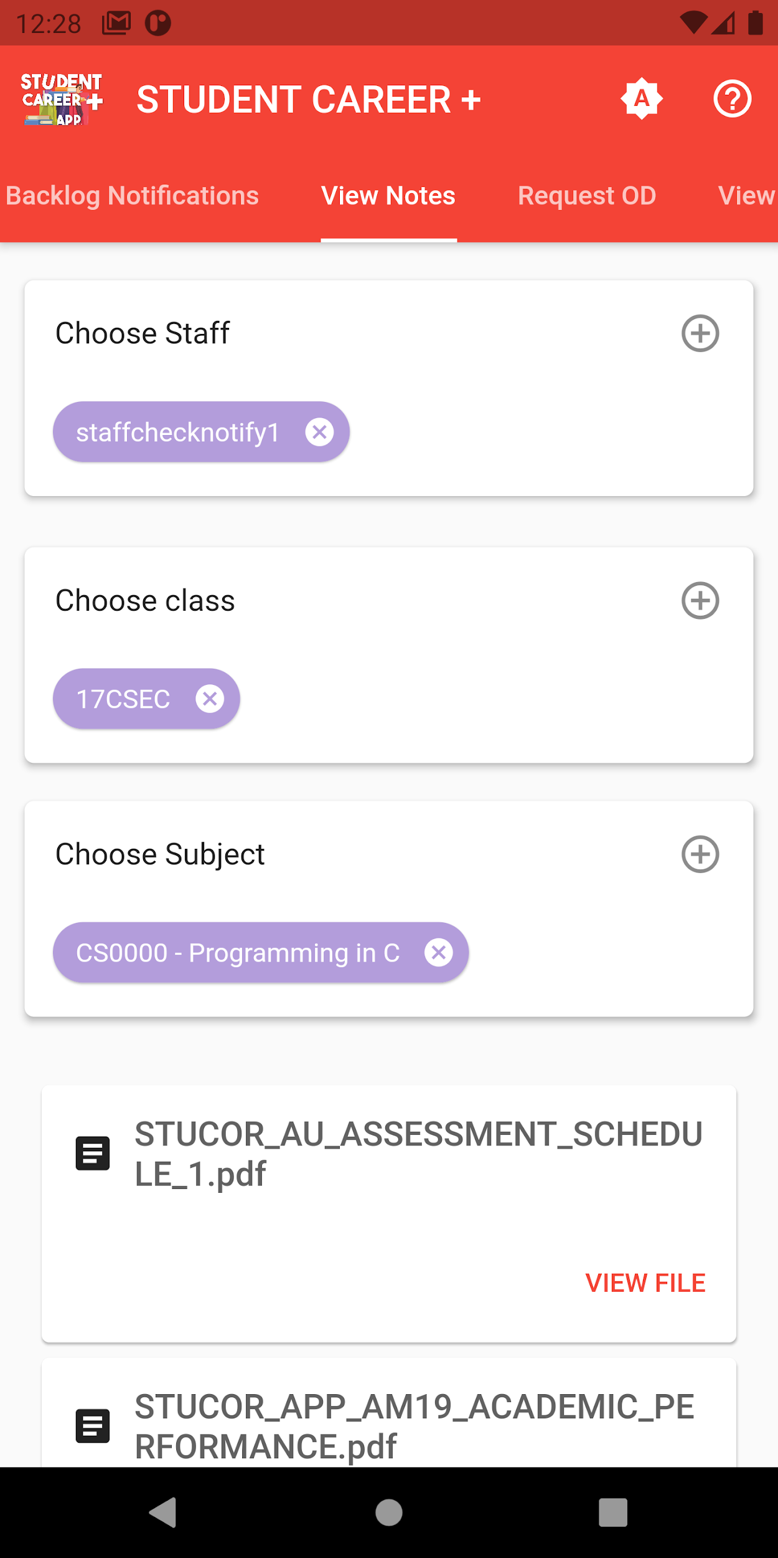 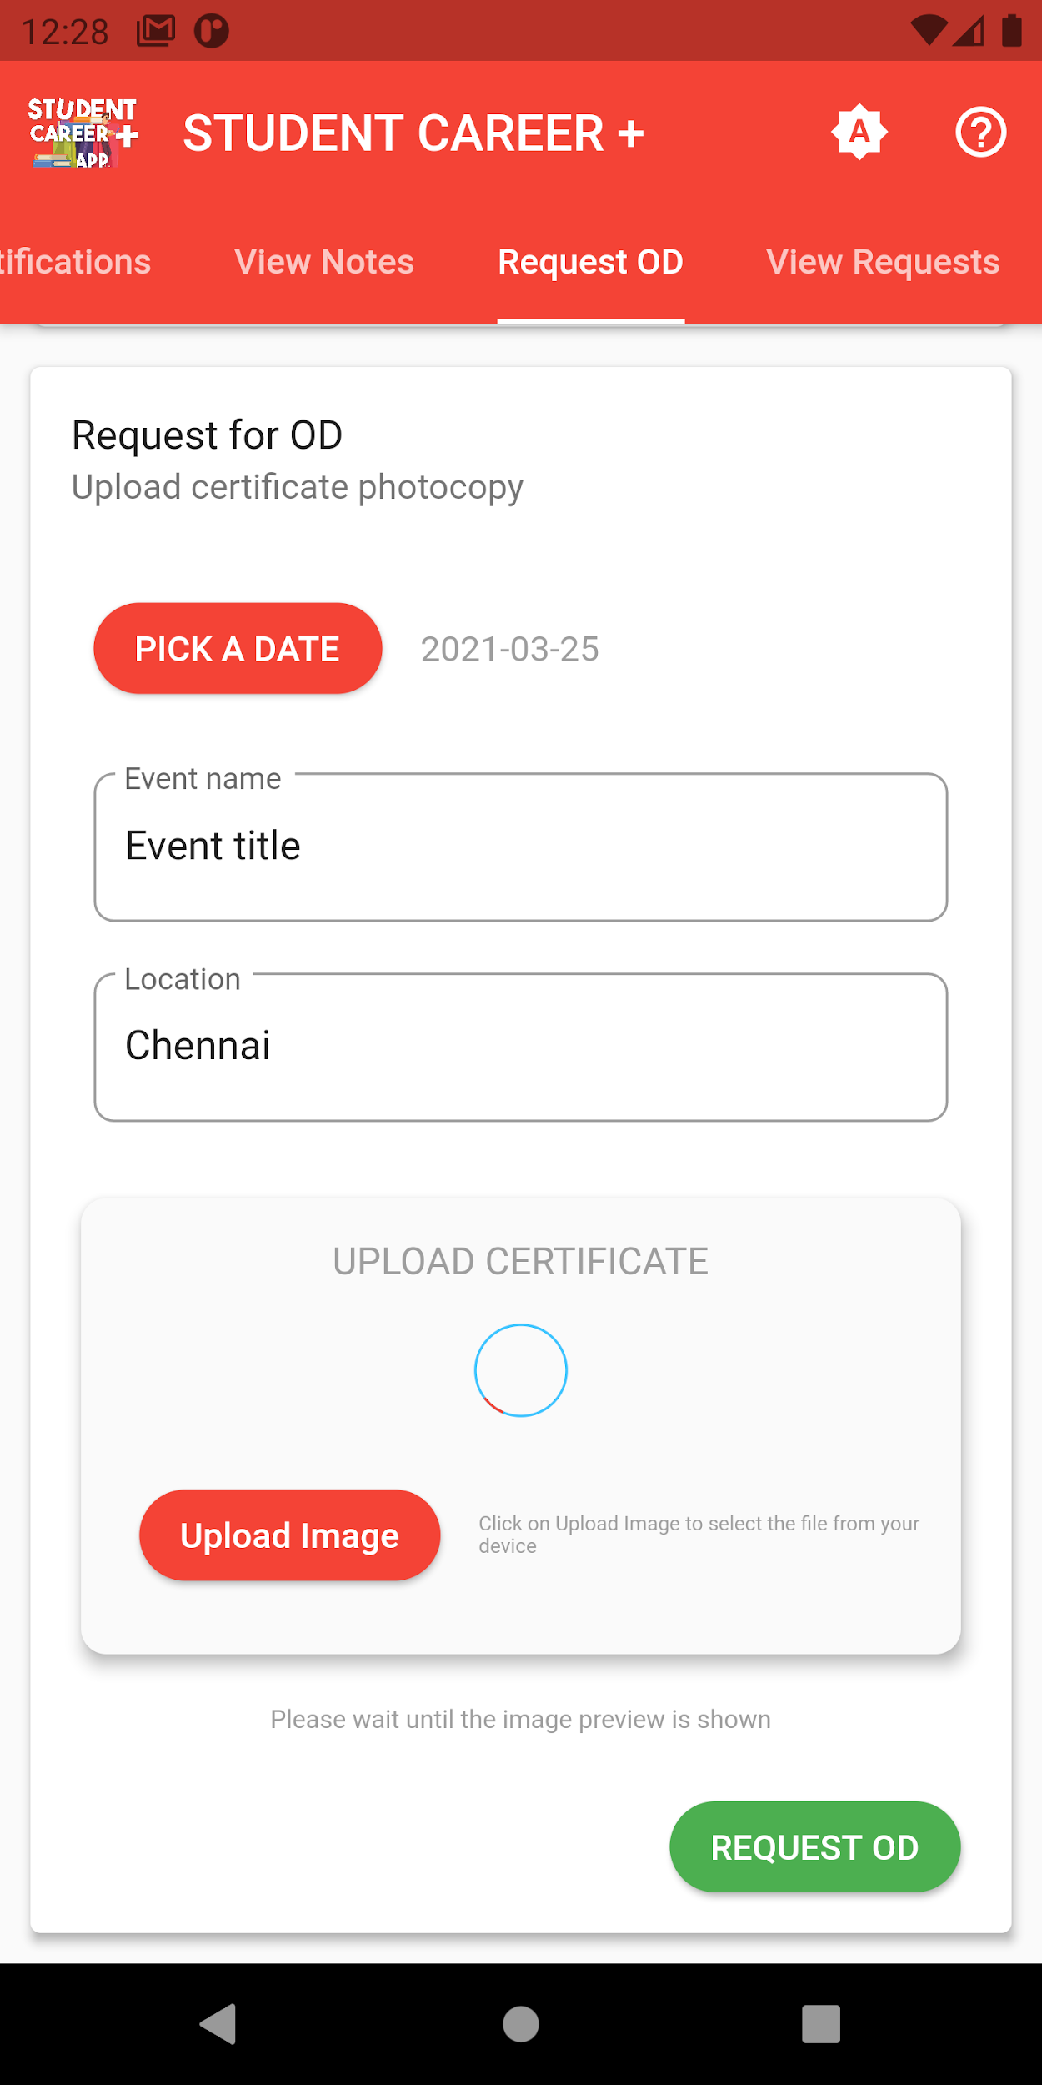

**Figure A.2.9 Figure A.2.10**

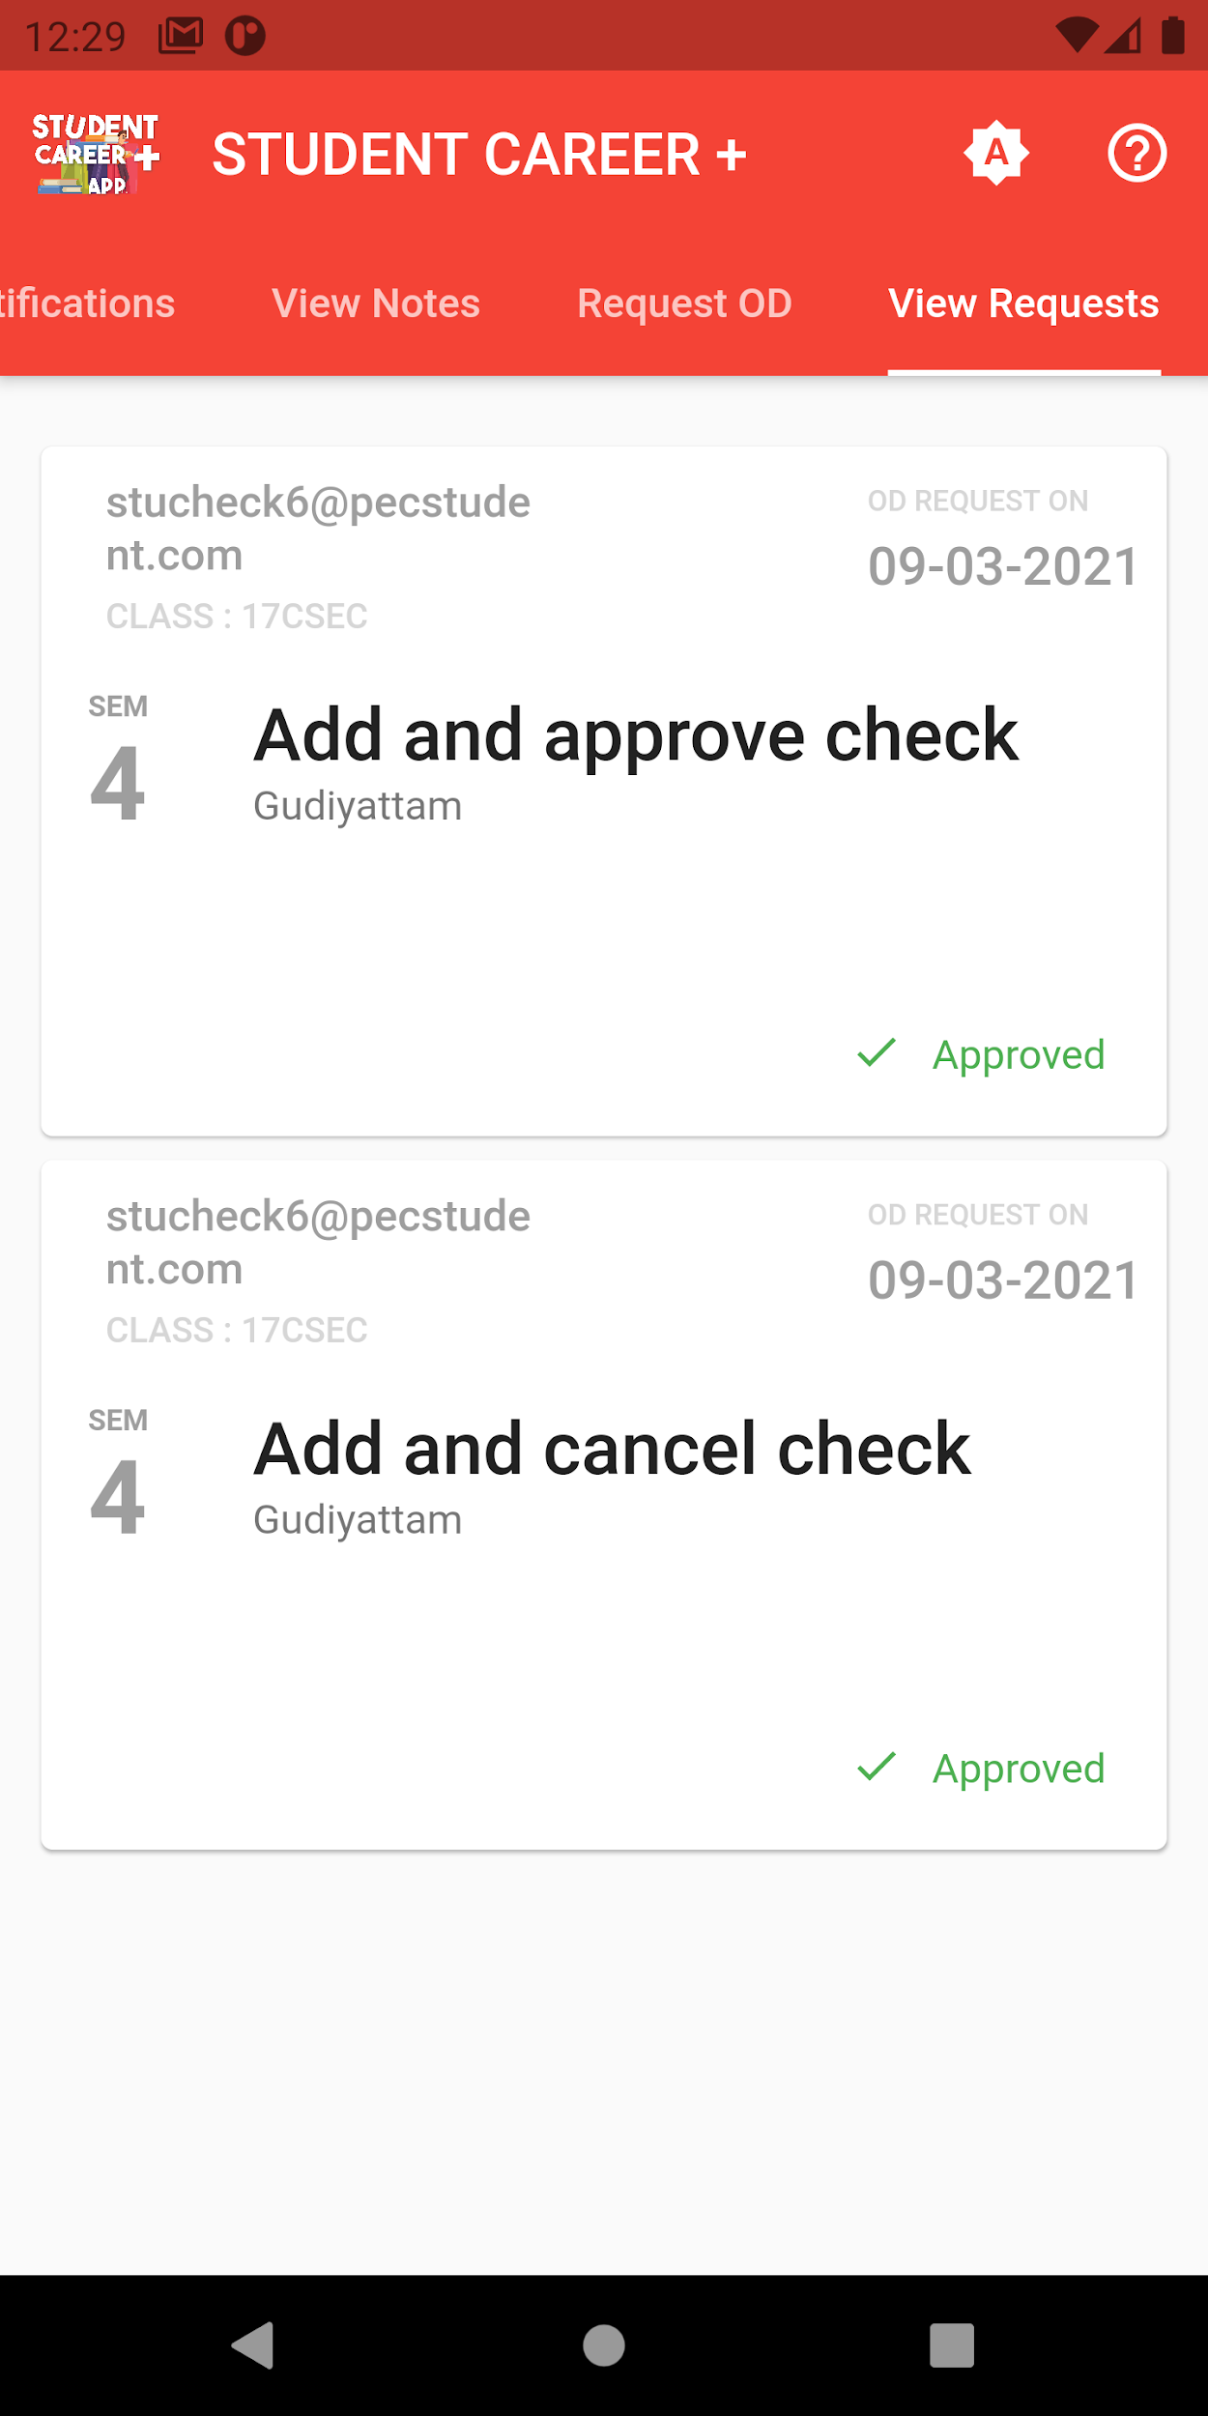 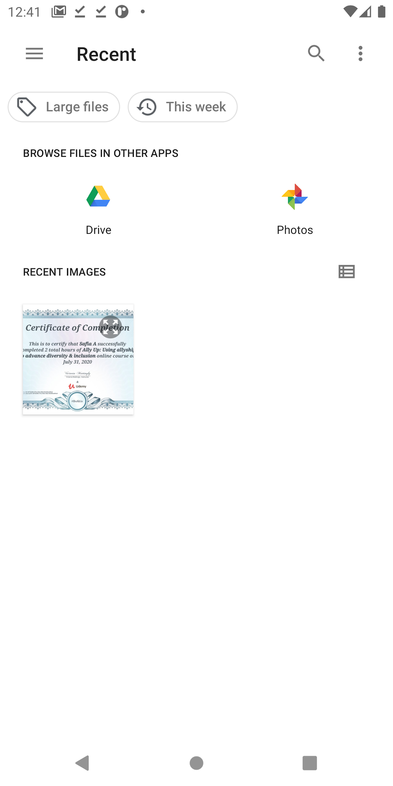

**Figure A.2.11 Figure A.2.12**

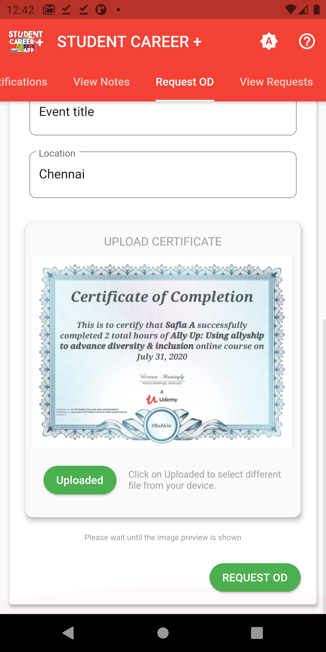 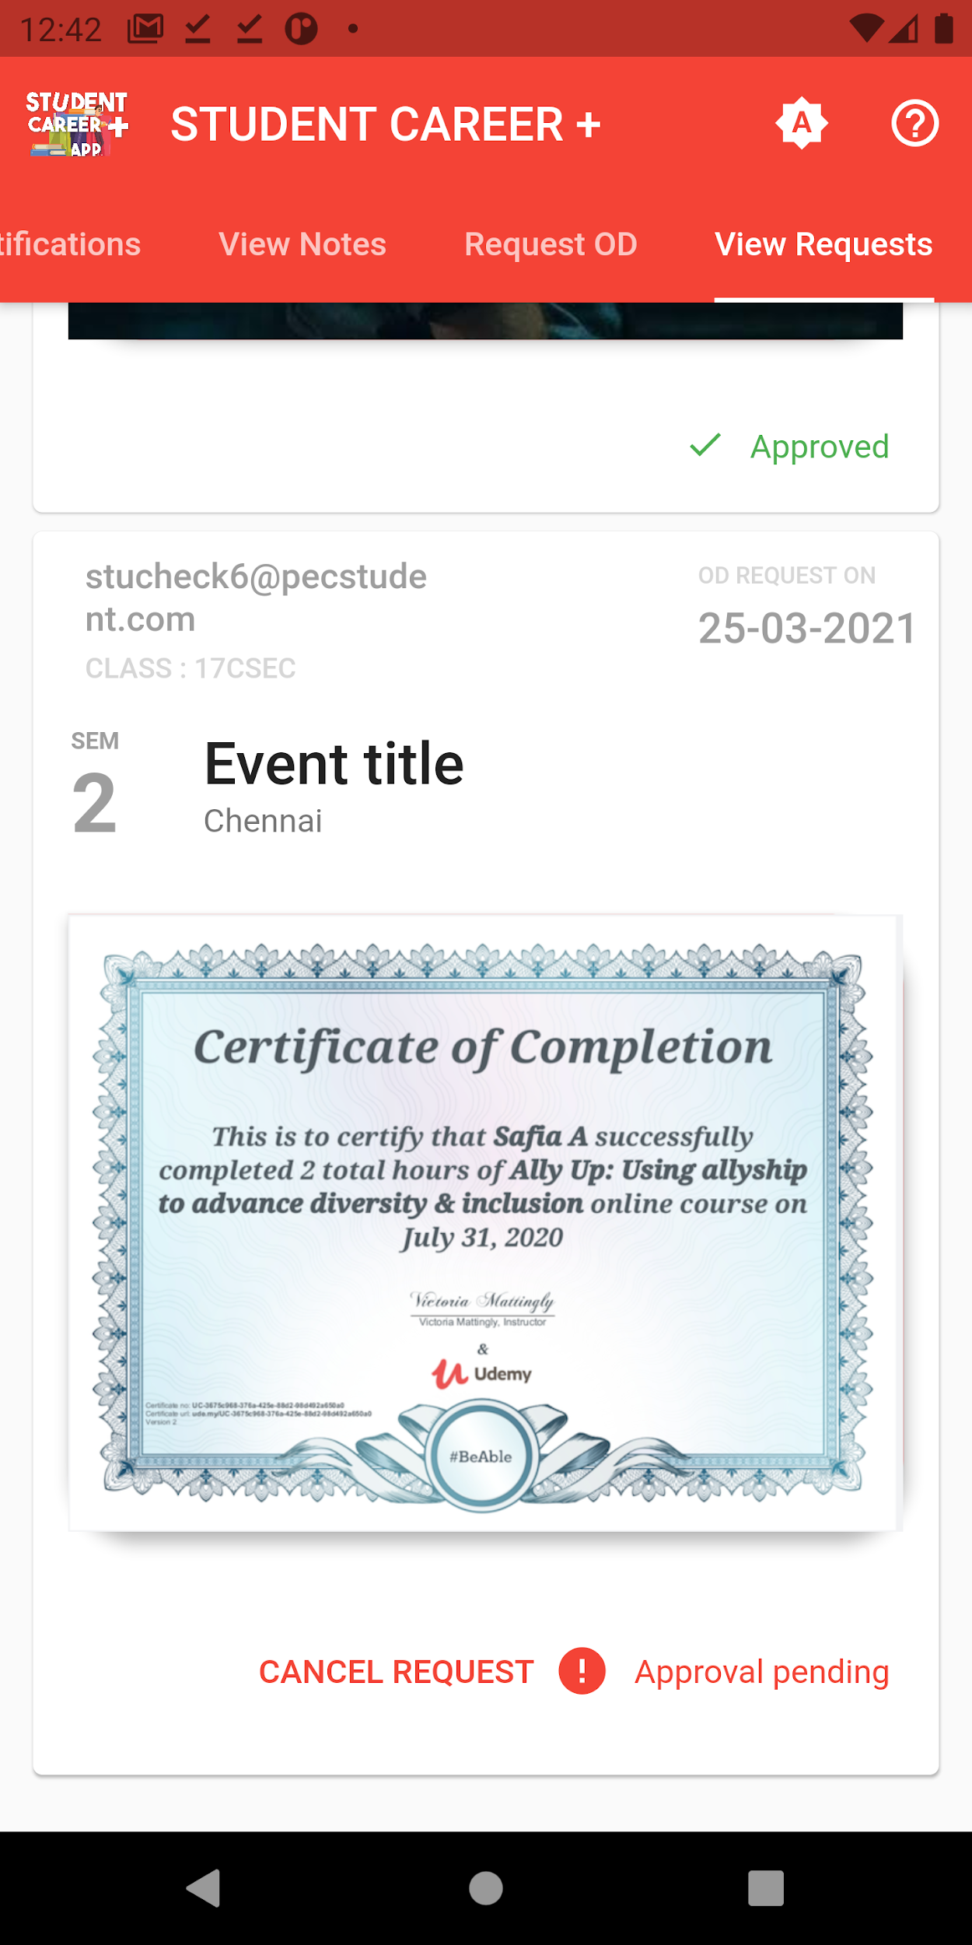

**Figure A.2.13 Figure A.2**

**REFERENCES**

**REFERENCES**

Main Course : <https://www.udemy.com/course/flutter-bootcamp-with-dart/>

GitHub Repository: <https://github.com/londonappbrewery/Flutter-Course-Resources>

**Reference for basics :**

Flutter documentation: <https://flutter.dev/docs>

Firebase documentation: <https://firebase.google.com/docs/build>

Firestore documentation: <https://firebase.flutter.dev/docs/firestore/usage/>

Cloud function documentation: <https://fireship.io/lessons/flutter-push-notifications-fcm-guide/>

**Package references:**

Google Sign In: <https://pub.dev/packages/google_sign_in>

Cupertino Icons: <https://pub.dev/packages/cupertino_icons>

Theme Patrol: <https://pub.dev/packages/theme_patrol>

Sticky Headers: <https://pub.dev/packages/sticky_headers>

Smart Select: <https://pub.dev/packages/smart_select>

Simple Animations: <https://pub.dev/packages/simple_animations>

Firebase Core: <https://pub.dev/packages/firebase_core>

Firebase Authentication: <https://pub.dev/packages/firebase_auth>

Firebase Storage: <https://pub.dev/packages/firebase_storage>

Firebase Messaging: <https://pub.dev/packages/firebase_messaging>

Cloud Firestore: <https://pub.dev/packages/cloud_firestore>

Modal Progress HUD: <https://pub.dev/packages/modal_progress_hud>

Image Picker: <https://pub.dev/packages/image_picker>

Permission Handler: <https://pub.dev/packages/permission_handler>

Shared Preferences: <https://pub.dev/packages/shared_preferences>

Flutter Toast: <https://pub.dev/packages/fluttertoast>

File Picker: <https://pub.dev/packages/file_picker>

PDF Viewer: <https://pub.dev/packages/flutter_plugin_pdf_viewer>

Carousel Slider: <https://pub.dev/packages/carousel_slider>

**Design Reference:**

Material Design Icons: <https://www.materialpalette.com/icons>